

TSplusSolutions for the   
Bring–Your–Own–Device (BYOD) Era

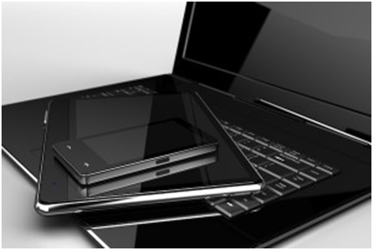

**Solutions for BYOD include:**

**TS*plus* HTML5 RDP Client** - One of the main challenges of BYOD is the wide variety of devices that IT staff must manage. TSplus enables employees to run MS Office and other Windows applications through HTML5 browsers, from anywhere, using any device. There's no client software to install, which minimizes the intervention required by IT staff.

**TS*plus* Web Access Portal** (the Alternative to Citrix) - the premium solution for organizations that want more control of BYOD.

**TS*plus*** Web Access Portal provides secure, managed and accelerated access from local and any remote servers location, to text or graphics-rich Windows applications and to Windows desktops.

These may be hosted on Terminal Services / RDS / Cloud hosted platforms, physical desktops and the Web.

Embrace BYOD - minimize IT hassles and help desk support load. Take advantage of **TS*plus*** features and secure, anywhere, any device connectivity and access management solutions.

It goes by many different names (BYOD, BYOT, BYOC, Consumerization of IT) but one thing is clear: More and more people want to use their own devices in their place of work or study.

**A recent study by Cisco reported the following:**

• 78% of employees in the surveyed US

companies have a mobile device for work.

•  In 41% of those enterprises, most of the smartphones connected to company networks today are employee-owned.

•    88% of IT leaders are seeing BYOD growth

in their organizations.

This trend will accelerate due to the proliferation of iPads, iPhones, Android tablets, smartphones and Chromebooks, as well as employee-owned laptop PCs. These devices are more powerful than ever before, and their capabilities and features will continue to expand.

Take advantage of what mobile devices have to offer and make BYOD work for you.

BYOD is found in many types of organizations, including Business, Education, Healthcare and more. **TS*plus*** BYOD solutions address the challenges and opportunities that are unique to each environment.

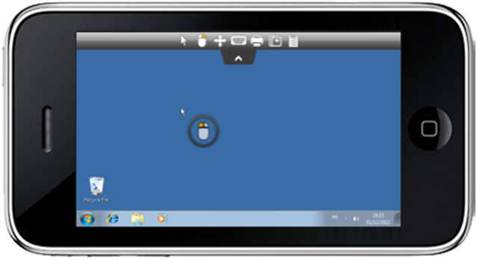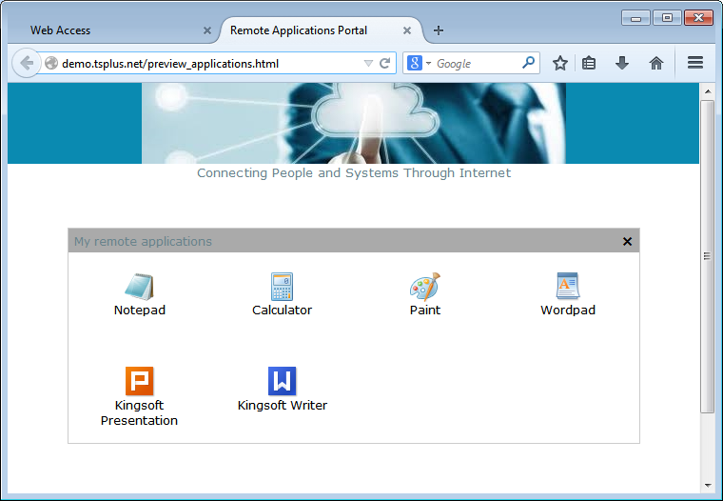

With **TS*plus*** you will leverage the advanced features of HTML5 to quickly and easily turn any HTML5-compatible browser or device into an enhanced RDP Client. Instantly connect to Windows desktops and applications, from iPad, iPhone, Android devices, computers running Windows, Mac OS X, Linux, Chrome OS, and even from locked-down work stations - without installing Flash, Java or any other software on the end-user device. That means zero client maintenance !

    •  Zero Client Software! No need to install: Flash, Silverlight, ActiveX or any other underlying technology on the end-user device.

    • Access and control your desktop from anywhere! Use any HTML5 enabled Device! Smartphones, Tablets including iPad, iPhone, Android devices, locked-down work stations and from computers running Windows, Mac OS X, Linux and Chrome OS.

  •  Extends the reach of VMware View, Citrix XenApp (some versions), Dell (Quest) vWorkspace, and Microsoft Windows Remote Desktop (RDS), to Chromebook and other HTML5-enabled devices and browsers.

  •        HTML5 remote desktop client integrates with the TSplus Web Access Portal Gateway for secure, encrypted, single-port entry into the organizational network. The TSplus Web Access Portal can be used with, or instead of, a VPN or an SSL VPN.

  •        Supports the latest bring-your-own-device (BYOD) initiatives.

  •        **TS*plus*** HTML5 client integrates with leading enterprise and home-grown portals.

  •        Enables mission-critical business continuity as employees can access their Windows applications and desktops from any available end-point device, anywhere, without having to install any software or plugin.

#### 

#### 

#### 

#### 

#### 

#### 

#### 

#### 

#### 

#### 

#### 

#### 

**TS*plus* Mobile Portal is an HTML5 remote desktop gateway that works from any device with an HTML5 compatible browser, including from Chromebooks and locked down devices.**

For IT staff, the central-point of administration helps to reduce the costs and complexities of managing and supporting desktops and other devices. **TS*plus*** Mobile and Corporate Edition's solutions include SecureWeb, enabling external users to securely connect to internal resources without requiring a VPN. TSplus' suite of solutions helps you address your concerns with BYOD, so you can empower your employees while minimizing the burden on your IT staff and enhancing security.