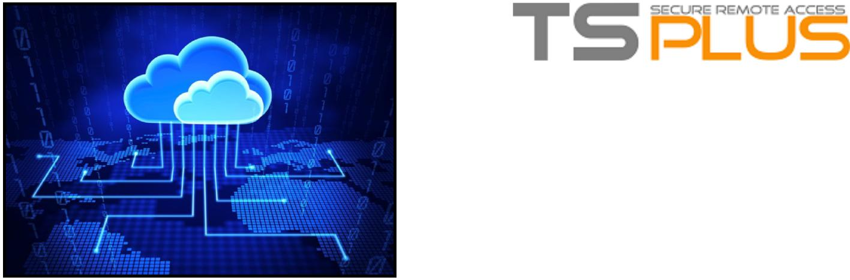

What is Cloud Computing?

Access your software and Windows
applications 24/7!

What is a Cloud Server ? It is an online form of computing where you can access your accounting software and other any windows applications via internet, while the software is installed and stored as well as the data) on a secure virtual private cloud server. You can access this server via internet 24x7.

Fully appreciate the benefits that come with the ability to access your windows applications such as Office, Peachtree, Sage, QuickBooks, SAP and many other windows applications in real-time via a browser, iPhone, iPAD, Smartphone, Android, Mac and Windows Desktop from anywhere in the world.

Simply install TSplus on your hosted Cloud Server as well as your Accounting Software/Windows Applications and access it from anywhere at anytime via internet 24x7.

You will benefit from high performance access to your windows applications without
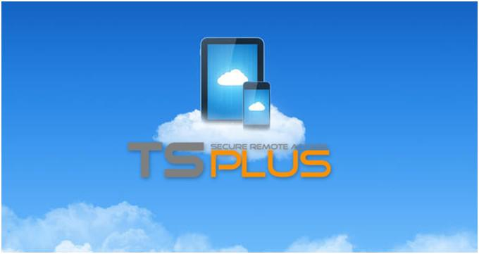
having to ever buy, maintain or replace expensive servers or telecom infrastructure.

TECHNOLOGY : Cloud hosted servers operate on a very solid infrastructure consisting of dedicated or shared
servers, Enterprise Class fast SAS disks, Redundant Network, etc. Automatic failover feature helps in keeping Cloud servers up and accessible if the existing node fails. In such a way, high availability of your server is achieved. Most of Cloud hosted providers are using advanced and secured cloud technology to manage your private virtual servers to provide fast access time, reliability and disaster recovery in their data centers.

With TSplus, Cloud Server Hosting services are providing many benefits. In very brief summary form they are as follows :

REDUCED COST. TSplus shares the CPU power, server memory and data storage among multiple concurrent users.

With TSplus, the Cloud server technology is paid incrementally per user, saving your organizations money.

SCALABILITY. With Cloud Hosted Servers, there are virtually no limits on how much power, space and memory you may need.

Extending your IT production capability is no more an investment decision; it is just a management one. Cloud Computing is suitable for any small, medium and large sized companies looking to reduce their investment in IT infrastructure and have their own affordable, fast and reliable cloud virtual server.

RELIABILITY / HIGH AVAILABILITY.

With TSplus Corporate Edition, the load-balancing function, the fail-over and the disk storage protected by RAID are warranting the highest possible availability rate.

REDUCED SUPPORT AND

DEPLOYMENT COSTS. By utilizing Cloud Server, you eliminate the user PCs maintenance tasks. Every day old
PCs and servers are requiring support. Cloudhosted servers, your key data bases and applications will be stored in a simple point of support.

MOBILITY. Employees can access Information wherever they are, using IPAD, Android devices, PCs, rather than having to remain at their desks. All you need is a broadband internet connection to log in and start using your windows applications from your personal computer, store, office, home, mobile phones and laptops.

