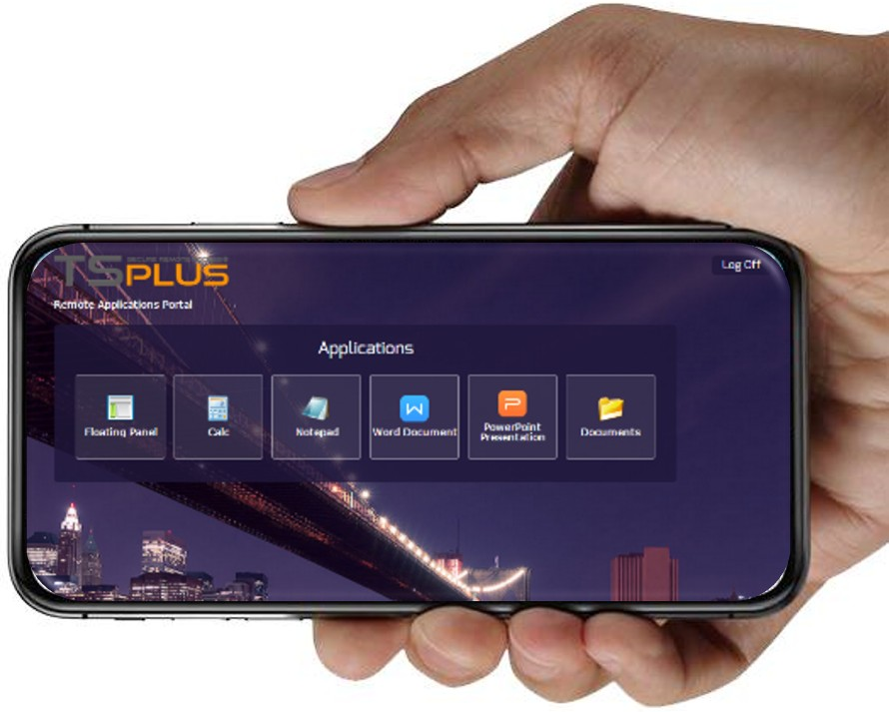
ACCESS YOUR WEB PORTAL AS LOCAL
With the TSplus New Progressive Web App

Download
TSplus latest release

New!!
T S P L U S W E B A P P E L I M I N A T E S
B R O W S E R I S S U E S A N D O F F E R S T H E S A M E B E N E F I T S A S A
N A T I V E
M O R E :
A P P L I C A T I O N ,
A N D
PROGRESSIVE:
WEB-BASED “NATIVE-LIKE” APP SUPPORTED BY MOST STANDARD COMPLIANT BROWSERS (CHROME, FIREFOX, SAFARI…)

FASTER LOADING: INSTALLED IN SECONDS WITHOUT GOOGLE PLAY OR
APPLE STORE, LOW DATA USAGE
& CONNECTIVITY INDEPENDENT
CROSS-PLATFORM:
GREAT MOBILE EXPERIENCE WITH LOCAL APP LOOK & FEEL (RESPONSIVENESS, INTERACTIVITY, LOCAL ICON)

RELIABLE:
PROVIDES THE SAME FEATURES, QUALITY & SECURITY THAN THE TSPLUS WEB PORTAL DOES
Our Web Portal can be installed as a Progressive Web App on any device.
The ongoing COVID-19 crisis has created new workplace paradigms and moved thousands of workers from the
Corporate Office to the Home Office…

Your organization needs a solution that provides a user- friendly, reliable and secure remote working
environment that can be accessed from anywhere.

With the TSplus Web Application Portal, Application Delivery from a centrally managed server is easy and simple! Give your users access to multiple assigned applications from a single secure HTTPS web interface. The portal is compatible with most common web browsers and customizable to reflect your company requirements. It’s the optimal 100% online workspace!

Give your users the ultimate remote work experience: their office just a tap away, wherever they are.

The TSplus Web App is included in TSplus Mobile and Enterprise editions.

