TSplus User Guide

Administration and Configuration for TSplus Remote Desktop Software

Contents

Introduction 3
Pre-requisites 3
Hardware 4
Operating System 4
Android RDP or HTML5 5
iPhone / iPad RDP or HTML5 6
Web Applications Portal 8
Why use TSplus for Server Based Computing? 10
Which TSplus version can best match your needs? 11
TSplus Mobile App 11
Terminal Service Plus Installation 12
Server Configuration with TSplus Admin Tool 14
Restart / Stop the Web Servers Service 15
Web Server Components Status 15
Manage Web Servers 16
Creating users 18
Application Publishing 20
Assigning applications to users or groups 22
RemoteApp On Client Feature 24
Connection Client Generator – Overview 27
RemoteApp and Seamless Connection Clients 29
RemoteApp connection client 29
Seamless connection client 31
Microsoft Remote Desktop 32
Printing remotely with TSplus 34
Universal Printer Manager 34
Printing with the Universal Printer 36
Securing a TSplus server 38
Changing the RDP port number and setting up the firewall 38
Server side security options 39
Hiding the server disk drives 39
Advanced security options 41
RDS-Knight and Server Genius 44

Introduction

TSplus offers a complete terminal server alternative with a Web Portal and application publishing, for all Windows operating systems from Windows XP to Windows 2016. Therefore, you can use any Windows PC as a terminal server and assign applications to users. It can either be accessed on the TSplus server via an encrypted SSL connection using a client (RDP) or via the Internet using an HTTPS / VPN connection to use with the possibility of user-defined certificates.

  - What do you need to use TSplus?

Pre-requisites

On Server side:
Windows XP Pro, Vista, Windows 7, W8.0, W8.1, W10 Pro, SBS, W2003, W2008, W2012 and 2016 with at least 2GB of memory. The operating system must be on the C drive. On Windows Server Environment (2003,2008,2012, 2016) please make sure that the TSE/RDS role and the TSE/RDS licensing role are not installed to prevent conflict with TSplus services.
It is mandatory to use a fixed private IP address and a fixed public IP address. If your ISP (Internet Service Provider) did not provide you with a fixed public IP address, you need to subscribe to a free DNS account : http://support.tsplus.net/kb/faq.php?id=30
Antivirus recommendation: In order to prevent your security software to block any of the TSplus services, we recommend to deactivate your antivirus before installing TSplus and set an exclusion rule on installation path is also highly recommended. You will need to set an exclusion rule in your antivirus on the following path: C:\Program Files (86)\TSPlus and C:\wsession
On Client side:

Microsoft workstation: Operating systems from Windows XP to W10 are supported. A PDF Reader (like FoxIt) should be installed on the users’ PCs.
Macintosh workstation: You can use any MAC RDP client, or TSplus HTML5 client.
Linux Workstation: You can use Linux Rdesktop RDP client or TSplus HTML5 client.

Hardware

Number of users | Equipment for XP/2003 | W2008 to 2016 or 7 to 10
3 - 5 | 1GB  ONE CPU | I5 or above  4 GB  One CPU 2 GHZ
10 | 1 GB  One CPU 2 GHZ  I5 or above | I5 or above  8 GB  One CPU 2 GHZ
25 | 4 GB  One CPU 2.5 GHZ  I5 or above | I7 or Xeon  8 GB
50 and above | 16 GB  Dual CPU | 16 GB - Dual CPU  SSD Disk dedicated to the system
Over 50 concurrent sessions, we recommend using a farm of servers. Each server (physical or virtual ones) handling up to 50 concurrent users.
Comment: The type of hardware you will need mostly depend on what kind of resources the applications you wish to publish consume the most (CPU/memory/Disk). You might consider getting a server with SSD drives if you plan on using an application that accesses a database on your TSplus server as it will greatly enhance the performances.

Operating System
Your hardware must use one of the operating systems below:
- Windows XP Professional or Windows XP Home
- Windows Vista Home Premium, Professional, Corporate, Ultimate Edition
- Windows 7 Home Premium, Professional, Corporate or Ultimate Edition
- Windows 8 Professional and W8.1
- Windows 10 Pro
- Windows 2003 Server or 2003 SBS
- Windows 2008 Server or 2008 SBS
- Windows 2012 Server
- Windows 2016 Server
32 and 64-bit are supported. However, the overall performances are optimized for 64-bit OSs.
- If you install TSplus on a Windows 2003 to 2016 make sure the RDS or Terminal Services roles as well as the RDS Terminal Services licensing role are not installed before installing TSplus. If these roles were present, remove them and reboot.
- For any Windows Home edition, you will need to create local administrators users accounts in order to be able to connect remotely.
You can also connect from other devices such as Android, Iphone, Ipad and any thin-client that comes with a browser and allows you to connect from where you want directly after the reboot.

Android RDP or HTML5
TSplus offers a unique solution to connect from Android phones and Android tablets. Using TSplus, Android devices can be used to remotely access a workstation or a server from any Wi-Fi or Internet spot.
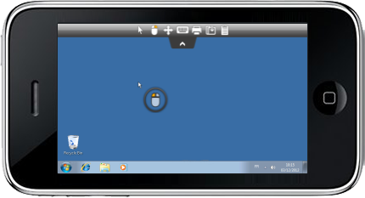

TSplus HTML5 Web Access Client is providing browser access to applications and desktops, running on any TSplus system. TSplus also offers any Android phones and Android tablets RDP client support.

iPhone / iPad RDP or HTML5
TSplus offers a unique solution to connect from iPhone and iPad devices.
Using TSplus, iOS (iPhone and iPad) devices can be used to remotely access a workstation or a server from any Wi-Fi or Internet spot.
Without having to download any application from Apple Store, TSplus HTML5 Web Access Client is providing Safari an instant access to applications and desktops running on any TSplus system. TSplus is also compatible with any iPhone/IPAD RDP client.
TSplus Android phones, Android tablets, iPhone and iPad client support has a lot of benefits:
- Zero Client Software! No "app" to download and install on the end-user device.
- Access your desktop from anywhere! Use any iPhone or iPad to connect to a remote computer!
- Extends the reach of TSplus Gateway Portal to Safari, Firefox, Opera and other HTML5-enabled browsers.
- Integrates HTML5 Web Access Client with leading enterprise and home-grown portals.
- Supports the Universal Printer to enable local printing from anywhere
- Integrated with SSL TSplus Secured server (no client required).
- Enables mission-critical business continuity, allowing employees to access their applications and desktops from any available iOS device, anywhere, without having to install any software or plugins.

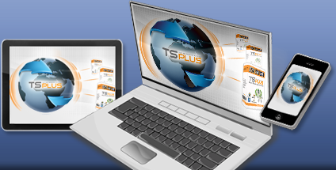

What is HTML5 Web Access Client?
HTML5 Web Access Client is an HTML5 RDP client written purely in HTML5.
- Runs completely inside the browser
- Does not install anything on the client device
- Looks, works and performs like the regular (native) RDP client.

What is Pure HTML?
This means that the HTML5 Web Access Client, which is implemented using only standard Web technologies (HTML, CSS and JavaScript), does not require Flash, Java, ActiveX, Silverlight or any other special software installed on the end-user device, it:
- Uses the same client for ALL platforms.
- Looks and works the same way on all platforms.
- Eliminates management of end-point devices – no installation, configuration, management, update, patching, etc...
- Integrates TSplus technology delivering great remote access performance.
- Works with locked-down devices.
- Supports the widest array of end-point devices, i.e., any HTML5 compatible browser on any platform, including Windows, Mac, Linux, iPad / iPhone , Android, Google RIM Blackberry and Playbook, etc.
- Works with devices that only support web apps, such as Google Chromebooks, IPAD, iPhone, Android.
- Comes with TSplus SSL Secure Gateway; provides secured and encrypted access when connecting from outside.
- Integrates with Home grown portals and Enterprise portals.

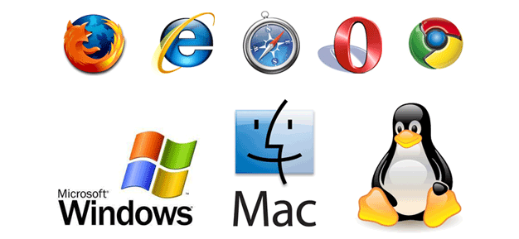
What will HTML5 mean for enterprise Portals?
HTML5 Web Access Client enables organizations to easily integrate Windows applications and desktops as portlets within IBM WebSphere, Microsoft SharePoint, Oracle WebCenter Suite, Oracle WebLogic, SAP NetWeaver, JBoss Enterprise, and other leading enterprise portals. By taking advantage of TSplus Gateway, you can extend the reach of portal-based Web access to Microsoft Excel, Word or line of business applications. Enable your users to remain connected, content, and productive, wherever they are and from whatever device they are using.

Web Applications Portal

With TSplus you have the choice between having a full remote desktop for your users or to automatically see the applications you set to them by enabling the Applications Portal on the Admin Tool (for more information on the AdminTool go to page 14):

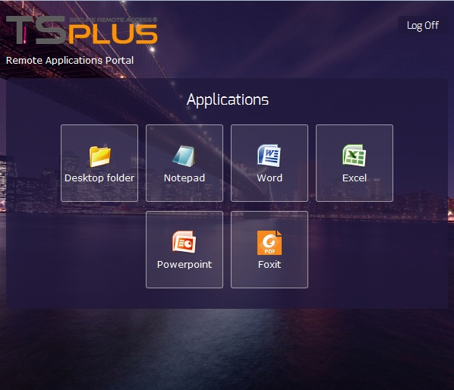

TSplus Web Applications Portal
With this logon page, the user is free to select his preferred web access client:

- HTML5 client
- Windows RemoteApp
You can also either Enter a PIN code or using your user email address as credentials to access applications.
Web Credentials are very easy to manage from the AdminTool, also on the web tab.

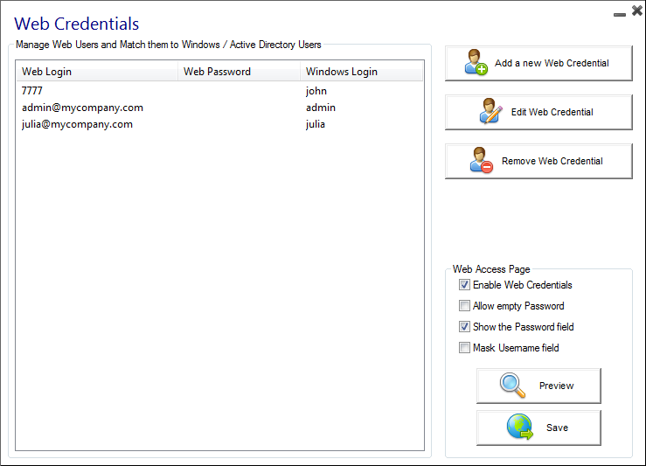

The user can also not have to type any credentials. Its own applications will start automatically. It can be the best solution if your applications include its own logon process (Single Sign On).

Since TSplus 9.50 version, you can also decide the maximum number of concurrent sessions for a user.

With TSplus, your users can access their applications directly from the Internet, simply by clicking on the application icon. Each of them opens on a new tab.

Why use TSplus for Server Based Computing?
TSplus offers simple configuration and operation, both from the perspective of the administrator and the user. TSplus combines all the components which should provide a modern terminal server and Application Server and thus contributes effectively to the saving of labor and IT costs.

TSplus provides cutting-edge server technology at an unbeatable price.

How does the UAC behave with TSplus?

TSplus does not interfere with the UAC of Windows. Both the local user accounts, as well as the Active Directory of a domain are adopted.

Included Features

Features | Contents
5/10/25 or unlimited concurrent users licenses | Server Technology for operating systems from Windows XP to W16
Universal Printer | Print documents from anywhere without installing printer software on the server
Application Publishing | Deployment of Windows applications without Microsoft Remote Desktop background (RemoteApp)
Application Control | Allocation of applications per user or user group
Load-balancing and failover | Unlimited number of servers in a farm
TSplus Remote Taskbar, Floating Panel or your own user Desktop Themes | Alternative shell for Microsoft Remote Desktop in different versions
Fast File Transfer | Between server and client, or vice versa via drag and drop

Which TSplus version can best match your needs?

TSplus offers a unique version for all Windows operating systems.
A distinction is made only through the licensing of the product (number of users), or through optional components. TSplus is 3, 5, 10, 25 and unlimited users licensable. TSplus licensing model is simple: one license per server. The trial version available on our website allows you 5 simultaneous access for 15 days. Don't hesitate to contact our support team if you wish to test TSplus in your environment for a longer time.

Optional products for TSplus are the Universal Printer, the Web Portal and Load Balancing. The Universal Printer allows to print documents from any TSplus client PC (regardless of the locally connected printer), and two different web interfaces (the Web access and HTTPS / VPN) for access via the Internet from any PC, with the possibility of HTTP or HTTPS / VPN access with SSL encryption on the server TSplus includes Print management. The associated HTTP server is already integrated in TSplus.

TSplus Mobile App

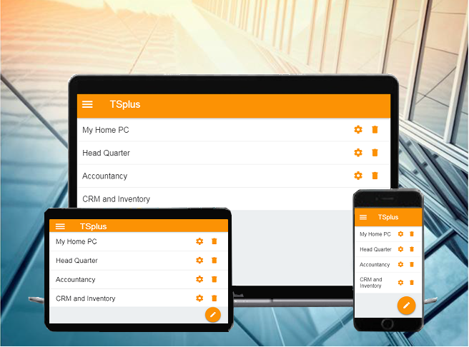
- The TSplus Mobile Apps are available for all major operating systems as web or native apps. After a quick download, your devices are ready for use within a few minutes.
Whether on your desktop or mobile device, the apps are a gateway to each TSplus system. With the click or touch of a button, you are connected to a TSplus server where you can use the assigned programs, such as QuickBooks, SAP or Office, in real time - wherever you are.
TSplus apps are free for any TSplus Mobile Web customer: Download it for Windows, Android or iOS on this page.

Terminal Service Plus Installation

The installation of TSplus (The trial periods delivers a full product for 15 days and 5 concurrent users) is done automatically in a few sub-steps and must be made with the Administrator account. The first window makes you choose the language. Then follow the instructions of the installer.
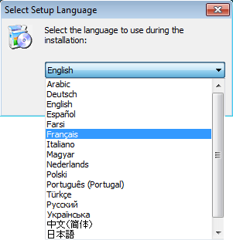
There are now twenty languages to chose from. Click on "I accept the agreement":

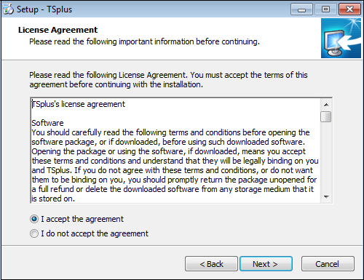
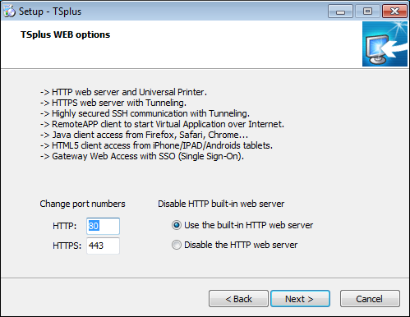

We recommend you accept our TSplus default installation settings. According to our experience, most of the production issues are due to Windows security features.

If you already have a web server installed, you can define alternative ports to avoid software conflicts. You can also disable TSplus Http server. These settings can be configured afterwards in the AdminTool, on the Manage Web Servers tile of the Web Tab. The installation path is by default: C:\Program Files(x86)\TSplus. The progress bar appears and allows you to follow the process duration. Finally, you must reboot your computer to complete the installation:

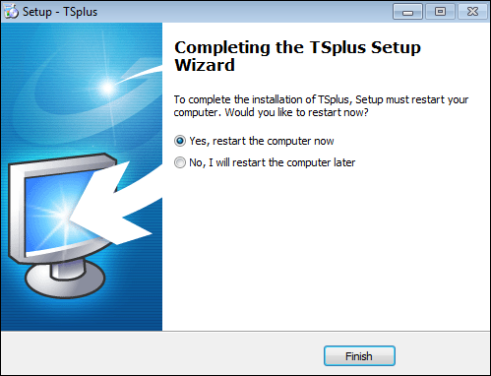

On the desktop you can now see two new program icons available:

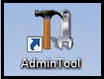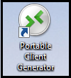
The Admin Tool The Portable Client Generator

Server Configuration with TSplus Admin Tool

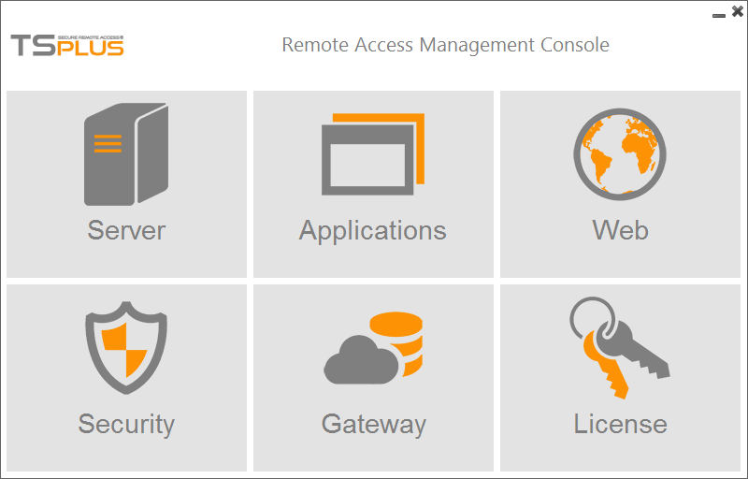
The TSplus Admin Tool is the central hub for the configuration and administration.

All settings, such as server settings, publishing applications and assigning them to users and groups, HTTP server configuration, load balancing, backup parameters, server management and license control are available here and much more. We're now going to see how you can manage the server’s options, on the Web tab of the AdminTool.
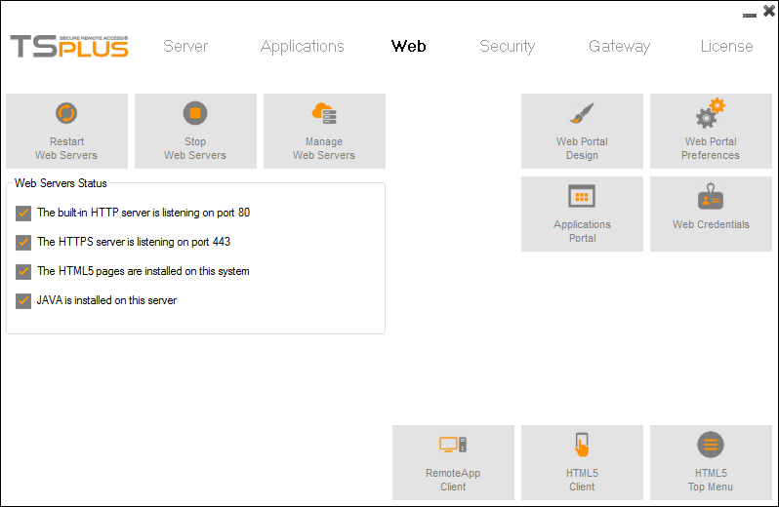

Restart / Stop the Web Servers Service
If you click on the "Restart Web Servers" button, the Web Servers will be restarted. If you click on the "Stop Web Servers" button, the Web servers will be stopped. The HTTP and HTTPS server status will now display a red "X" indicating that the HTTP / HTTPS services are stopped:
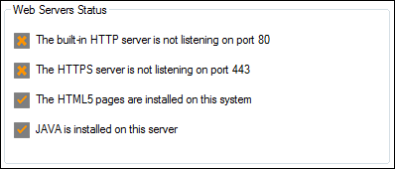

Web Server Components Status

The status of the Web Server main components is displayed in the Web Server Management Console.

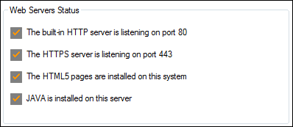

You can change the Domain name of the Server by clicking on the "Web Portal Preferences" tile.

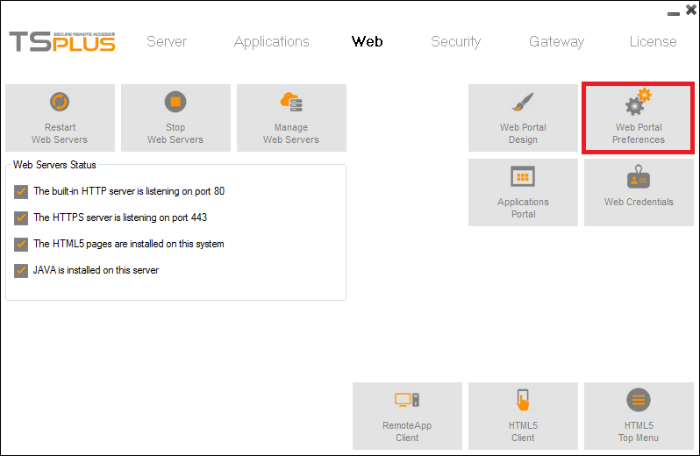
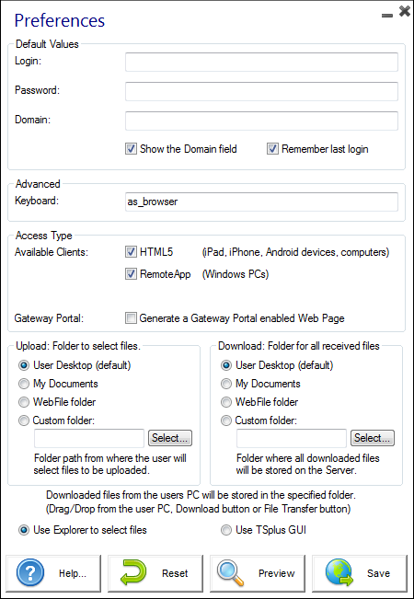
If your TSplus server is not member of an Active Directory, we recommend you set the hostname of your server in the Domain field. This window allows you to configure the Web Access page. For more information on the Web Portal Preferences, see this page.

Manage Web Servers

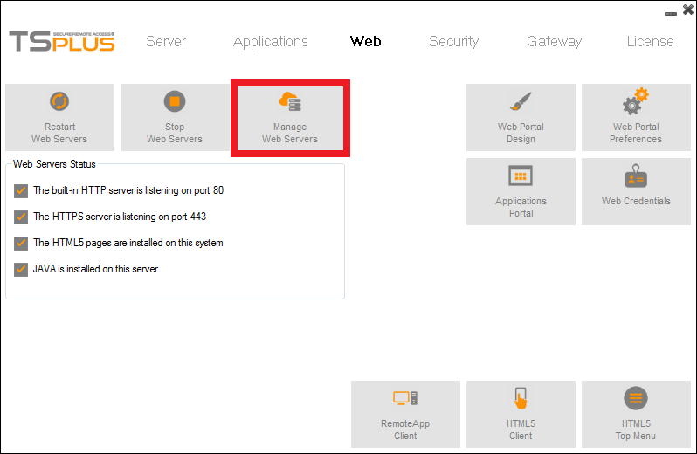
On this tile, you can choose to use a different HTTP web server, modify the Web Server root path and the HTTP/HTTPS ports number. Once again, make sure that these ports are available before changing them. Once these modifications done, the AdminTool will restart.

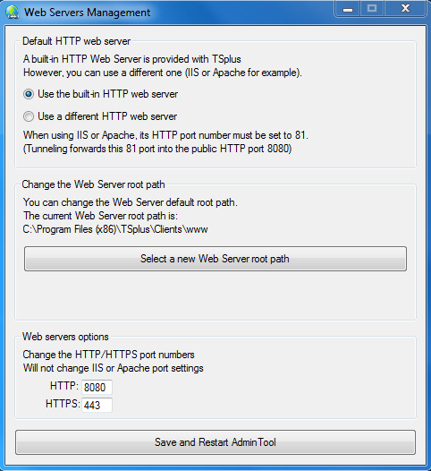

Creating users

You first need to create users to be able to assign them applications and to create the corresponding generated clients. Click on the Users and groups tile on the server tab:

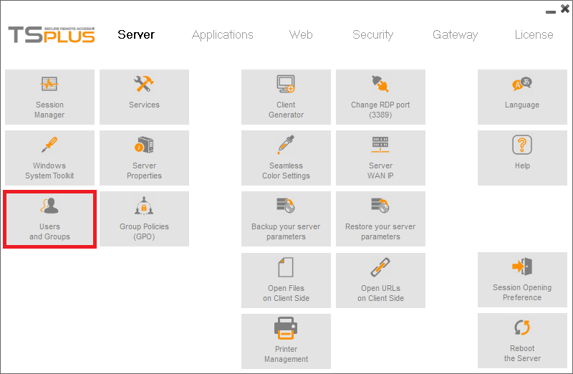
Then, go to the Users folder and right-click to create a new user.

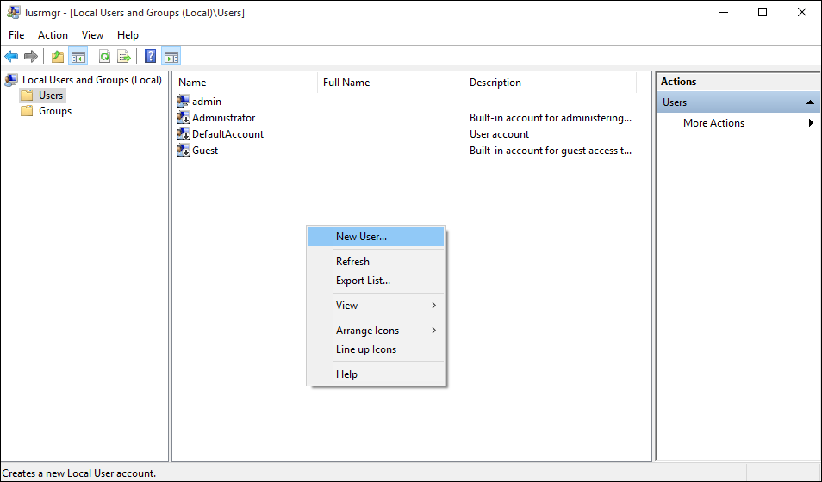
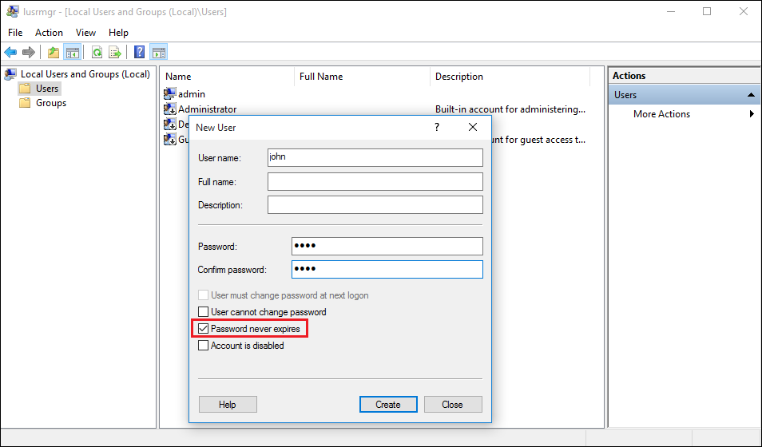
Create your user with its user name and password. The "user must change password at next logon" box is checked by default. Check the box "password
never expires" in order to avoid it.

Application Publishing

You will add or delete applications using the AdminTool, by clicking on the "Application Publishing tab" on the Applications tile:
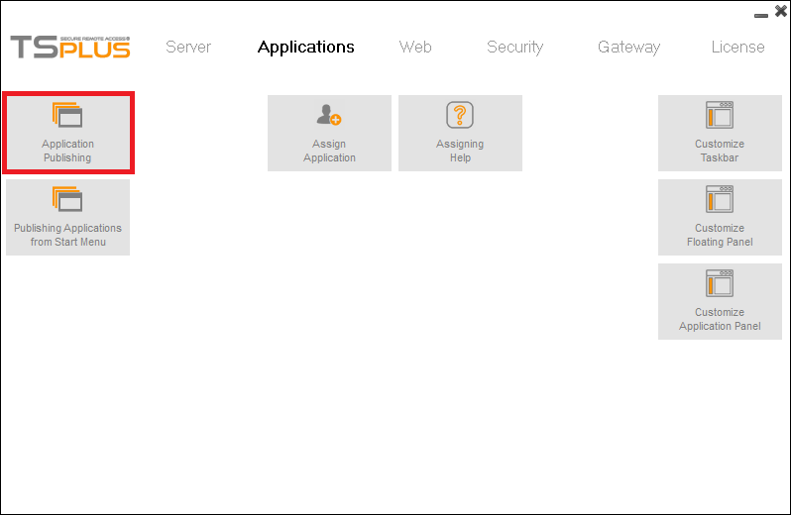
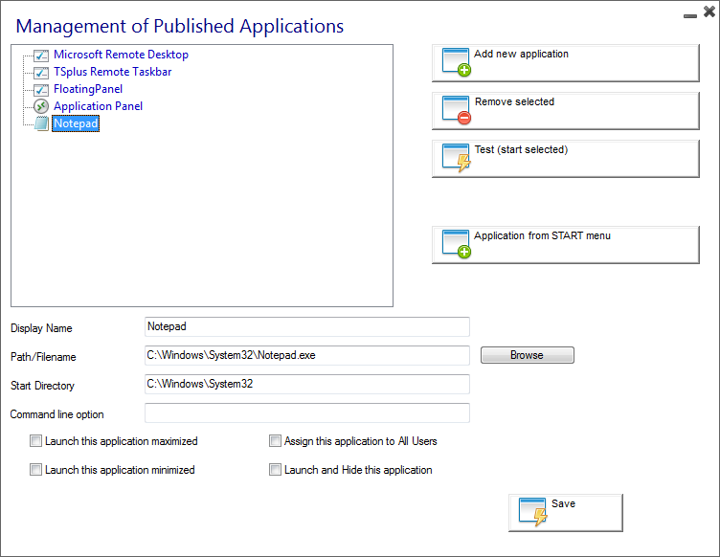
Notepad is published here as an example.

- First, click on "Add a new application".
- Then, click on the "Browse" button and select the application's path.
- Enter the name of the application on the "Display Name" field.
- You must click on "Save" to store any modification.
- After declaring a new application, we recommend using the "Test (start selected)" button to check that the application has correctly started.
You can then decide if you want this application to be launched maximized or minimized, or to launch and hide it.
You can also decide to assign this application to all users.
Application publishing from Start menu
You can also publish applications from the Start Menu of your server, by clicking on the "Application from Start Menu" button on the previous window. You can also click on this tile:
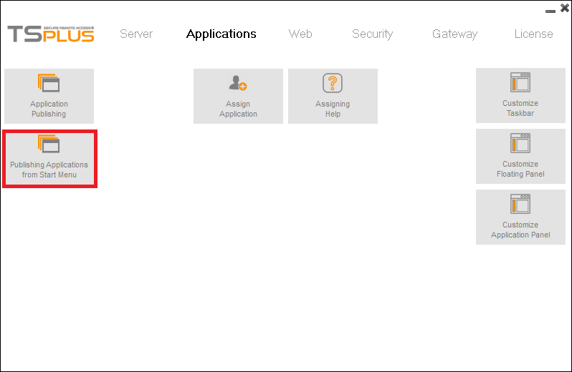

Select and save the desired applications to publish (on this example, Excel):
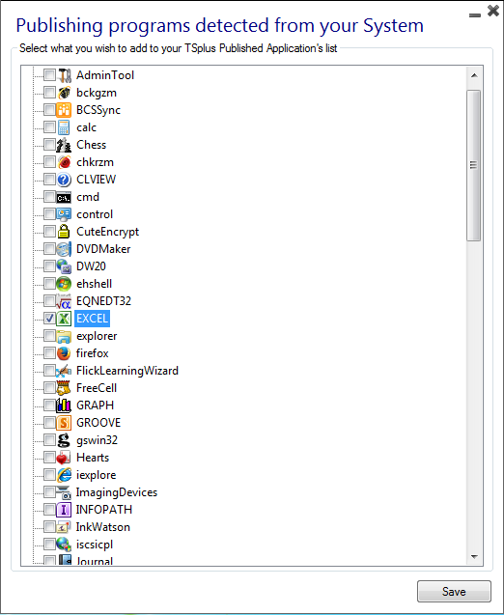

Assigning applications to users or groups

Once you created your users on your server and published applications, you can now assign them to users or to groups. By clicking on the "Assign applications" tile, you can either assign the published applications for each user separately or for a specific group. In the left tree view, you can see a complete list of all your users and groups (local as well as from your Active Directory if any). All users and groups having at least one application assigned are displayed with their name in bold.
Click on a user (or a group): his currently assigned applications will be checked in the right tree view.

- You can check an application to assign it to the currently selected user (or group).
- You can uncheck an application to unassign it.
- Changes to user’s assignments are instantly applied.
- Changes to group’s assignments are instantly applied.

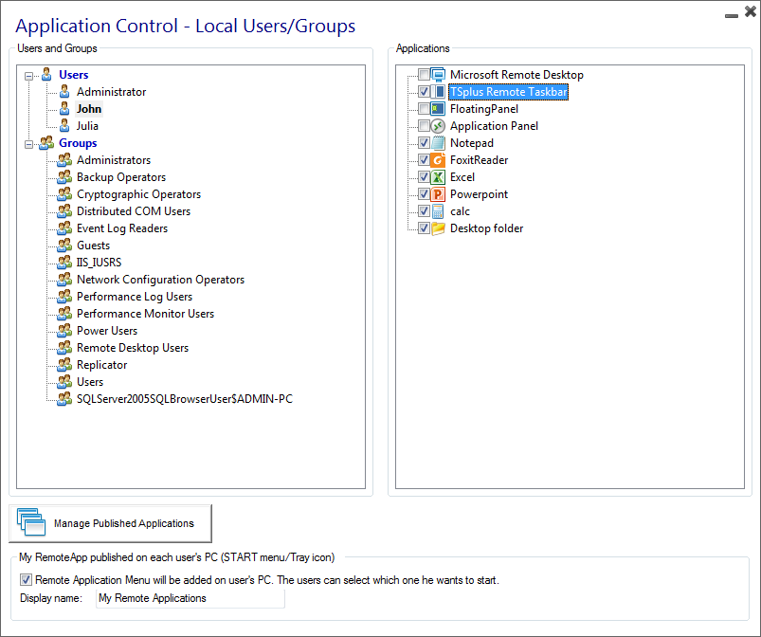

On this example, we decided to assign the TSplus Remote Taskbar, Notepad, Foxit, Excel, Powerpoint, the calculator and The Desktop Folder to the user John.
To assign applications to groups, just select the group you want to assign the applications to:

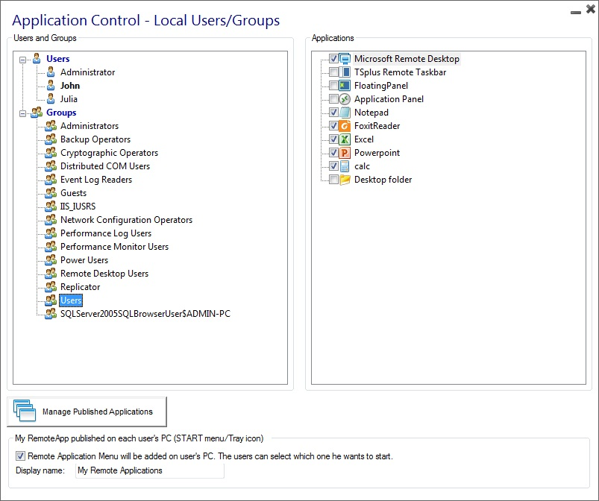

RemoteApp On Client Feature

You will notice that there is a pre-ticked box on the bottom of this window:

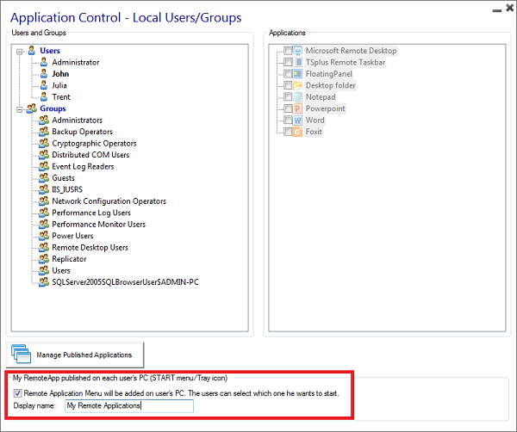

This is the new RemoteApp on Client feature, which allows the user who opened a session with a generated client to see a list of his assigned applications on the START menu or with a Tray icon and start any of them in just one click, even offline.

This is a new way for administrators to deliver remote applications (referred to as “RemoteApps“) to their users. Specifically, RemoteApp On Client enables a straightforward publishing process that allows applications installed directly on the server to be provided to users, allows RemoteApp programs to run side-by-side with local programs, and offers integration with a custom “launcher” application to make it simple for users to find and launch RemoteApp programs.

Example: The user "Laura" is using TSplus to access her remote application. To do so, she is using a generated client named LauraPortableClient.exe. When she runs it on her PC she gets the following result:

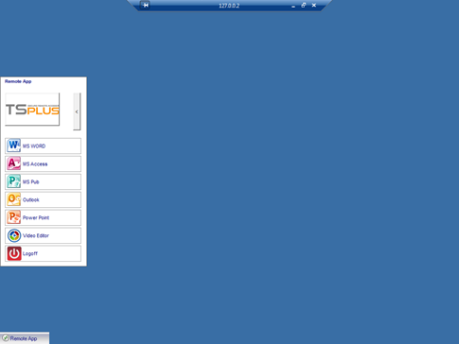

You can change the menu name as you wish by adding it on the display name box. What will happen on her PC when she will run once her new generated client: She will see a new icon in the Notification Area of her local task bar.

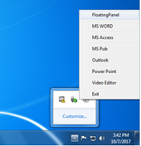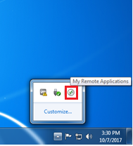

She will also see a new entry within her Start menu Program list named "My Remote Applications":

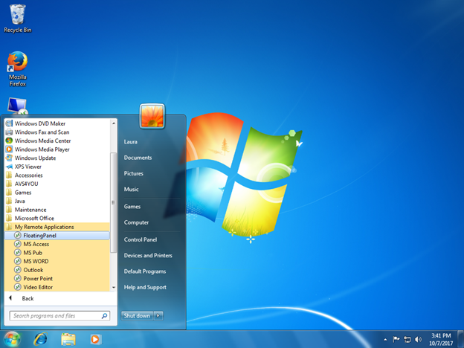

She will now be able to select one of these listed applications and to start it as a RemoteApp. She will not need to use the provided LauraPortableClient.exe generated client. For example, if she selects the Floating Panel, she will get this result:
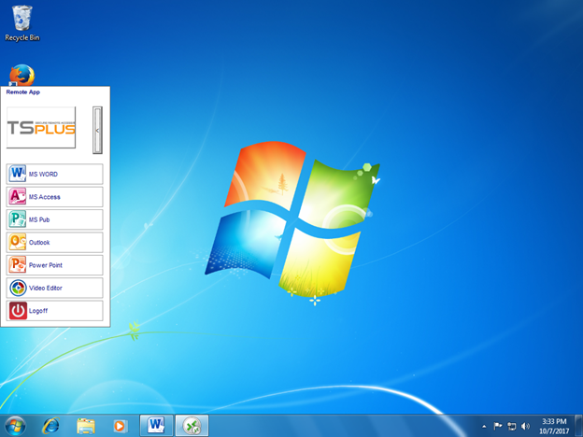

Connection Client Generator – Overview

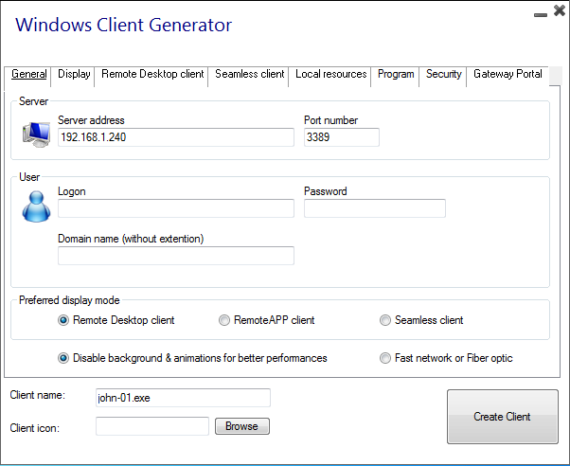
The generated clients can be copied to users’ Desktop or onto a USB stick for portable use.

Main window - General Settings
The Connection Client Generator program allows you to change the icon and the connection client program name.
- Server Address: Enter the IP address of the server to which the client must be connected.

- Port Number: Enter the server port number.

- User and Password: If you enter a user/password, the client program will not ask to retype it at each session. If you type *SSO in the user name field, the client program will just ask once the logon/password at the very first connection and will save this information on the user’s workstation so that the user doesn’t have to identify himself ever again.
To reset this logon/password saving, you must create and edit a shortcut of the Remote Desktop Client and add -reset on switch at the end of the target field.

- Domain name: Enter a domain name if any.
- Preferred Display Mode: You can choose your preferred Display Mode between:
- The classical Remote Desktop.
- The Microsoft RemoteApp connection client, which has a better graphical performance over minimized applications.
- The Seamless Client, which only displays published applications as if they were installed on the local computer, the advantages of the Seamless client are its compatibility with any Windows version.

- Network speed: You can also now choose between two options depending on your network speed:
- Disabling background display & graphic animations for low speed networks.
- Enabling background display and graphic animations for fiber optic or fast network.

RemoteApp and Seamless Connection Clients

You can choose between 3 display modes on the general tab of the client generator:
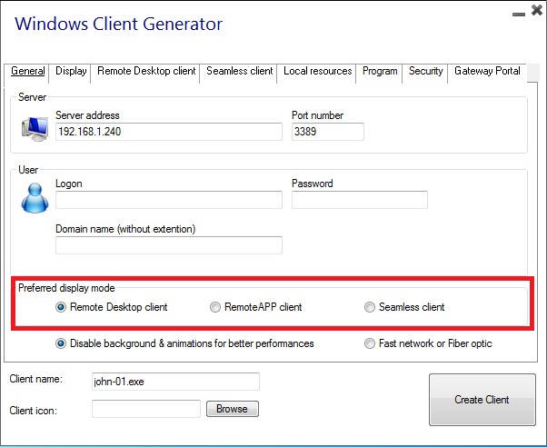

RemoteApp connection client
The RemoteApp connection client, contrary to the Seamless client, does not depend on the transparency color settings.
Hence, it enables a perfect application display as well as a native Windows behavior.
- On the Client side, the installation of RDP6 or above is imperative.
- On the Server side, TSplus has to be installed on a Windows 7 Ultimate or Enterprise, Windows 8 or 8.1 Enterprise, W10 or Windows 2008 to 2016.

You can change the RemoteApp client display and Printing preferences on the Web tab of the Admintool:
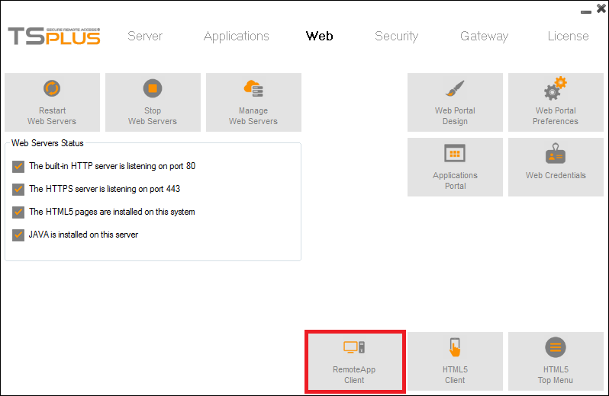
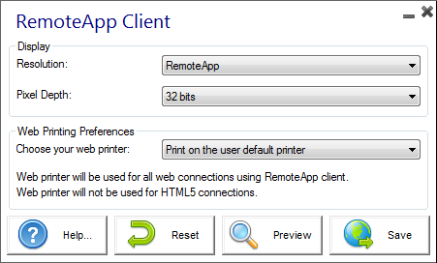
Minimized applications can be directly found inside the Windows taskbar, like a local application. On this example, Firefox and Paint are launched locally; Notepad, Word and Foxit are launched remotely.

Seamless connection client
The Seamless connection client works on every Operating System, regardless of the version on the client or on the server side.
When connecting remotely, you can access your applications by selecting the seamless mode as if they were installed locally on your computer.
A transparency color can be set manually to insure your application will appear perfectly (green, blue or pink).
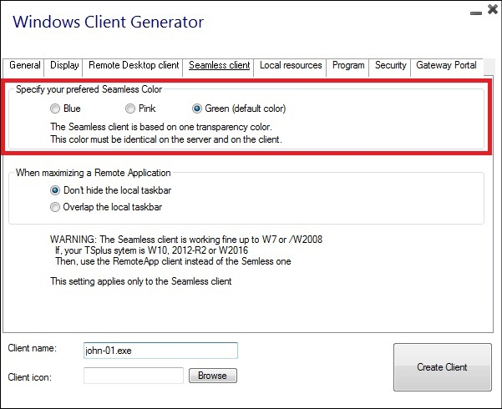
On the server tab of the AdminTool:
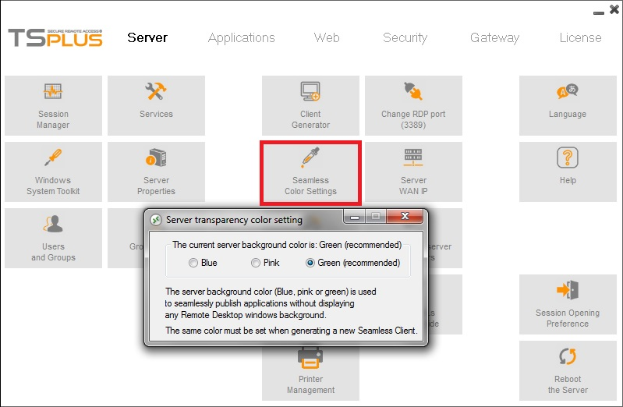
The Seamless Client is based on one transparency color selected by the Administrator. As the Remote Desktop background color is painted with the selected transparent color, the Microsoft Remote Desktop is not displayed anymore, and the user will just see his published applications.
Warning: Installation default is green and should work fine with most applications. We offer you the choice between 3 transparency colors: Pink, Green and Blue. Of course, the server and the connection clients must use the same color.
Some elements on an application can also not be visible anymore because of the transparency color.
For both the Seamless and the Remoteapp connection clients, you can choose to publish one unique application to be launched seamlessly at the user's logon. You can also publish applications with the TSplus Remote Taskbar, the Floating Panel or the Application Panel.

Microsoft Remote Desktop

You can also generate the whole Remote Desktop experience into your session.

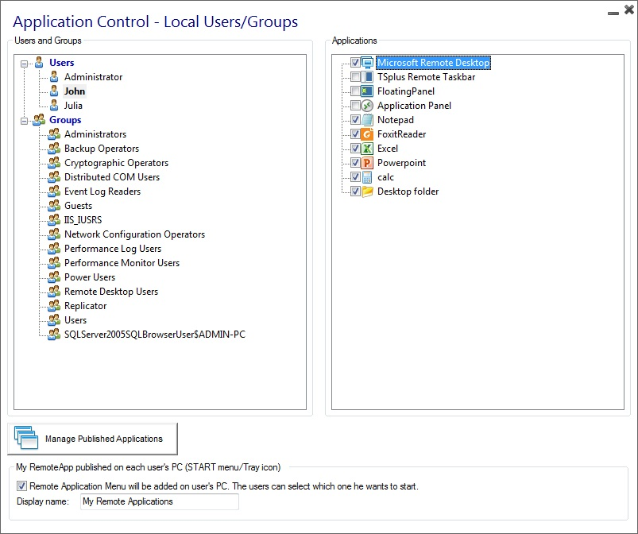
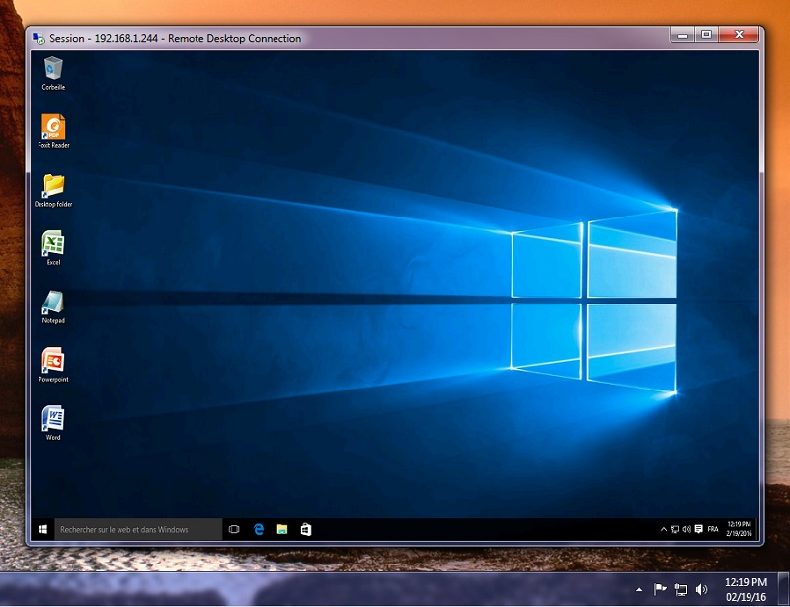
To customize the Desktop theme, you have to assign the TSplus Remote Taskbar, see this documentation for more information.

Printing remotely with TSplus
The TSplus Universal Printer allows you to print documents from any PC or mobile device.

Universal Printer Manager
Since the release of TSplus 11.10 version, you can find the Universal Printer Manager tile on the Server tab of the AdminTool:
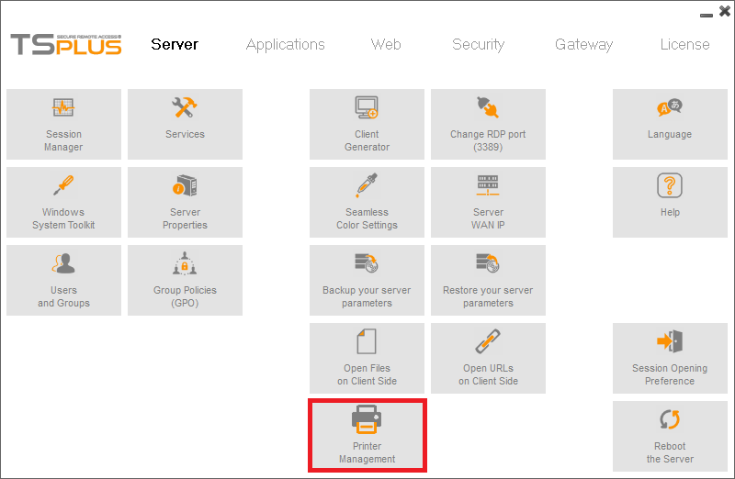
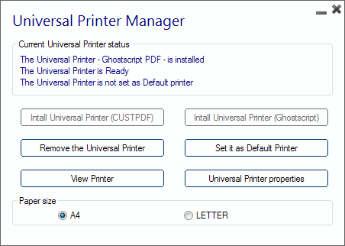
The Universal Printer Manager gathers all the required tools to install, uninstall, display and handle the Universal Printer options.
This tool enables administrators to help users with dynamic printing requirements.
Information can be found at the top concerning the current universal printer status: You can check if the newest version, which uses GhostScript, is installed. You can see if the printer is ready. And you can verify that the printer is set to default.
The Buttons below allow you to:
- Install the Universal Printer CUSTPDF, which is the old printer, before TSplus version 9.
- Install the New Universal Printer (Ghostscript), which is more stable with more printing format support.
- Remove the Universal Printer.
- Set it as default printer.
- View Printer: Opens a window where you can see the status of your printing documents, pause, resume or cancel the print job. You can also set your printing preferences and properties.
- Universal Printer Properties: Opens this window, where you can see all the printing properties. After the General Tab, there are tabs for sharing, ports, advanced, color management, security and device settings.
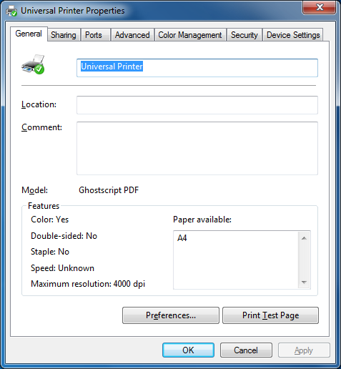
On the Printer Manager tile, you can also set the Paper size for printing to A4 or Letter.

Printing with the Universal Printer

When selecting this printer, the document to print is automatically converted into a PDF file. This PDF file is automatically pushed to the local PDF Reader of the user's workstation.
Each print job is opened as soon as it is ready on the user's local disk, without waiting for the previous Acrobat preview to be closed. The printing process starts only once the PDF is fully created on the client' side, which guarantees the print job starting without delay.

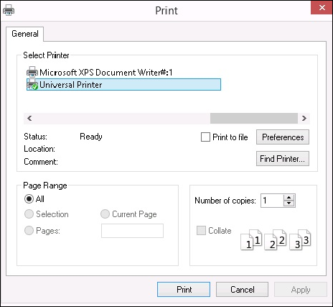

You can choose from 3 printing options on the Local Resources tab of the Portable Client generator:

- Local PDF Reader preview: the document will be pushed, and the local Acrobat Reader will open with the generated PDF file. The user can print it or save a copy on his local disk drive.
- Print on the user's default printer: the document will be automatically pushed to the default user's printer (the local printing driver is included into the TSplus connection client). (Key value: This option is to be used for people who have a lot of printing to do per day and use the same printer for this purpose.)
- Select a local printer: The user can select one of his local printer (the local printing driver is included into the TSplus connection client).
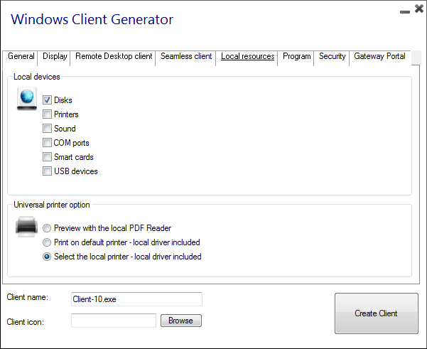

If you do not have a PDF Reader installed on your machine, we recommend the use of Foxit Reader.
See the video tutorial to print with the Universal Printer.

Securing a TSplus server
Securing any server is a never-ending story where every expert could add another chapter.
TSplus benefits from and is compatible with existing security infrastructure in a company (Active Directory, GPOs, HTTPS servers, SSL or SSL telecommunication systems, VPN, access control with or without ID cards, etc). For customers who want to easily secure their servers, TSplus offers a set of simple and effective ways to enforce good levels of security.

Changing the RDP port number and setting up the firewall
With the AdminTool, you can select a different TCP/IP port number for the RDP service to accept connections on. The default one is 3389. You can choose any arbitrary port, assuming that it is not already used on your network and that you set the same port number on your firewalls and on each TSplus user access programs.
TSplus includes a unique port forwarding capability: regardless the RDP port that has been set, the RDP will also be available on the HTTP and on the HTTPS port number!
If users want to access your TSplus server outside from your network, you must ensure all incoming connections on the port chosen are forwarded to the server. On the Server tab, click on the "Change RDP port" tab:
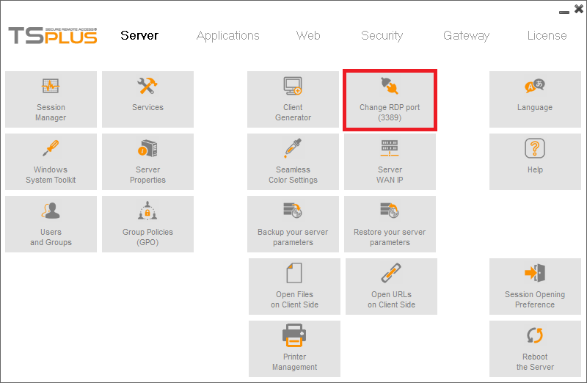
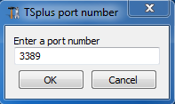

Server side security options

The AdminTool allows you to deny access to any user that is not using a TSplus connection program generated by the administrator. In this case, any user that would attempt to open a session with any Remote Desktop client other than the TSplus one (assuming he has the correct server address, the port number, a valid logon and a valid password) will be disconnected automatically.

The administrator can decide that only members of the Remote Desktop User group will be allowed to open a session.

The administrator can decide that a password is mandatory to open a session.
Through setting the applicable local Group Policy, the administrator can specify whether to enforce an encryption level for all data sent between the client and the remote computer during a Terminal Services session. If the status is set to Enabled, encryption for all connections to the server is set to the level decided by the administrator. By default, encryption is set to High.

The administrator can also set as a rule that only users with a TSplus connection client will be able to open a session.
Any incoming access with a standard RDP or a web access will be automatically rejected.

Hiding the server disk drives
The AdminTool includes a tool that enables hiding the server disk drives to prevent users from accessing folders through My Computer or standard Windows dialog boxes.

On the Security tab, click on "Hide Disk drives":
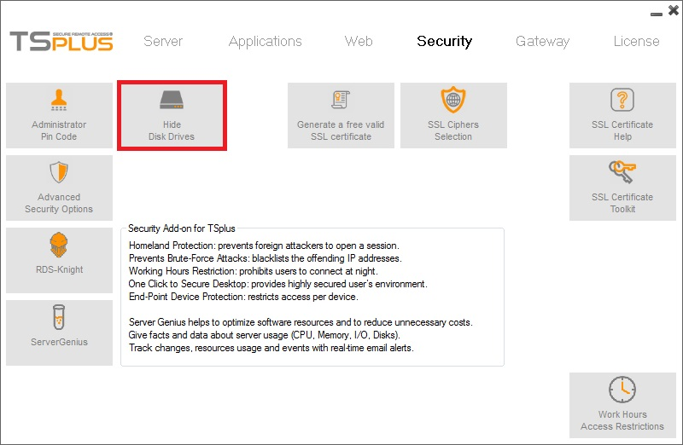
This tool works globally. This means that even the administrator will not have a normal access to drives after the settings have been applied. This functionality is powerful and does not disable the access to the disk drives. It just prevents the user to display it.

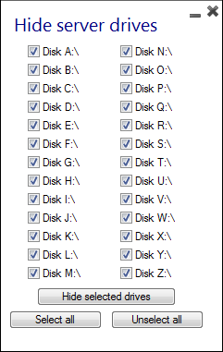

Comment: This functionality is powerful and does not disable the access to the disk drives. It just prevents the user to display it.

Notes: The tool flags the disks drives as hidden, but it also adds the HIDDEN property to the entire root folders and users list in Document and Settings.
If the administrator wants to see these files he must:
- Type the disk drive letter. For example: D:\ which will take you to the D: drive.
- Turn on SHOW HIDDEN FILES AND FOLDERS in the folder view properties.

Advanced security options

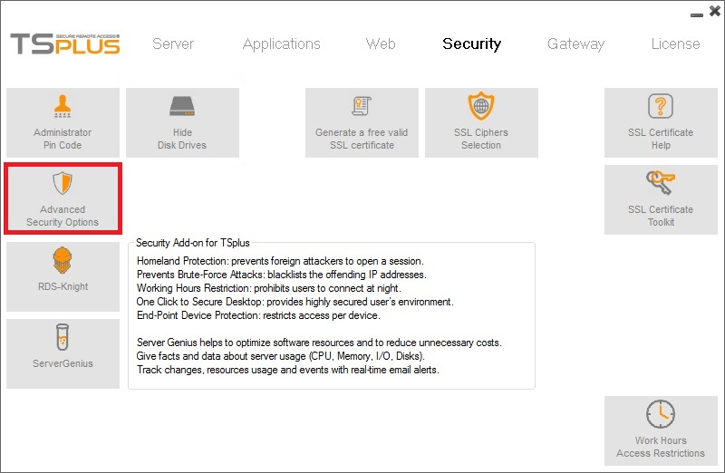

You can find multiple advanced security options if you click on the Security tile:
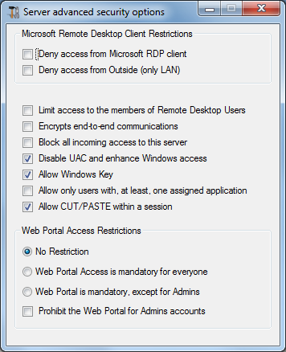
- Deny access from Microsoft RDP client: Prevent anyone to be able to connect using mstsc.exe.
- Deny access from Outside: It means that only private IPs from LAN will be able to open a session.
- Limit access to the members of Remote Desktop users: This limit applies only to this local group of users (which you can see by clicking on the Users and Groups tile.
- Encrypts end-to-end communications: High Encrypts client/server communication using 128-bit encryption. Use this level when the clients accessing the terminal server also support 128-bit encryption.
- Block all incoming access to this server: All alive sessions will remain active, while all incoming connexions tentatives will be blocked. Make sure that you can access physically the console of the server if you check this box. Do not use this option if your server is hosted on a Cloud environment.
- Disable UAC and enhance Windows Access: Deactivates the User Accounts Controls, remove all unwanted security pop-ups from Windows. users limitation (messages) while launching applications.
- The "Allow Windows Key" box allow the use of the Windows keys and combinations inside a TSplus session.
- Allow only users with, at least, one assigned application: User with one application and more are allowed to open a session.
- Allow CUT/PASTE within a session: unchecking this box will disable the CTRL C/CTRL V commands
Web Portal Access Restrictions
- No Restriction
- Web Portal is mandatory for everyone: users can only connect via the Web Portal.
- Web Portal is mandatory, except for Admins: users can only connect via the Web Portal, except Administrators.
- Prohibit the Web Portal for Admins accounts: Administrators cannot connect via the Web Portal.

Administrator Pin Code
The Administrator can secure the Administrator Tool access by setting a pin code which will be asked at every start:
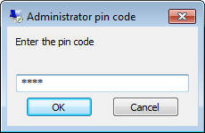

TSplus access program security options
The TSplus client generator gives the capability to lock the TSplus client to:
- A specific PC’s name. It means this program will not be able to start from any other PC.
- A physical drive serial number (PC HDD or USB stick). This is a very easy and powerful way to set a high level of security. The only way to connect is with a specific client, and this specific client can only start on a specific USB stick or PC HDD. Some of our customers are delivering fingerprint-reading USB sticks to each of their users and each generated program is locked to the device serial number.
This way, they can restrict access to the client's program itself, as well as ensuring it cannot be copied off the USB stick and used elsewhere.

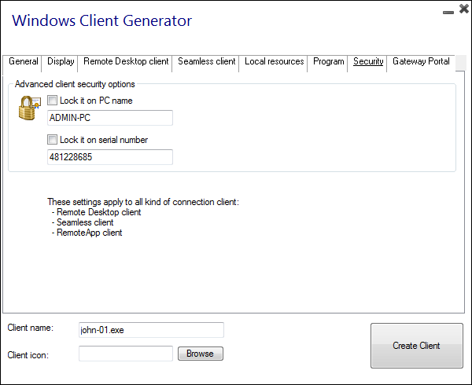

RDS-Knight and Server Genius

RDS-Knight and Server Genius are two powerful add-ons for securing and monitoring your TSplus server.

RDS-Knight is your perfect ally for TSplus Protection. This best-in-class program is the next-generation security tool that will keep your remote connections completely safe.
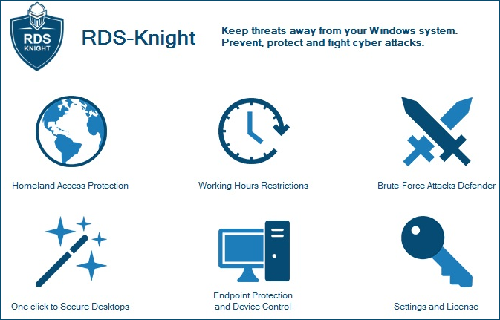
RDS-Knight provides five major protections:
- Prevent foreign attackers to open a session.
- Prohibit users to connect at night.
- Avoid brute-force attacks.
- Provide highly secured user’s environment.
- Restrict access per device.
It just works out of the box and displays the most useful data extracted from your server.
- Download a free trial version including all RDS-Knight Ultimate Protection features on this page.

Server Genius is the perfect tool to easily monitor your TSplus server and website. Monitor your server for unexpected usage spikes, and site for long time responses or downtime duration. The Web interface allows you to get a complete overview of your server and website's activities even from your tablet or mobile phone.
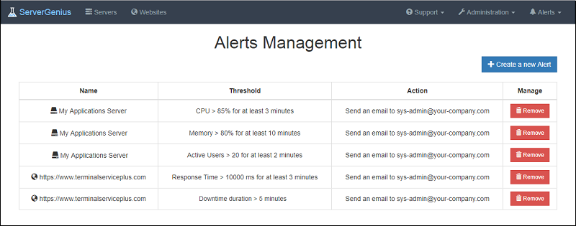

Track changes, resources usage and events with real-time email alerts!

- Start monitoring your server now by downloading a free trial version, which includes all the software features, free to use for 2 weeks.

Check our online documentation for explanations on more advanced features. There's a lot more to discover!
Download a free trial right now!

