THE WORLD IS YOUR OFFICE

When you Can’t be at the Office,
Take the Office with You!

USER GUIDE

- INSTALLATION GUIDE

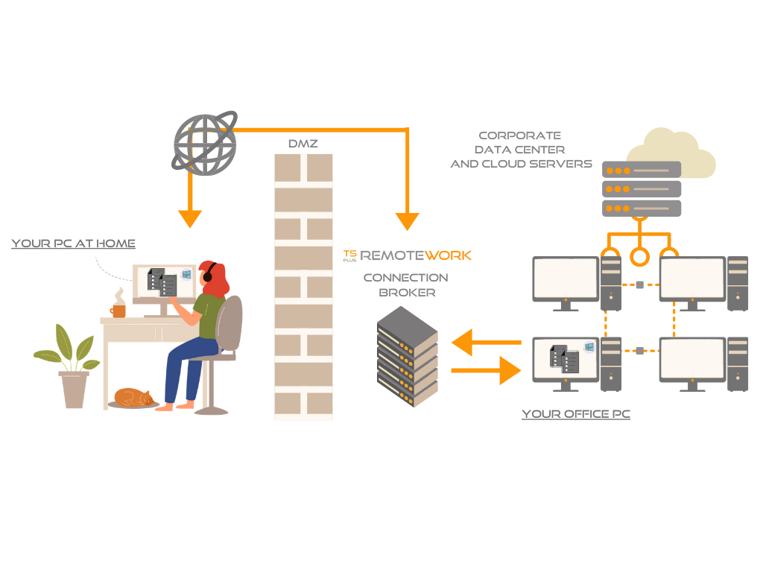
TSplus Remote Work enables easy remote desktop access from your home office to your workstation at the office.

Your office workstation (the host) can be any PC running a Windows Professional OS from Windows XP Pro to Windows 10 Pro. Please note that Windows Home, Basic and Family additions are not supported.

The TSplus Remote Work Server is both your Web Portal and Connection Broker. It redirects connection requests to your own office workstation. The Connection Broker can be installed on any Windows system, server, or workstation. The Connection Broker PC can also be remotely accessed like any other one.

The Connection Broker is usually installed nearby your ISP’s Router. A NAT (Network Address Translation) rule redirects the HTTP and/or the HTTPS ports (default value is port 80/443) from the external IP to the LAN IP of your Connection Broker. In this configuration, your Connection Broker is the only system exposed to Internet.

For the most reliable access to your Remote Work Server, a Static Public IP Address is required.
If you do not have a Static Public IP Address, you may also try alternative Dynamic DNS services like DynDNS.org or NO-IP.org.

Unlike traditional Remote Desktop services, Remote Work does not require the default remote desktop port (3389) to be exposed to the internet. All traffic is web based, using HTTP/HTTPS. This enables administrators to use SSL certificates for encrypted connections from the outside world.

Download the TSplus Remote Work setup program here:

https://setup.dl-files.com/Setup-TSplus-RemoteWork.exe

- INSTALLATION PROCESS

The installation process is easy, and the configuration is straight forward.

Just run Setup-TSplus-RemoteWork.exe program on the system you decided to use as the Connection Broker.

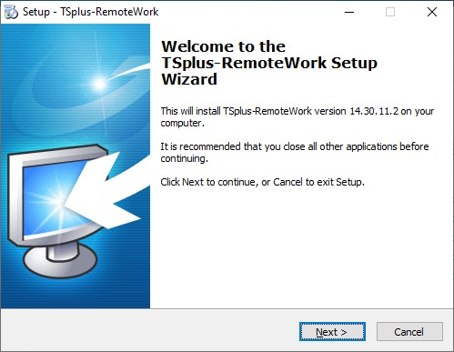
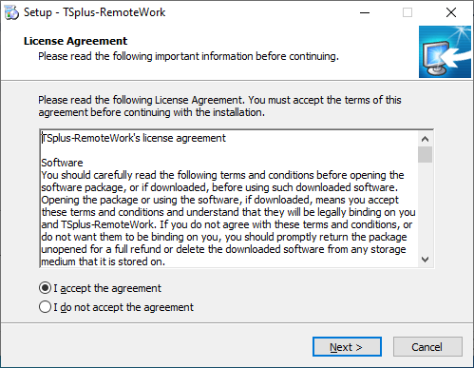
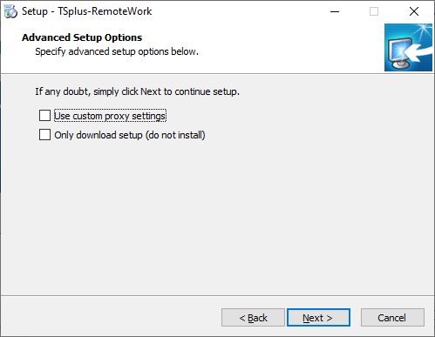
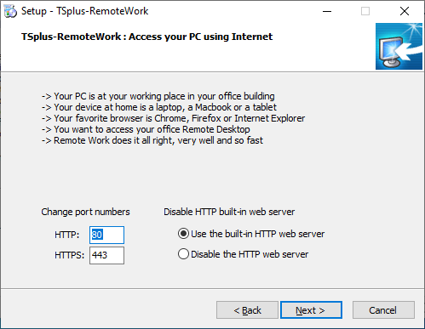

By default, the Remote Work web server is configured to use the standard HTTP/HTTPS port numbers (80/443). However, if another web server is already active on this system (IIS for example) the TSplus built-in web server will enter into a port number conflict. The easy solution is to change these default values (8080/4430 for example) during setup.

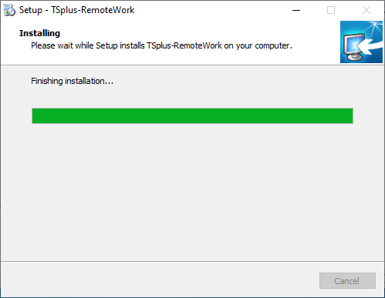
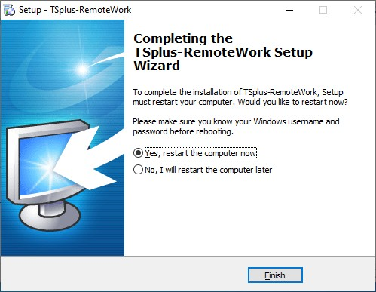

That´s it for the installation. Reboot and begin your workstation assignments.

- Start by opening the Administrator tool:
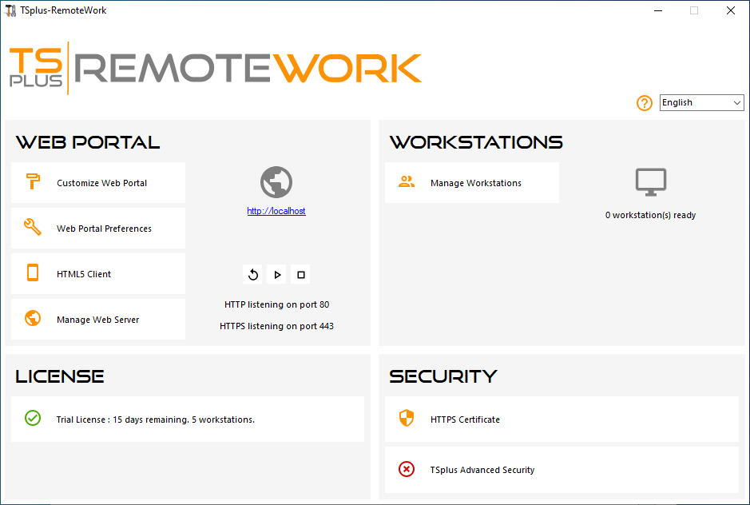

All you need is the Windows logon and the LAN IP address of each of your office Workstations.
The trial version of TS Remote Work enables you to assign 5 workstations.

- Click on Manage Workstations to begin:

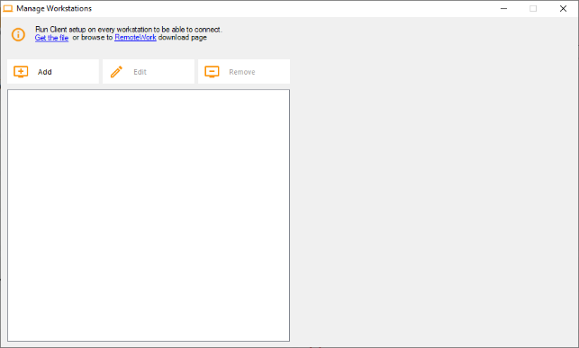

- Click on Add and enter a friendly Workstation name and it’s IP address:

Of course, all of your users’ workstations and the “Connection Broker” must have a fixed IP address.

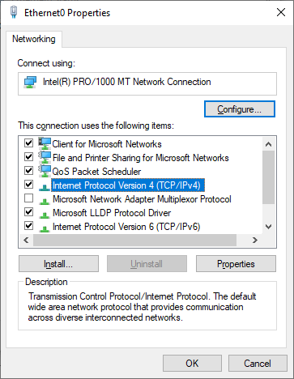
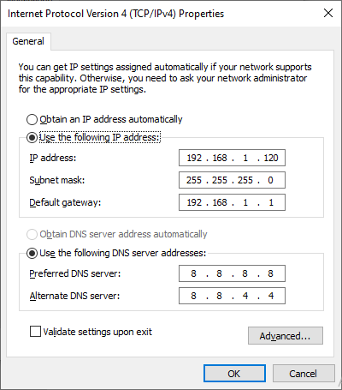

In the case of Elisabeth, her PC’s IP address is 192.168.1.135

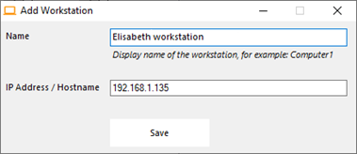

Repeat this process for the rest of your client PCs:

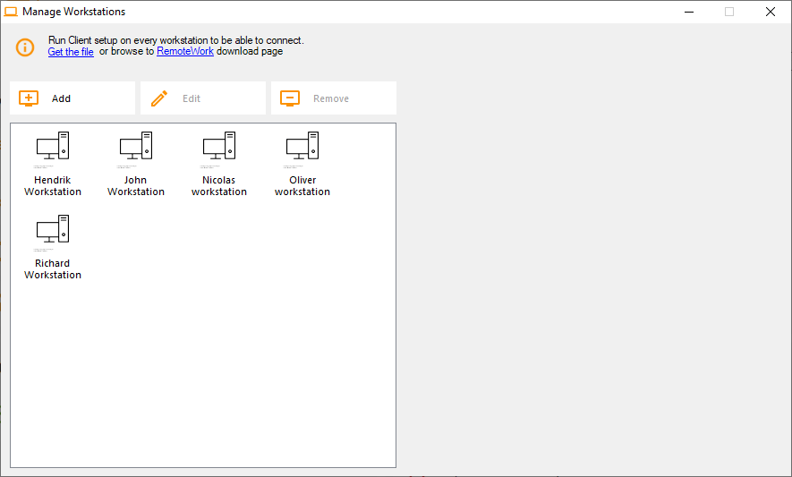

- Assign PCs to users:

Let’s take the example of John.
Select ‘John Workstation’ and click on ‘Add’ in Users section on the right:

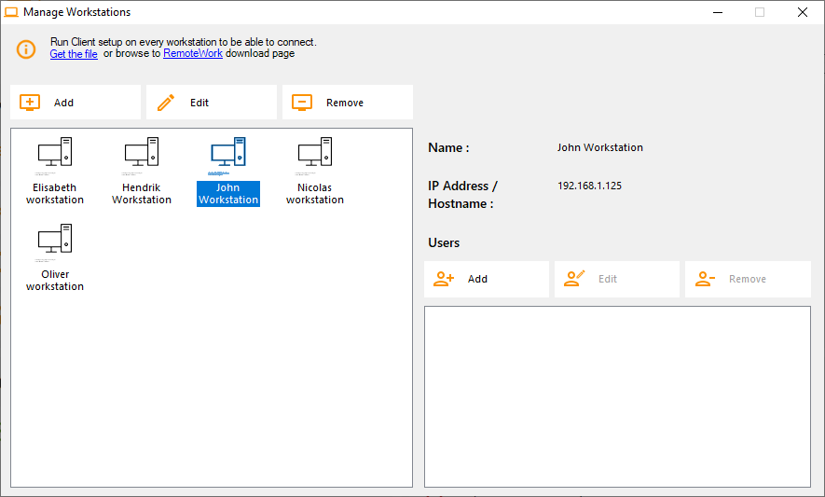

In this example, the Windows login on this PC is “John”.
You can use the Active Directory login if PCs are members of a domain:

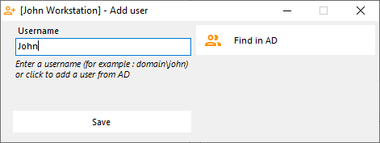

John’s workstation is now all set and ready to go:

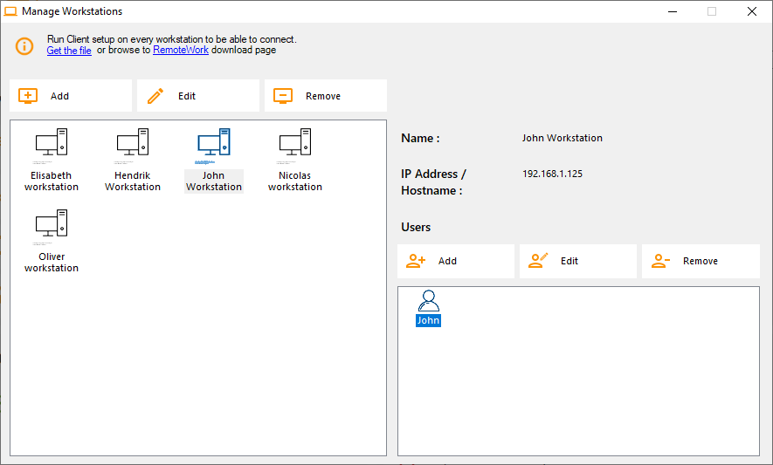

- Multiple users:

Nicolas and Paul share a PC at work. Paul uses it during the morning shift and Nicolas, during the evening shift.
So, for this example, we will assign two users to Nicolas’ workstation.

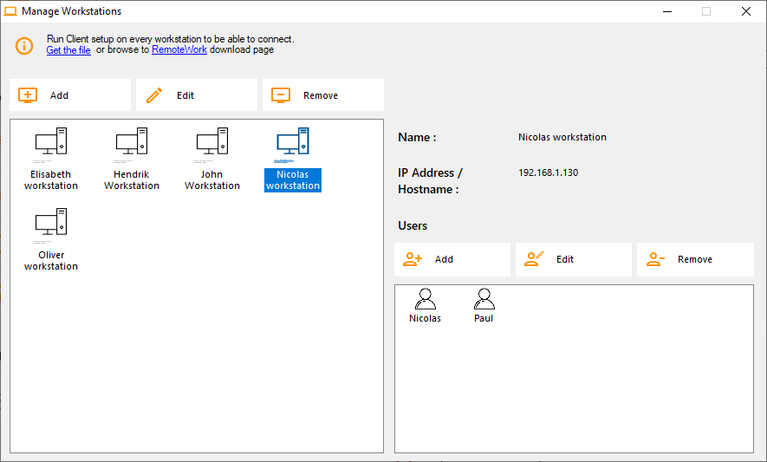

- Workstation setup:

On each of the 5 users’ workstation assigned in the Connection Broker, download and run the client setup program. It is a small program: You can easily ask each of your users to do it themselves.

The download link is http://192.168.1.120/download

Where 192.168.1.120 is the IP address of your TSplus Remote Work Connection Broker.

ONCE THESE 6 STEPS ARE COMPLETED, YOU’RE ALL SET.

- TEST

From a PC in your office, open web browser (Firefox, Chrome or Edge for example). Type the address of your Connection Broker and enter the demo login.

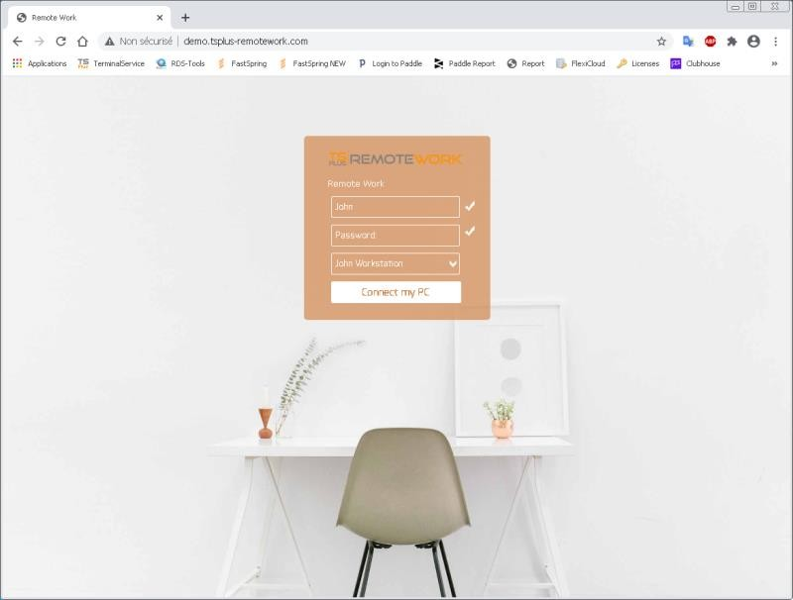

Done: The logon goes to John’s office workstation.

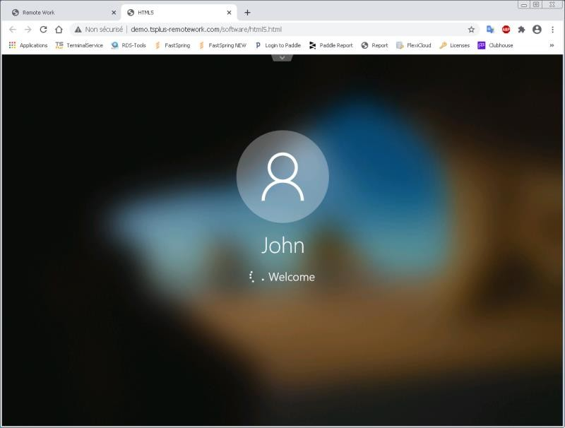

This is exactly what you wanted…

BUT WAIT… THERE IS MORE!

If John leaves the office with unfinished work and an opens a session on his workstation, TSplus Remote Work will capture his Desktop when he will start working from home.

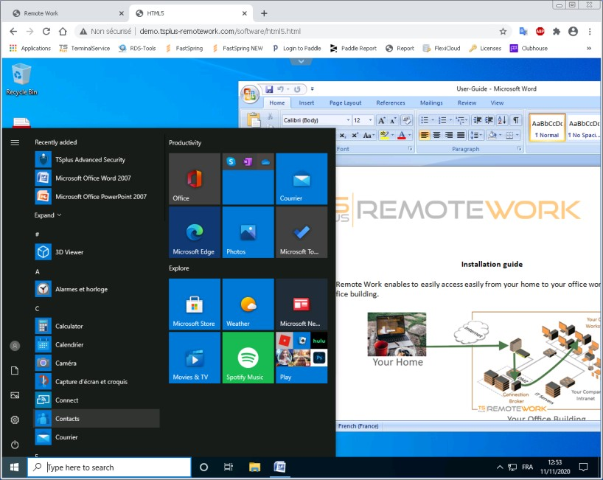

Moreover, John can print documents on his local printer at home. He just has to select the Universal Printer.

The Universal Printer turns each of John’s print into a PDF file. This PDF is saved by his web browser.

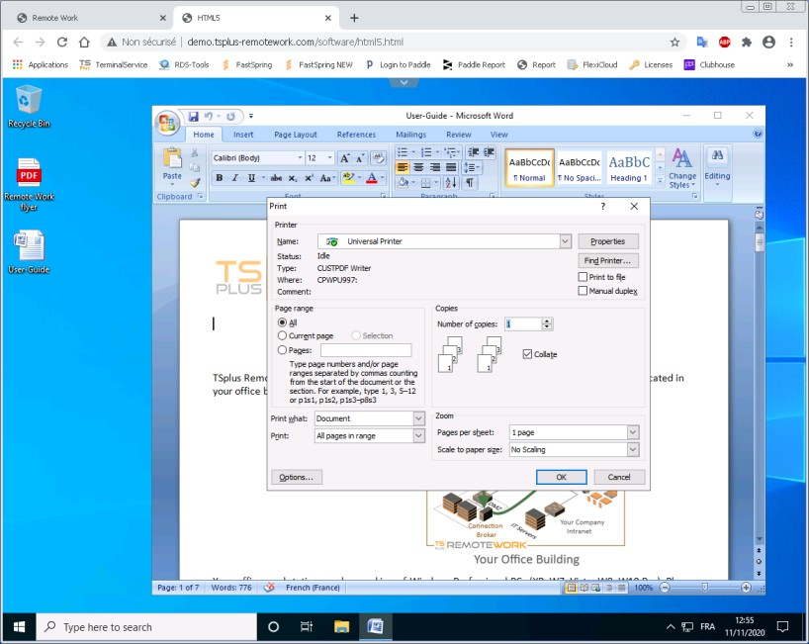
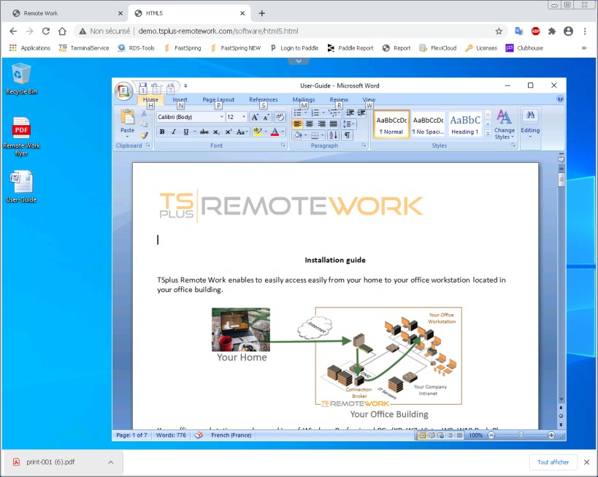

John can display, print or save this PDF print file on his home PC.

