Release Notes

TSplus 14 release announcement:
- A new Licensing Management System has been built with simplicity and security in mind. Licenses files were replaced by a unique Activation Key, which activates all your products. In order to see and use it, just log in to our Licensing Portal.
For more information, consult our TSplus Customer Portal User Guide.

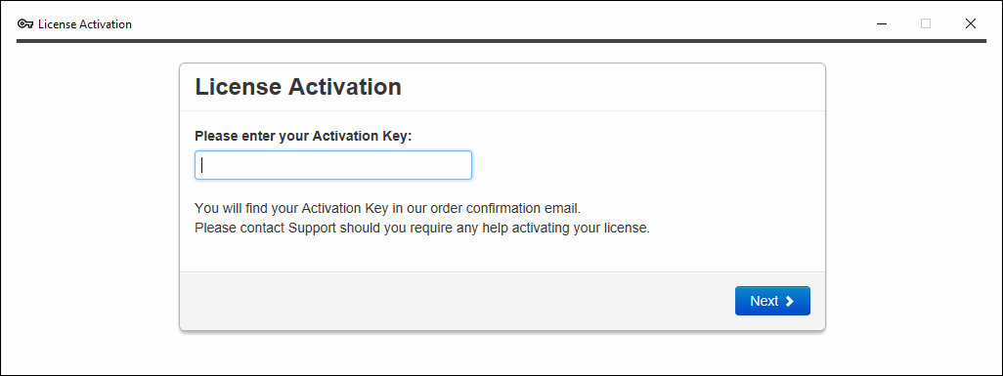

- TSplus Advanced Security Ransomware Protection has been greatly enhanced, with the possibility to configure and restore snapshots. Ransomware protection possesses two analysis process: a static one, which reacts immediately when an extension name changes – a behavioral one, which detects new kinds of ransomware by looking at how a program will interact with files.
Possibilities to define file extensions to be ignored by the feature, as well as marking a program publisher as distrusted have been added into Settings.
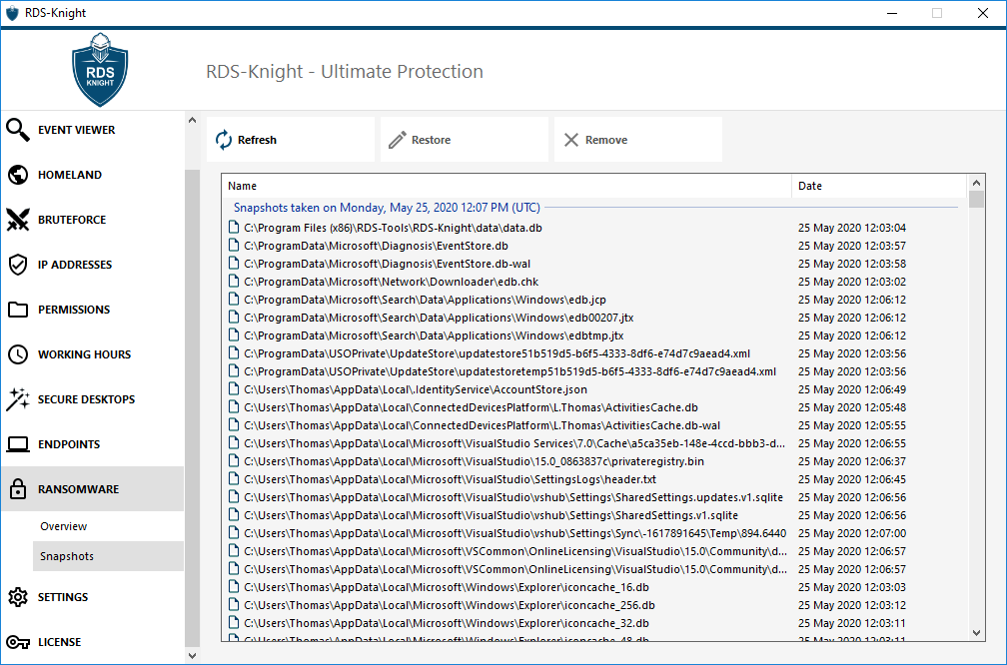

- TSplus 14 includes all the improvements and fixes released in previous versions.
TSplus 12.70 release announcement:

- Introducing TSplus Web App:
Whether you’re on a PC or a mobile device, the new TSplus Web App makes your remote applications feel like native applications. Using Progressive Web App technology, its fast and easy installation makes it an amazing tool to connect directly to your TSplus Web Portal, without the need of a web browser.

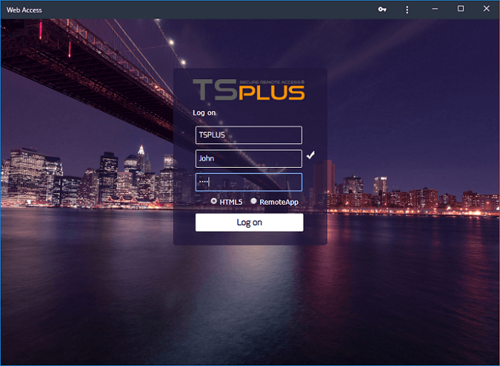

Check the TSplus Web App Documentation.

- Introducing TSplus Virtual Printer Add-On: Easy printing from your remote applications to your local printer. Native print dialogs, driver-less and faster printing make it the ultimate remote desktop printing tool. 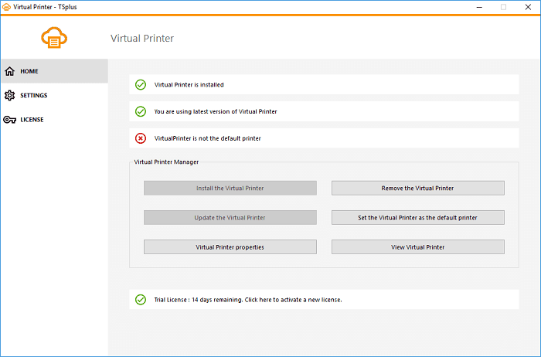

Check the TSplus Virtual Printer Documentation.

- TSplus Enterprise PLUS Edition is out now: Our most featured filled edition of TSplus and our most advanced security and companion tools. Including TSplus Advanced Security, Server Genius, TSplus 2FA and TSplus Virtual Printer, it is the ultimate package. Buy Now!

- TSplus 12.70 includes all the improvements and fixes released in previous versions.

TSplus 12.60 release announcement:

- Compatibility and Session enhancements: TSplus is now compatible with Windows 10 20H1 and Workstation Printers Redirection is now granted with latest Windows versions.
- Changelog: You can now to directly access and consult TSplus Changelog from the AdminTool Dashboard:
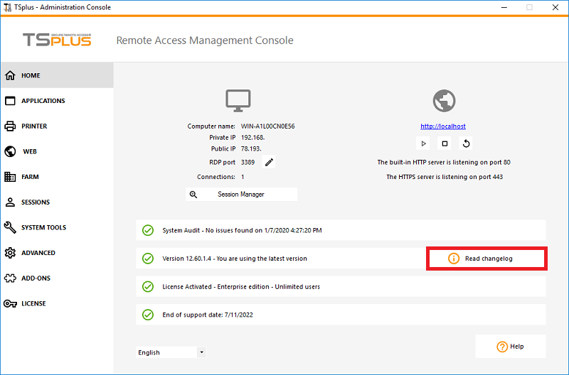
- Applications Publishing Display: It is now possible to display or hide the logoff
button on the TSplus Floating/Application Panel, Folder Panel and TaskBar:
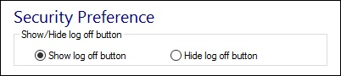
- TSplus 12.60 includes all the improvements and fixes released in previous versions and is getting ready for LTS 12 (Long Term Support version).

TSplus 12.50 release announcement:
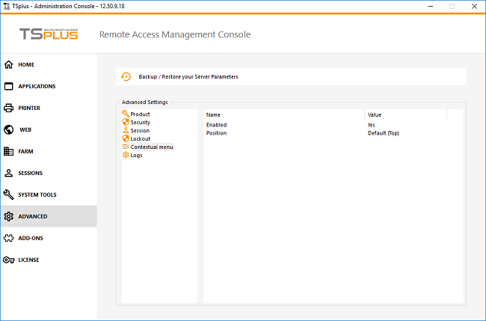
- A new "Send to Client" contextual menu (right-click menu) can be enabled on the AdminTool, under the Advanced > Contextual Menu tab to easily send files to Client Workstation:

The contextual menu is available by right-clicking on the desired file or folder, selecting the TSplus tab and by clicking on "Download":
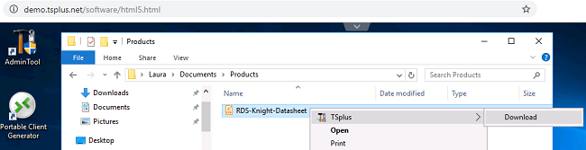
More information can be found on this documentation.
- The setting "Allow access from Microsoft RDP Client for Admins only" was added in Sessions > Permissions:
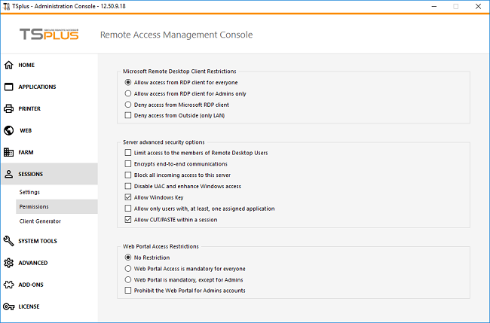

- Printer: Page orientation settings were added for the Universal Printer, you can now choose between Portrait or Landscape:
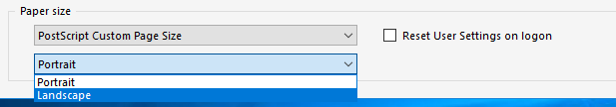
- Add-Ons are now automatically updated when TSplus is.
- TSplus 12.50 includes all the improvements and fixes released in previous versions.

TSplus 12.40 release announcement:
- The Connection Client program and Web Plugin ("RemoteAppClient") have been merged together and can now be deployed with a single Setup. Both files remain under the same names and each embarks both setups.
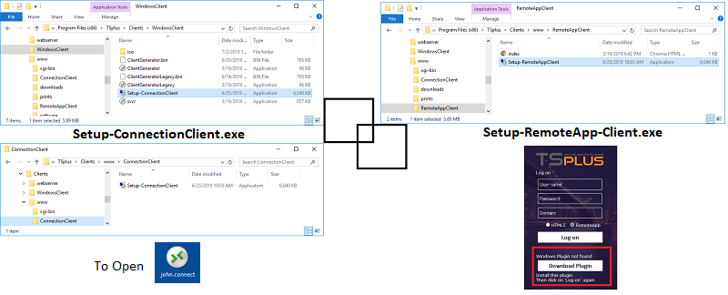
- Applications Publishing: applications can now be grouped in "folders" in AdminTool > Applications. Permissions are then handled per folder for all the applications in a folder, and all the TSplus programs (Floating Panel, Application Panel, Taskbar, Folder, Web Applications Portal) and Mobile App will then display these folders accordingly.
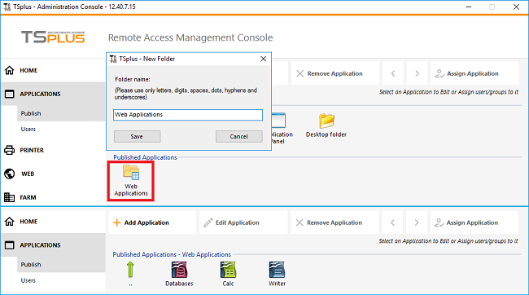
- TSplus has integrated one of the core features of our leading security software suite, TSplus Advanced Security. Now operating as a native TSplus security feature, we’re proud to introduce TSplus Lockout.

Lockout monitors failed web login attempts on your TSplus server. It logs attempts and automatically blocks the corresponding user after the authorized number of failed attempts has been reached. You will easily see if an Address has been locked under the "Locked" column:
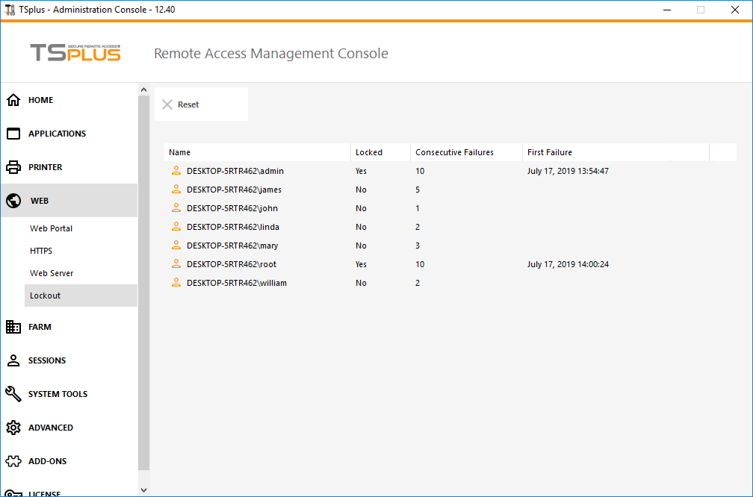
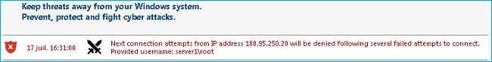
Failed Brute-Force connections attempts are also visible on RDS-Knight Events Log:

- TSplus 12.40 includes all the improvements and fixes released in previous versions.

TSplus 12.30 release announcement:
Two-Factor Authentication can now be done by SMS, thanks to a third-party third-party cloud platform, Twilio. You will just have to create a free account on their website: https://twilio.com and enter the corresponding account information on the Configure SMS tab of the Two-Factor Authentication Add-On.
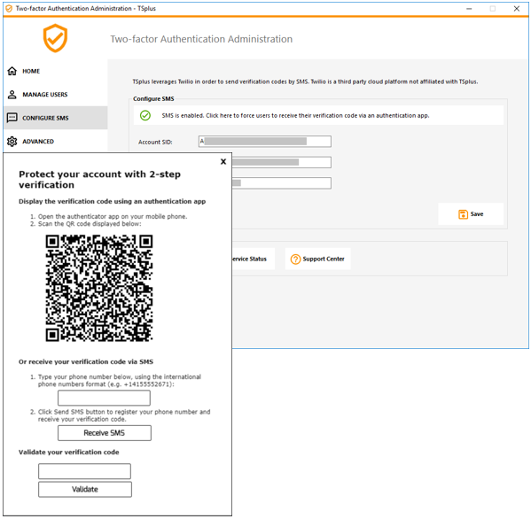
For more information about this new feature, read our documentation.
Two-factor authentication is available with HTML5 and Remoteapp connections on TSplus Web portal only, on TSplus Mobile Web and Enterprise Editions. This authentication mode does not support login through Remote Desktop client.

TSplus 12.20 release announcement:
The TSplus team is proud to offer the release of Version 12, which introduces a brand new AdminTool interface designed with 3 qualities in mind - Speed, Security and Simplicity.
Many functionalities were enhanced, reorganized and simplified for smoother management and administration.

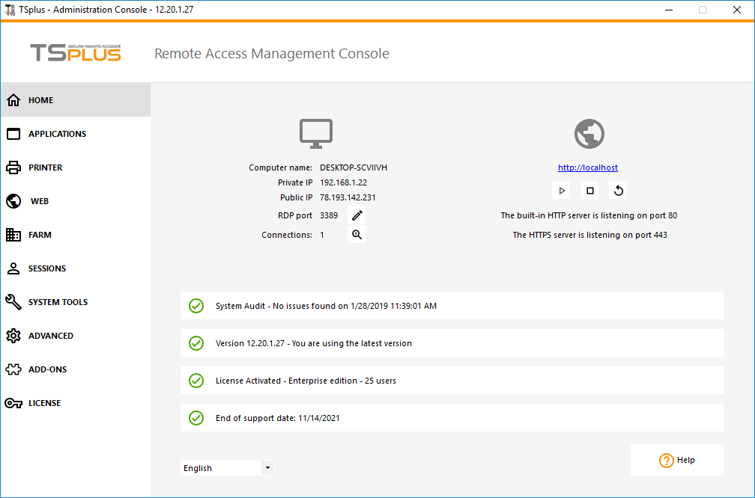
- A modern and user-friendly design: At once clean and functional, using modern design language to make management a breeze for administrators.
- An easy, intuitive navigation and simplified management: Menu Tabs are now displayed in a bar on the left. The AdminTool has been reorganized to make access to critical functionality more visible.
- Home page: The home page offers a real dashboard, displaying the most important information about your software and allowing quick actions on your server. It also includes an automatic audit of your system to make sure everything is running normally as soon as you start the AdminTool.
- Applications: The Application tab is a new addition to the top-level menu that creates a central management console for application publishing.
- Printer: Printer Management now has its own tab, with access all Universal Printer settings in one click.
- Web: All Web Portal, Web Server Customization and Web Administration parameters are centralized under this tab.
- Farm: Set all Farm Manager settings from this tab (only with Enterprise Edition).
- Sessions: Set all parameters and permissions for your users’ sessions from one single place.
- System Tools: Access all your server, users and groups properties from this tab.
- Advanced: Quickly and easily add specific parameters directly into TSplus program code.
- Add-Ons: Integrate additional programs to benefit from the ultimate Remote Desktop Solution with RDS-Knight, Server Genius and the amazing new Two Factor Authentication tool!
The 2-FA Add-On is an amazing new TSplus tool, integrated as a 30 days trial for 10 users. Two-factor authentication adds an extra layer of security and prevent access to your users' session even if someone knows their password.

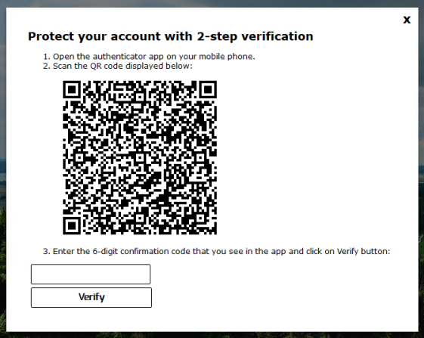
It enables a double authentication by combining two different factors:
- The user credentials (Logon/Password)
- One security code provided by something each user immediately has at hand: His Smartphone with an authentication app such as Google Authenticate.

Two-factor authentication is available for the TSplus Web portal only. For more information, check this documentation.

OpenJDK integrated installation: Last year Oracle announced a new release train for Java: Starting with Java 9, most Java versions will only have a lifetime of 6 months. Updates will not be provided for the version after this period.
As a solution to Oracle's new schedule, TSplus 12.20 embeds its own solution: in case the latest version of Java is not found on the system, TSplus automatically offers - during setup and updates - to download and install OpenJDK 11. OpenJDK is the open source part of Java, also used to build the Oracle JDK. Therefore it works perfectly fine with TSplus!

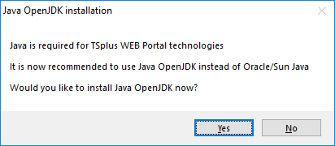

TSplus 11.70 release announcement:
- TSplus Alternate Shell: Following the October 10 Windows Update, administrators allowing their users to start a Remote Desktop saw the Windows shell as an issue. The main problem resides in the session opening/black screen issue when a complete desktop is assigned to multiple users on Windows 10 and Server 2016.

To protect our customers, we decided to invest in a technical solution which is eliminating these Windows shell issues: The TSplus Alternate shell. It provides features and graphical experience similar to Windows 2016 Windows shell, such as the display of the 2016 Start button and taskbar. Therefore, on W10 or 2016, TSplus remote users can enjoy the Desktop experience on the latest's release of Windows version without experiencing Windows shell issues.

Thus, for administrators managing 10 users or more on these Operating Systems we recommend you activate the WinXshell alternate shell on the Session Opening preference tile located under the Server tab of the Administrator Tool:

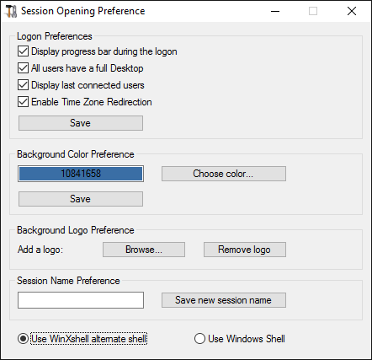

- It is now possible to speed up users logons by disabling per user services on the Session Management and Local Group Policies tile:

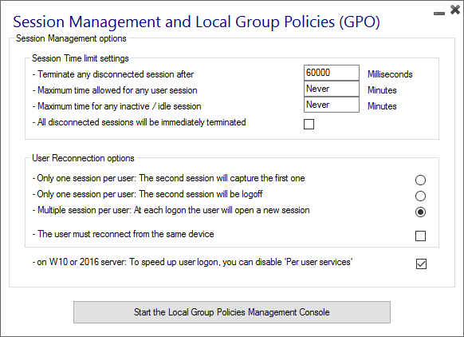
- Application Control: Customization of the minimized buttons display is now possible on the Customize Taskbar tile under the Applications tab. You can either show or hide Systray Notifications area and specify minimized buttons positions: on the right side, the centre or the left side of the screen. The administrator can even decide to display it on top of the user screen instead of the default bottom side:

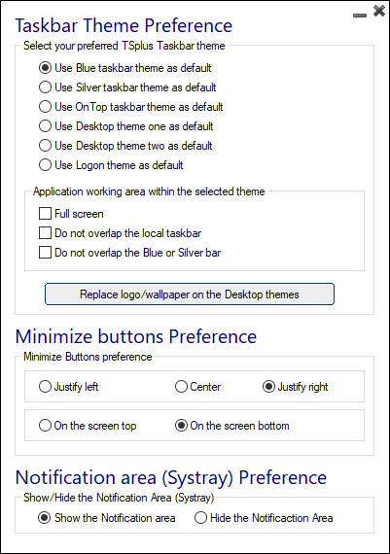

TSplus 11.60 release announcement:
- This version is optimized for Windows 2016 and Windows 10 latest releases.
Microsoft never sleeps and rolled out its new major Update (version 1809) this week.
TSplus 11.60 fully benefits from these new Window enhancements and has included the proper feature to outperform in W10 / 2016 environments. The new TSplus Alternate Shell enable can be selected to replace the Windows Shell and this simple enhancement avoids using too many server resources. The RemoteApp support has also been greatly improved to deliver a great users experience.
Great new enhancements were made to RDS-Knight, the included cyber security add-on, available in a free trial version. The new 3.0 release is officially available and includes great new features:
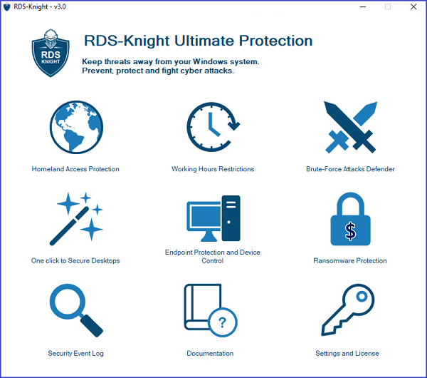
- Anti-Ransomware Protection: this game-changing feature is exclusively included free of charge in the latest version of RDS-Knight ULTIMATE Protection.
RDS-Knight provides a powerful cyber weapon that efficiently DETECTS, BLOCKS and PREVENTS ransomware attacks.
It reacts as soon as it detects ransomware on your session. It quickly scans your disk(s) and displays the file(s) or program(s) responsible, in addition to providing a list of the infected items.
RDS-Knight automatically stops the attack and quarantines the program(s) along with the file(s) encrypted before its intervention. Only the administrator can whitelist them.
RDS-Knight prevents catastrophic events for businesses by removing ransomware at an early stage. The administrator has access to information regarding the source of the attack and running processes, and therefore learns how to anticipate these threats.

In addition, RDS-Knight takes into account the most common crypto methods as well as foreseeable changes for an optimal protection. RDS-Knight Anti-Ransomware action allows quick response, limited damage, increased awareness and time savings with respect to data recovery.
- Brute-Force and Homeland Protection were extended to VNC: with RDS-Knight 3.0, the well-known VNC security holes are closed. You can also enjoy a high level of protection against VNC hackers and other countries and/or brute force attacks.
- Homeland protection before a session-opening: RDS-Knight 3.0 detects and blocks blacklisted countries' IPs trying to connect even before the session opens.

TSplus 11.50 release announcement:
- Automatic Updates: When the administrator checks for a TSplus update on the AdminTool, it now automatically downloads and applies it when requested.
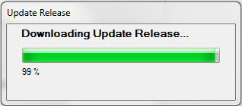
- Local Devices: On the Local Resources tab of the Client Generator, all local devices are now pre-selected by default to ease the COM ports or printer’s redirection.
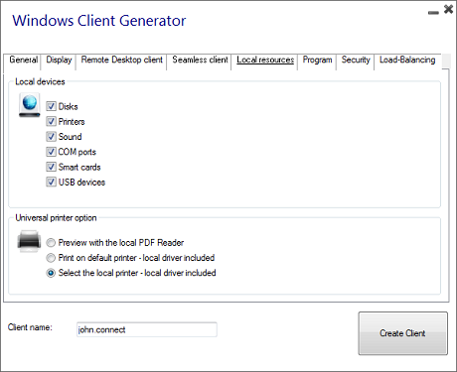

- The Session Management and Local Group Policies (GPO) code displayed on the Server’s tab of the AdminTool has been rewritten and simplified in order to ease the Administrator’s task.
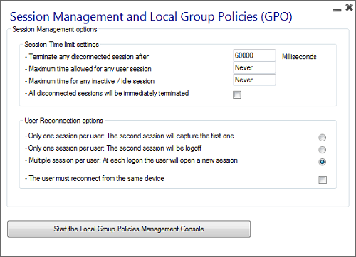

- The latest HTML5 code has been included.
- The latest RDS-Knight version which offers 5 strong Security features is available on the Security tab of the AdminTool as a trial.
TSplus 11.40 release announcement:
- The Client Generator has been redesigned to be numerically signed and to avoid false/positive antiviruses reactions. Instead of a ".exe" program, the new Client Generator is creating a flat encrypted file with the extension ".connect":
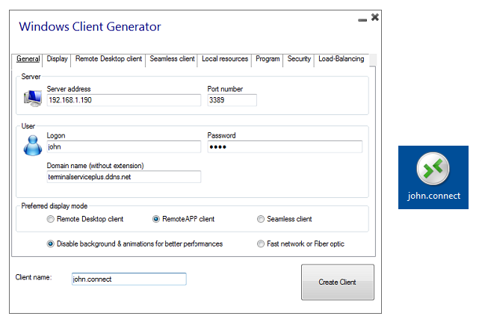
As a pre-requisite on client side, a signed program named "Setup-ConnectionClient.exe” has to be installed. This program is available on this path in the TSplus program folder: TSplus\Clients\WindowsClient or by downloading it. It will locally open the required TSplus client. Then, the user will just have to double click on the ".connect" file to start his session.
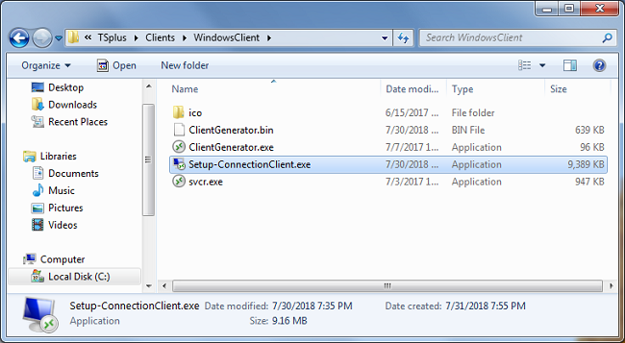
- TSplus strong security Add-On RDS-Knight is now included in TSplus as a trial version. When installing TSplus 11.40 program or Update Release, you will have the choice to install it or not:
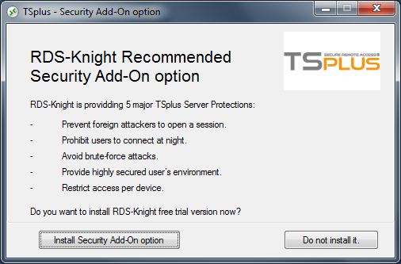
It will create an icon on your Desktop, which allows you to launch it. TSplus Security tab also includes a tile to start RDS-Knight:
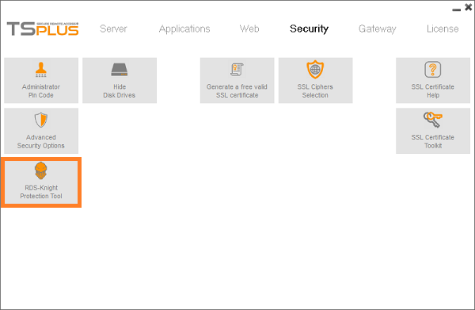
- Brute-force Attacks on the Web Portal are now blocked when users enter wrong credentials. After 10 failed attempts during a period of 10 minutes, the Web Portal will prohibit the logon for 20 minutes (default settings). All blocked connections and logs are visible on the Brute-Force Defender tile of RDS-Knight Ultimate Protection, see this documentation for more information.
- More security enhancements were made: Security audits were taken, and components updates were made to even more improve users safety.
Display enhancements were also made:
- Application publishing: The administrator can now move up or down declared applications for a better presentation on the Floating Panel.
- The TSplus Taskbar’s customization tile has been enhanced to enable the change of minimized buttons position on the taskbar (on top of the screen, on the bottom, on the right, the left side, or in the center).
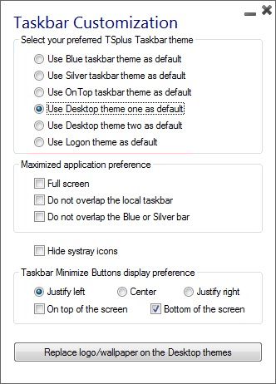
- The Folder.exe design has been improved.

TSplus 11.30 release announcement:
- On the Program tab of the Client Generator, you can now specify for the Startup Program: - The application full path - The application startup Directory - Parameters if required for this application.

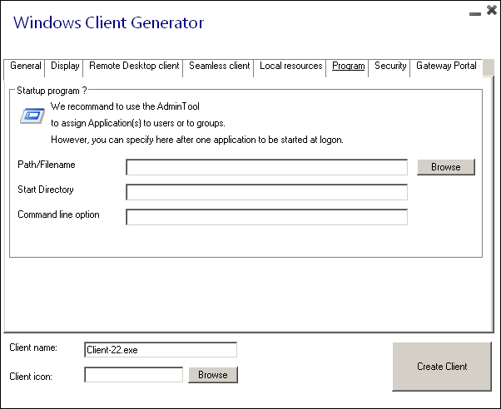
- For a better understanding:
- The AdminTool Gateway tab has been redesigned.
- The Farm Manager tiles were moved to the Gateway tab.

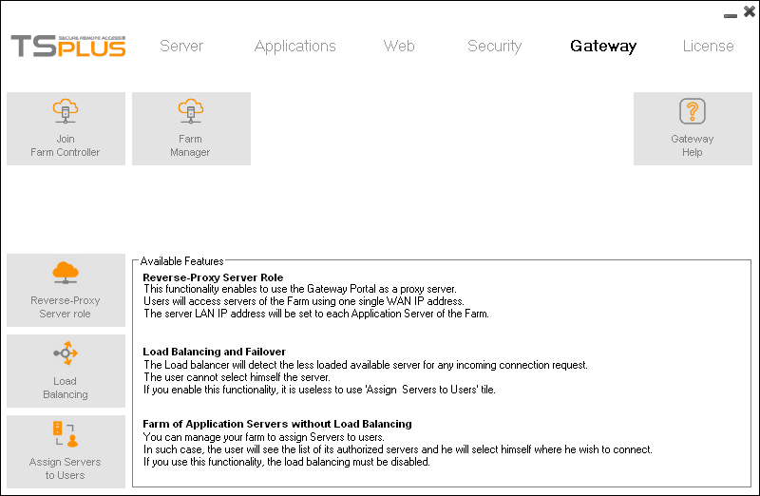
TSplus 11.20 release announcement:
Working in the cloud... wherever you are, whenever you want. With the 11.20 release of TSplus, your Windows applications are available anywhere in real time, simply by using Wifi or Internet connections.

The TSplus HTML5 client has been greatly enhanced to warrant the best possible user experience even from Smartphones or tablets.
- The keyboard has been redesigned to automatically pop-up when the focus is over an entry field. If the keyboard is hiding such entry field, the application is moved up and the user is still able to see what he is typing.
- The mouse pointer has been redesigned to facilitate the selection of buttons and fields even if located on the left or the bottom borders of a Smartphone. The administrator can select a small, a medium or a large size for the mouse pointer. It makes intuitive for the user to navigate inside his application.
- The Zoom-in and Zoom-out new feature is great too. On the small screen of a Smartphone, it can be difficult to read or to select a commercial application form. With just one click, the user is now able to zoom the display, to work and to use a Windows application.
- The AdminTool HTML5 client tile has been enhanced to show the most useful display settings.
- All TSplus 11.10 known issues have been fixed.

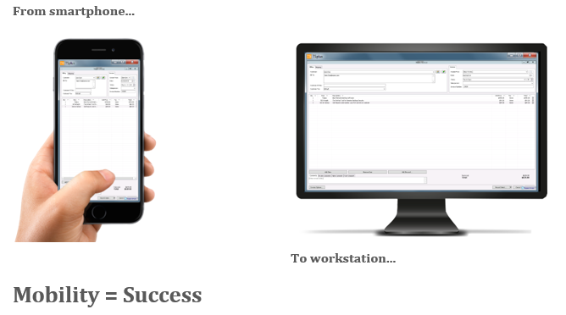

TSplus Mobile App announcement

With TSplus 11.20 release, the exciting announcement we are proud to make today is the availability of the new TSplus App. Download TSplus App from Google Store (Android) or Apple iTune Store (IOS). The TSplus App is free for all TSplus customers. Try it now and you will easily understand why all your users will enjoy using it every day. The TSplus app is simple, smart and efficient to run remote applications with any kind of mobile devices (Smartphones, tablets and even PCs).
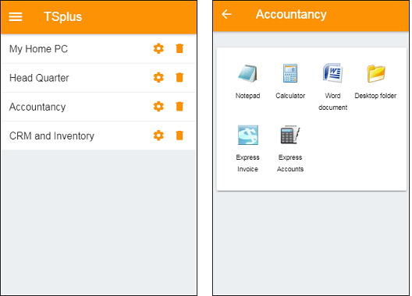
Download links
- Android (Google Play Store) : https://play.google.com/store/apps/details?id=com.terminalserviceplus.mobile
- iOS (Apple App Store) :
https://itunes.apple.com/us/app/tsplus/id1346566246
- Windows :
https://dl-files.com/app/Setup-TSplusApp.exe

Pre-requisites:
The TSplus App has 2 pre-requisites:
- The host site must be a TSplus Web Mobile or Enterprise system
- The release 11.20 must be installed on this host

TSplus 11.10 release announcement:
- The new Application Panel tile on the Applications tab now enables to organize the displayed applications, exactly like on the Web Application Portal, but by simply assigning it to one user or group:

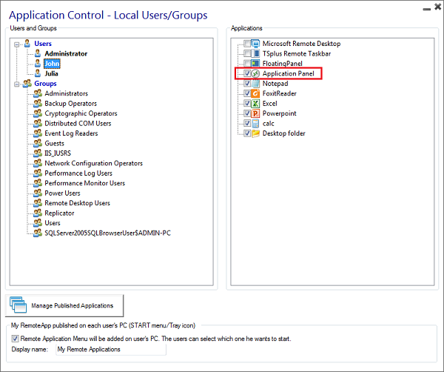

It works with TSplus generated client as well as MSTSC/RDP. This program can be customized by the administrator to deliver a nice user experience:

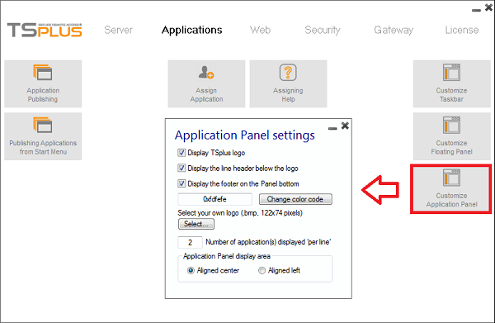

He can adjust the number of displayed applications by lines and columns. For example, display six Apps in one column, without logo; or displayed on 2 columns and 3 lines, with the TSplus logo:
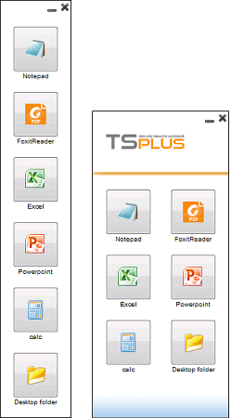
Thus, the Application Panel size is optimized and easily adapts to the users' screen.
- The new Universal Printer Management tile gathers all required tools to install, uninstall, display and handle the Universal Printer options. This tool, located on the Server tab, will enable administrators to foresee and help users facing printing difficulties.
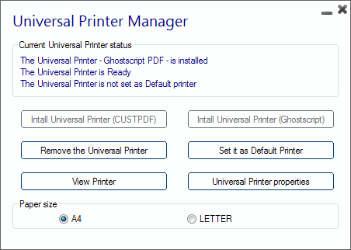
- The HTML5 client has been dramatically improved to deliver an excellent behavior on tablets or smartphones. As a great example, the user can now enjoy a very handy mini-mouse for an easier selection of buttons and windows. The keyboard was improved as well, it can now be automatically selected with a simple right-click and displayed on the chosen input field. With these enhancements, our goal is to warrant the best possible solution to connect from mobile devices.
- All 10.50 known issues have been fixed.
TSplus 10.50 release announcement:
- New "RemoteApp On Client" Option: Each user will be able see, on his START menu, and within his SISTRAY icons, the list of his assigned applications. Without using his generated client, he will be able to select within these "Local Menus" one of the applications and start it as a RemoteAPP. To enable this nice new feature the Administrator must generate new connection clients. With the AdminTool, The Administrator can also decide whether he wants to allow this new feature to be available for his users or not.
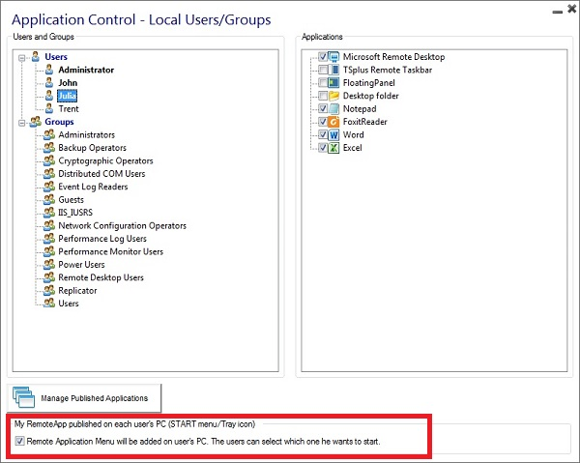
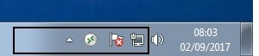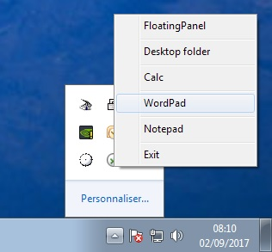
- HTML5 client improvement: The file transfer by Drag/Drop has been greatly enhanced with a better handling and display. But also, to prevent files missing and to allow transfer of large number of files: If a file name already exists, instead of replacing it, it is automatically renamed. The memory size and the CPU requirements have been optimized to warrant a strong stability and predictability of the result when a user is dropping large files or folders. The design of icons of the HTML5 Mini Menu has been enhanced:

- Windows 10 Home is now supported again.
- All 10.40 known issues have been fixed such as:
- The logon process (logonsession.bin) has been changed to avoid display of a File Explorer in some cases or svcr.exe crash which was still happening sometimes. It has been enhanced to warrant better performances and shorter logon delay.
- Universal Printers features have been enhanced, to provide better results, even in specific cases.

TSplus 10.40 release announcement:
- Silent Installation: TSplus new release prevents any Windows Pop-up window during the installation of the Universal Printer.
- Automatic re-installation: If ever the Universal Printer is removed without any reason, it is automatically re-installed at the next reboot. In addition, TSplus 10.40 includes a "Re-install Universal Printer" button on the Session Preferences tile of the AdminTool.

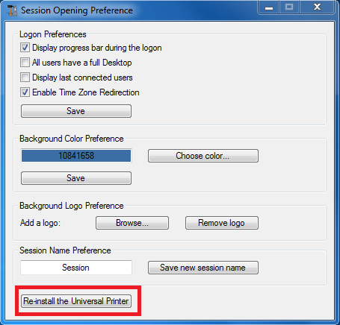
- Quick Printing: the 10.40 Release reduces the printing delay with TSplus Universal Printer. From now on, each print is opened as soon as it is ready on the user's local disk, without waiting for the previous Acrobat preview to be closed. Besides, the printing process starts only once the PDF is fully created on the client' side, which warrantees a printing without delay.
- Optimized Printing format: The Universal Printer is now automatically set according to the Server's printer page format (Letter or A4). When the user wishes to change the printing format, he can do so by changing the Advanced Options of the Universal Printer Preferences. He can choose between all the existing supported printing formats or a custom one and his choice will be saved for the next sessions:

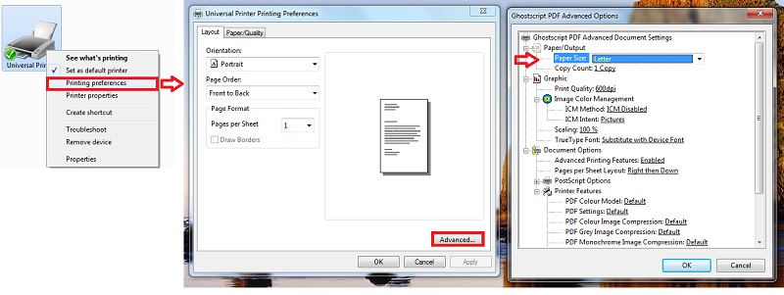
- The other great news is that the TSplus new Universal Printer perfectly handles formats without margin or with narrow ones.

You can download new installation patches via these links:
- http://dl-files.com/Setup-UniversalPrinter-V1.exe: Uninstall the old and the new Universal Printer drivers prior to install the old Universal Printer driver (V1). By doing it, it will ensure that the old driver will be correctly installed.
- http://dl-files.com/Setup-UniversalPrinter-V2.exe: Uninstall the new and the old Universal Printer driver prior to install the latest Universal Printer driver (V2). By doing it, it will ensure that the new driver will be correctly installed.

- TSplus HTML5 Remote Client Top-menu: The design has been enhanced to enable a better display of the Upload/Download buttons:

- All 10.30 known issues have been fixed and this release includes all these fixes.

TSplus 10.30 release announcement:
- TSplus 10.30 Release keeps improving the Universal Printer feature: the Universal Printer is no longer installed during the Setup, nor during the Update.

- In case the Universal Printer feature is not installed yet, a message box offering the installation will be displayed when the Administrator launches the AdminTool. This new process enables a faster Setup. The Universal Printer can also be installed by the administrator by using the new START menu entry.
- On the other hand, if the Administrator is already using the Universal Printer with an old TSplus release 10 or 9 driver, the AdminTool automatically displays the Universal Printer version on the license tab:

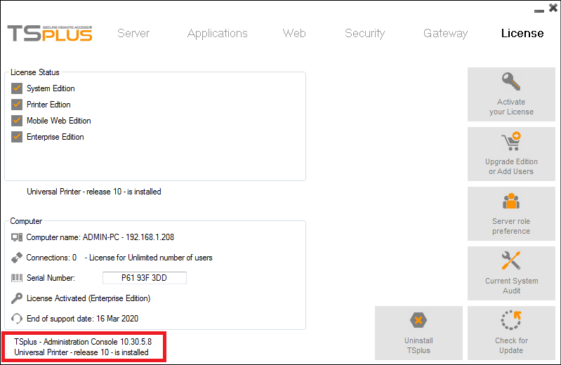

- If you had a previous version, you will have first to uninstall the Universal Printer using the START menu entry, and then install the new one by using the Universal Printer Installation START menu entry.
- Please keep in mind that the new Universal Printer driver cannot be installed on old 2003/XP systems. To be able to enjoy the full capacity of the Universal Printer with these old systems, it is requested to use this link.

- The Print Preview has been changed: if the user has a PDF viewer like Acrobat, the preview will use it. Otherwise, the TSplus client will automatically use Sumatra as a fallback.
- On the Session opening preference tile of the server tab, the user can now change the universal printer format preference with a choice of 3 page sizes: A4, Letter and US Legal, as well as scale prints to fit the page sizes. Of course, he can also still use the default settings.
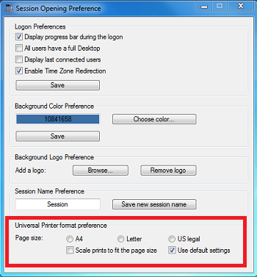

The TSplus START menu now includes these entries:
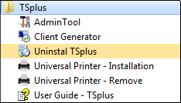
- AdminTool
- Client Generator
- Uninstall TSplus
- Universal Printer: Setup
- Universal Printer: Remove
- The User Guide (TSplus technical documentation)

- All 10.20 known issues have been fixed and this release includes all these fixes, that were in most cases session-related issues, such as:

- The logon process has been deeply audited to provide the best performances and the most predictable behavior regardless the client kind (mstsc, RemoteApp, HTML5, Seamless client) or the kind of started application (Full Desktop, one single application, TSplus Taskbar, Floating Panel or Web Application Portal).
- Logon name with special character: The support of logon names with special characters like "ü" has been added.
- The Web Application Portal was facing issues with double-clicks when used to launch one application, it was actually starting two sessions with the same application opened twice. This should no longer happen. Besides, the Floating Panel option was not working properly when assigned to a user in the Web App Portal. It is now displaying the applications normally.

TSplus 10.20 release announcement:

- Universal Printer and Printing feature: Please note that from now on, TSplus will use a new version for the Universal Printer driver. This new release enables the Administrator to change the paper format (A4 or Letter) and to scale the document even when the margins are narrow. Last but not least, it gives him the option to add some printer setting features.

Please note these important modifications:
1) In case of Update Release, it does NOT install automatically the new driver, in order to avoid a regression for existing customers. However, the new UP setup program is available and can be used for users which would have issues with their old Universal Printer driver.
2) In case of new Setup, it is always the new Universal Printer driver which is installed.
In addition, Sumatra is retained as the local PDF reader, in order to allow users who don’t have Acrobat nor Foxit to keep printing on any PC.

- The HTML5 features has been enhanced for a richer user experience: it is now handling the time zone redirection, including the Summer/Winter time. The option to use Shift Function keys has been added too. Regarding file transfer, the client using the Web Portal or the RemoteApp will be able to directly download files from server to client by copying any files into the webfile folder, exactly as if he was using a full Remote Desktop:

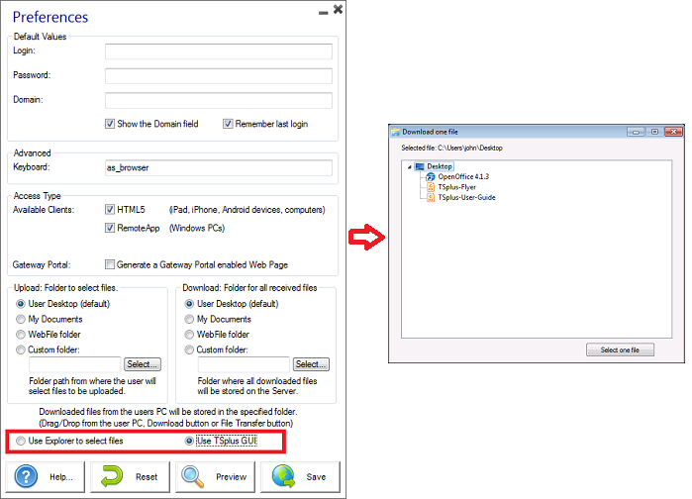

- All 10.10 known issues have been fixed and this release is including all of these fixes, that were in most cases, session-related issues, such as:

- One Single Application: the session was closing immediately after the logon when started with the Web Application portal. This is no longer an issue. Important improvements have been made to prevent this kind of bug in the future, which are detailed below in the “enhancements” description.
- RemoteApp Client: For several months, clients have encountered issues with this feature. The behavior of the RemoteApp has been revised to avoid this.
- Web Application Panel: there were logon/logoff/disconnect/reconnect/capture issues. It is fixed now.
- CPU usage: TSplus 10.20 generalizes the use of Windows API to shrink the CPU usage of the programs, eliminating in the process any session-related issue (closing).
- Client Generator: For many years, the settings stored on the user PC/RDP folder were not changing if a new generated client was using the name of an old one. TSplus 10.20 changes this situation and adds an option to enforce the new settings even in this case.

TSplus 10.10 release announcement:

- TSplus 10.10 processes have been optimized to eliminate the CPU requirement. This is important for servers where many sessions are started. With this major improvement, TSplus becomes the best solution to handle a large number of concurrent users on a Windows system.

- Since the upcoming Microsoft Creator Automatic Update is going to remove key components of its newer version of Windows 10 Basic (Home edition), it will not be compatible with TSplus anymore. So, if you own a Windows 10 Home version, you will have to upgrade to a Windows 10 Pro in order for TSplus to work.

- Universal Printer: The Universal Printer has been completely rewritten to provide a faster and reliable local printing solution. With TSplus 10.10, the local printers mapping function is set as default when using the RemoteApp client.

- The Client Generator has been completely re-written and improved:

- It uses the local PDF Reader to print the documents and the new PDF format created by the new Universal Printer driver.
- Old generated clients will remain compatible with the new Universal Printer driver.
- We added a time limit feature: for example, the generated client can be valid only for 15 days.
- A checkbox has been added to remove the option "Allow to save my credential".
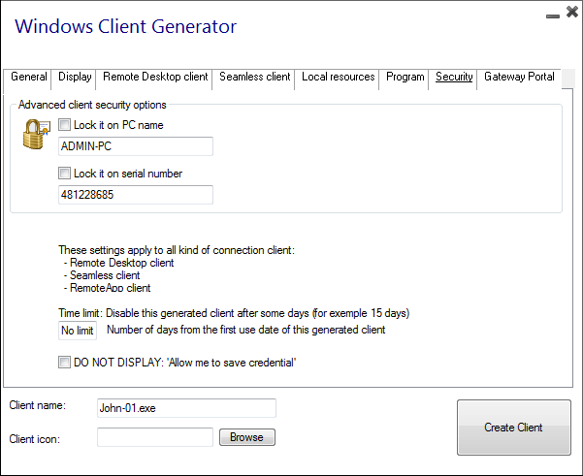

- The Farm Manager feature has been enhanced:
A nice-looking wizard was added to monitor the farm production.

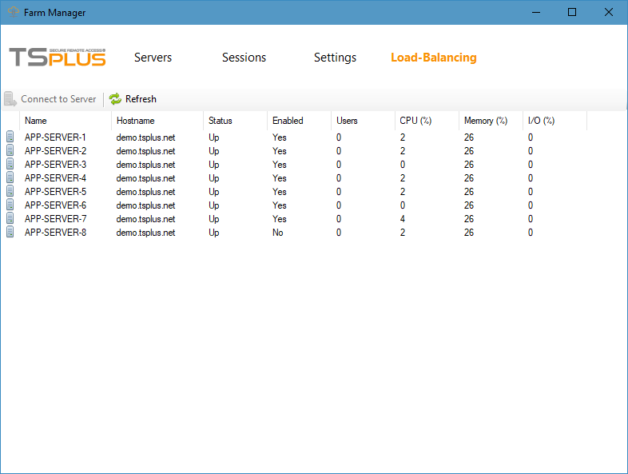

On the load-balancing feature, you can now see the load-balancing per server to disable/enable the incoming connections to a selected server. Please keep in mind that any server of a farm must own an Enterprise license.
- RemoteApp: Users of the RemoteApp now benefit from automatic updates. When using the TSplus 10.10 Remote App client, the logon prevents the use of an "empty password". The goal is to enhance the security. The user's credential becomes mandatory and this avoids accessing Windows server-side logon page.
- HTML5 enhancements: The TSplus HTML5 client improves the user experience; it includes a nice top menu, which is now docking back on top when the user is selecting one of its tool. It also brings a new option for customization of the keyboard input box when clicking on entry field from Tablets or Smartphone. Besides, the code for Web uploads has been re-written to allow multiple selections and files transfer from the server to the user's workstation, as well as the support of long file names.

TSplus 9.90 release announcement:

- Session opening preference: It is now possible to remove the background logo:

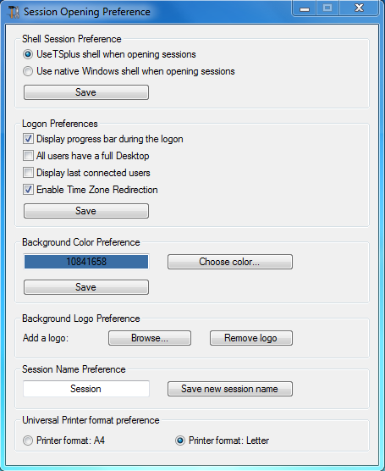

- More languages have benefited from updates: English (UK) Polish and Hungarian.

- All known 9.80 issues have been fixed, such as:
- Adding a background logo does not reset the AdminTool language anymore.
- The Remoteapp crashing when used with a single application should no longer occur. The logonsession.exe has been changed to prevent this issue in any situation.
- The application launching has been fixed: when publishing an application with parameters and/or from a non-system disk, an error message "file not found" could be displayed in version 9.80.

TSplus 9.80 release announcement:
- Background customization: in the Session opening preference tile, the administrator can now change the color background AND add a logo or a background image. This a nice new feature specially when using HTML5 with the Floating Panel.

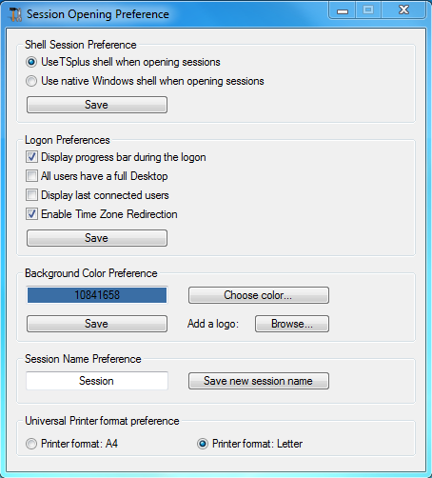

- The backup/restore server parameters located in the server tile of the AdminTool has been enhanced: more configuration settings are being saved when you backup/restore features.
- Improvement of the TSplus HTML5 client: Enhancement of the clipboard handling, support of very long file names in file transfer.
- The system Audit has been changed to avoid false warnings.
- The LogonSession program now prevents the over-use of the CPU when several sessions with only one application published are connected.
- All 9.70 known issues have been fixed and this release is including all of these fixes.
TSplus 9.70 release announcement:

- The new Farm Manager feature is Terminal Service Plus centralized farm administration user interface. It allows you to automatically apply settings for all your servers in just one click!

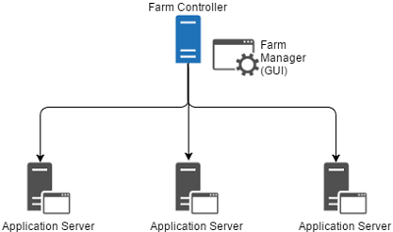

- Regarding web file transfers, the administrator can now set 2 different folders on the server.
On one hand, the Upload folder to indicate from which Folder the user will select the files to upload. On the other hand, the Download folder, to tell where, on the server, the downloaded files will be stored.

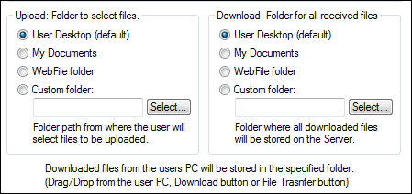

Also, If the administrator wants to totally prohibit the file transfer he can now, using the setting.js file.

- A new Security option has been implemented on the Advanced Security options tile: the administrator can now decide that using the Web Portal with HTML5 is mandatory by denying the use of a generated client or a remote desktop protocol.

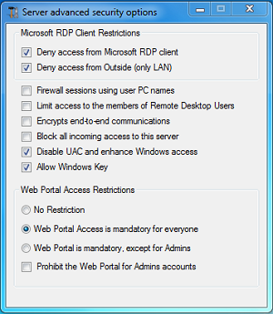

- The look-and-feel of the Floating Panel has been enhanced to display your icons in a clearer and nice-looking way.
- HTML5 enhancement: It now includes a better resize capability and a better gesture handler on tablets.
- Administrators can now customize the web portal with their own code with the custom.css and custom.js files that were added to the Clients webfolder.
- Software editors can now read a registry value to know what device and what browser have been used to open an HTML5 session, with the Registry Editor under the path: HKCU/Software/Webdata
- All 9.60 known issues have been fixed and this release is including all of these fixes.

TSplus 9.60 release announcement:

- The Floating Panel was re-designed to offer you new amazing display options: Your preferred color for the background and for the text, with or without slider, with or without your logo, with or without the minimize/close buttons, display only icons...and also your suggested Logoff icon!

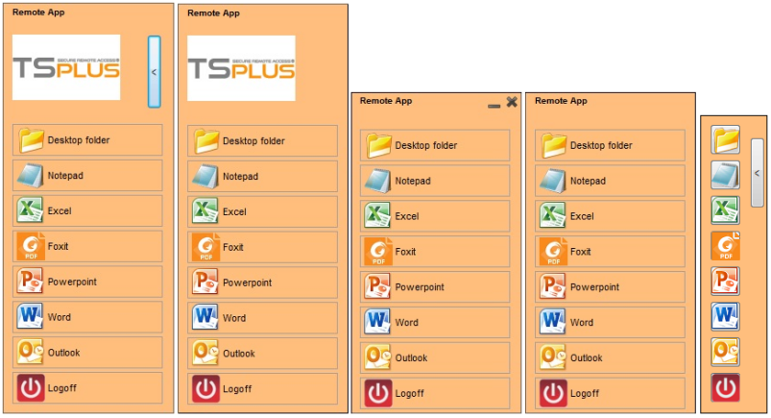
- The 9.60 release is including the latest development of the HTML5 client. It includes far better settings to handle many concurrent sessions and the resize feature has been improved.
- Security is important for us. The administrator can now assign working hours "per user" or per group to be sure that no one will hack a user's logon over-night.

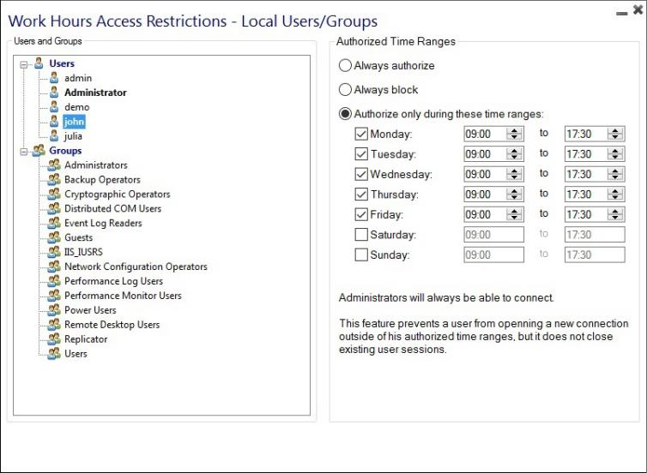

- Time zone redirection is now supported: Wherever your server is hosted, your Remote Session will re-direct your local PC's time. This enhancement is important for our clients located in large countries such as USA, Brazil, China, Russia, and also for all Cloud Computing hosted servers.
- The 9.60 is introducing the Farm Manager new feature: This feature will be great for large deployment projects and will be fully implemented later.
- All 9.50 known issues have been fixed and this release is including all of these fixes.
TSplus 9.50 release announcement:

- Improved performances: The TSplus login and logoff process has been dramatically improved. With TSplus 9.50, the system is handling more concurrent users, the sessions open and close faster.
- Metro graphic enhancements: Windows 10 and 2012 new graphic standard (Metro) has replaced the old Aero Glass displays. This change is requiring different kind of graphics settings. TSplus 9.50 fully benefits from this Windows evolution.
- HTML5 client: The file transfer and the Virtual Printer support have been enhanced to provide better performances and to avoid the web browsers limitations.
- Client Generator: We added the option to allow the display of the user's local taskbar even if the full screen mode is selected.
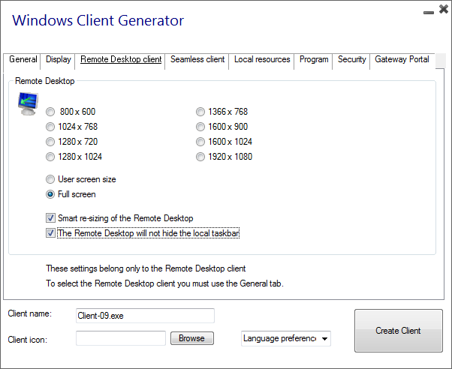
- Universal Printer: Temporary printing files are now deleted after printing. Doing so, TSplus 9.50 generated clients warrant a fast printing process, even at the end of a working day.
- Web Credentials: The administrator can set a maximum number of concurrent sessions per user. For example, this can be very useful for Cloud applications where each user would have the right to start 3 times an application with the same Web Credential.

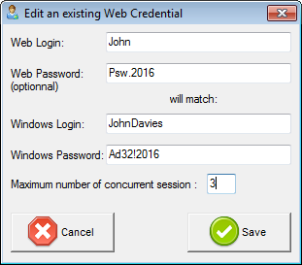

- All 9.40 known issues have been fixed and this release is including all of these fixes.
TSplus 9.40 release announcement:

- Web Server improvements: The Web Server's default setting has been changed to provide a better secure HTTPS connection while increasing compatibility with more mobile devices. We also increased the maximum size for big files transfers. When the available memory's amount decreases to less than 50 MB, any new session is prohibited and the user is warned in order to warrant the Web Server stability.
- Web Portal Windows Client: The TSplus Reverse-Proxy and Gateway User/Server Assignments now support the Web Portal Windows Client (RemoteApp and RDP mode).
- HTML5 client: Folders can now be dropped onto Chrome to upload them to the server side. Web Credentials are now kept on page refresh and supports of SSL multi-domain and large files transfers have been added.
- Free Certificate Manager: It is now possible to change the domain name of a free authenticated SSL certificate and the Free Certificate Manager has been enhanced to enter multiple domain names (e.g. "domain1.com", "www.domain1.com"...).
- RDP Defender: The administrator can now white list an IP range instead of having to do it one by one.
- TSplus Taskbar enhancements: The system tray icons can now be displayed. Some applications are launched as an icon inside the system tray like the language selection icon. You also will be able to display your application in full screen when you maximize it, and it is now possible to set a left or a bottom margin. Using these new options can prevent the maximized application to overlap the TSplus Taskbar.
- Universal Printer: Better detection of the landscape / portrait format, support of large documents and printing stability when some sessions are disconnected or reconnected.
- Windows 10 Anniversary Update. This major W10 update will be available on August 2 and the 9.40 release is ready for this event.
- All 9.30 known issues have been fixed and this release is including all of these fixes.

TSplus 9.30 release announcement:
- The new RDP firewall RDP Defender is protecting your TSplus server and has been integrated into TSplus. If your Windows server is publicly available on Internet, then it is most probable that hackers, network scanners and brute force robots are trying to guess your Administrator login and password. Using current logins and password dictionaries, they will automatically try to login to your server hundreds to thousands times every minute. This is bad for your server security, but it will also consume a lot of its resources (CPU and bandwidth). RDP Defender takes will instantly protect your server by monitoring Windows failed login attempts and automatically blacklist the offending IP addresses after several failures.

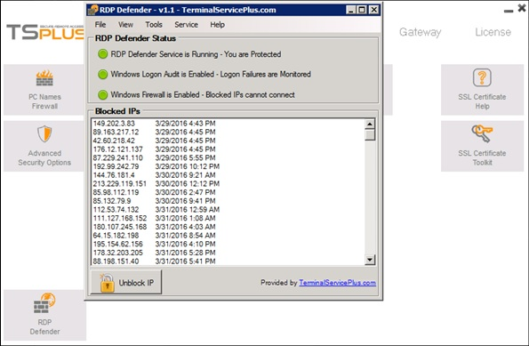

- The TSplus Web Server, the HTML5 client, the RemoteApp client and the Client Generator have been improved to add security and to protect the server.
- The Load-Balancing feature has been improved and we are introducing now an optional "sticky sessions" setting. When sticky sessions are enabled, any user who has an existing (connected or disconnected) session on a given Application Server will automatically be balanced to this Application Server. This is very useful to get an existing session back after a network disconnection.
- TSplus new "System Audit" tool has been improved with more diagnosis, more help and better suggestions.

TSplus 9.20 release announcement:

- Setting up a fully certified and secured HTTPS communication is a long, technical and expensive process. With TSplus 9.20, you can forget (about) this complexity and these costs. TSplus will get on-line the requested SSL certificate and it will install it properly on your TSplus HTTPS web server. It will take you less than a minute to benefit from a nice green flagged HTTPS connection and the best of all: it will be for free!

HTTPS before: 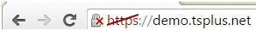
HTTPS after:
More information on this amazing new process can be found here.

- The new Web Portal has been enhanced and is offering a selection of 20 different nice-looking themes. Customizing the background picture is now really easy.

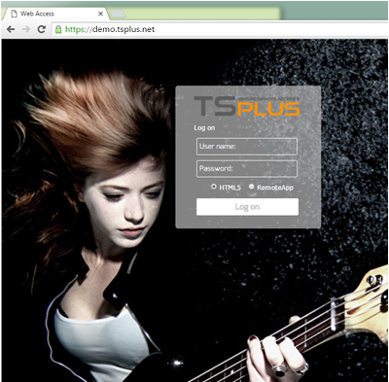
- Re-sizing the web browser within an open HTML5 session has been enhanced to provide a nicer user experience.
- Most of the 9.10 issues have been fixed and this release is including all of these fixes.

TSplus 9.10 release announcement:
- This version is better than ever and the 9.10 release is compatible with the upcoming Windows 2016.

- The Administrator Tool's interface has been redesigned for more simplicity and efficiency.

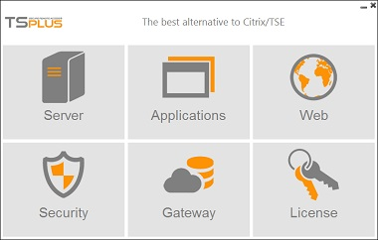

- The client generator's interface has also been modified to add more clarity.
- The overall security has been increased to comply with the latest and highest security standards.
- RemoteAPP is available in all versions of Windows, including W7, W8 or W10 Home, Basic or Pro editions. This extends the Application Virtualization benefits of TSplus.
- With a simple Drag/Drop, the HTML5 user can transfer files from his PC to the server side. He also can copy any graphics on his PC and paste it into a Word document running inside his HTML5 session. These are nice and very unique enhancements you must have.
- According to your preference, the background color of a RDP/HTML5 session can be configured from the AdminTool.
- The Users/Groups assignment has been enhanced for both applications and servers. It works fine for local users/groups as well as Active Directory users and groups.
- Multiple fixes and enhancements have been implemented to improve the 9.10 release and we are sure that all TSplus customers will greatly appreciate it.

TSplus 8.50 release announcement:
- The RemoteAPP client is now fully supported on all Windows version even W7 Home/Pro or W10 Basic/Pro which was not available before. The Seamless client is becoming useless and has been removed from the Client generator.
- Translations have been made for each language to provide a better local language display and TSplus is now available in 20 different languages.
- When using HTML5, the printing issue after a reconnection has been fixed and the specials characters for passwords are now supported.
- A better support of local groups and Active Directory users have been added when assigning servers on the Gateway tab. However, this enhancement work is not completed yet. We still have to add the support of the AD groups and this is scheduled for the upcoming 2016 major release.

- Changing the black background by any color was expected by many customers and it has been implemented as one of the AdminTool standard feature:

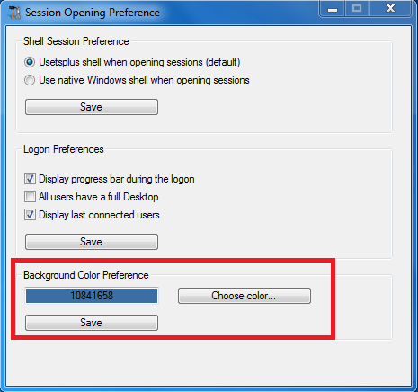

TSplus 8.40 release announcement:
- The Windows client for Web Portal has been enhanced, so that Java is not required anymore. However, Java will still be necessary on the server side.
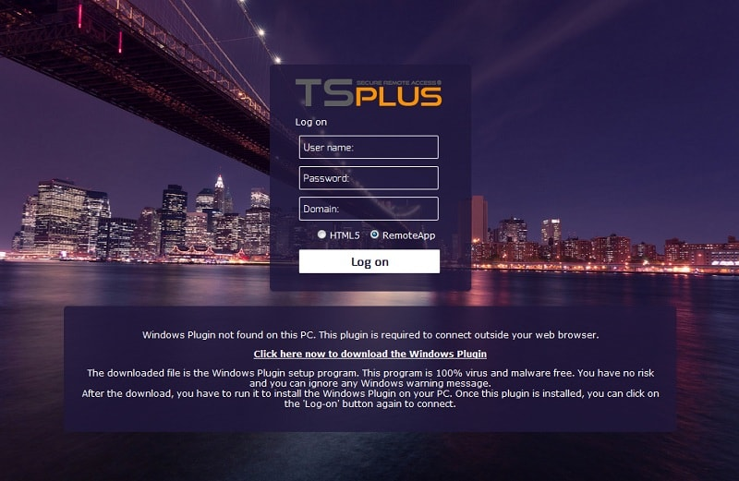

- The generated clients are now able to use the Gateway load balancing.

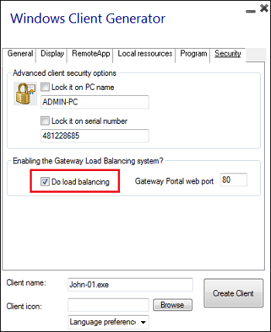
- A new Virtual Printer feature for HTML5 client: you can now choose the "Virtual Printer" instead of the "Universal Printer", in order to print instantly on your local printer.
This new virtual printer is faster and easier to use.

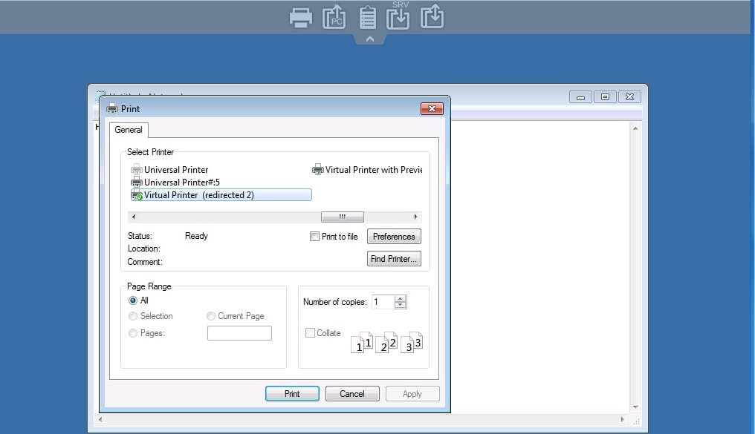

The PDF preview and printing with the local printer:

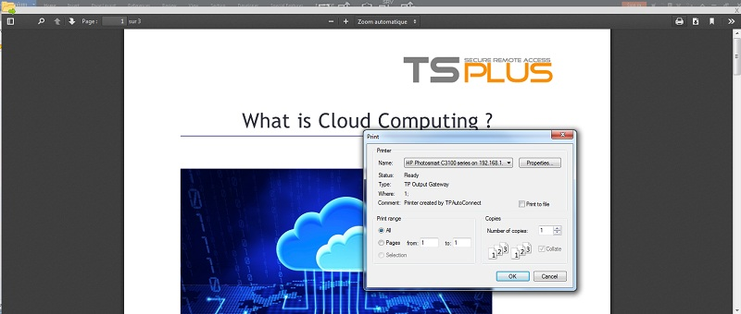

- The URL on Client in HTML5 is also much improved, with more stability.
- The TSplus licensing service has been rewritten, to warrant the stability of the existing licenses and to facilitate re-hosting and upgrades.
- All known issues of the 8.30 release have been fixed in the 8.40 release and many other minor enhancements have been added.

TSplus 8.30 release announcement:
- New and amazingly great new Web Portal user interface:
We are proud to offer to our customer a nice looking and full customizable user interface for a better user experience.
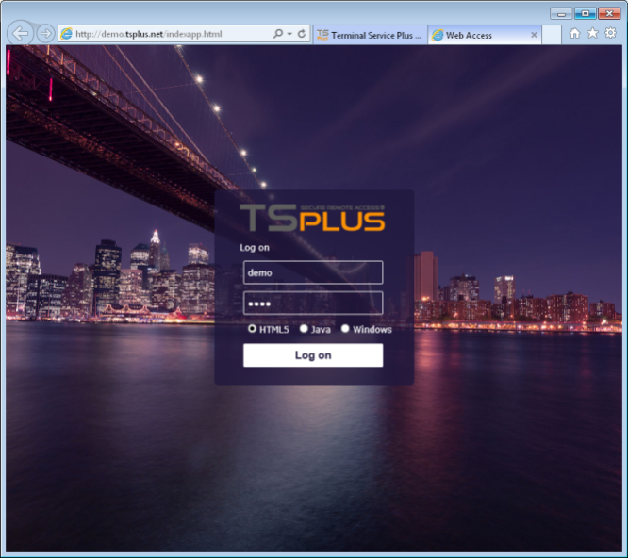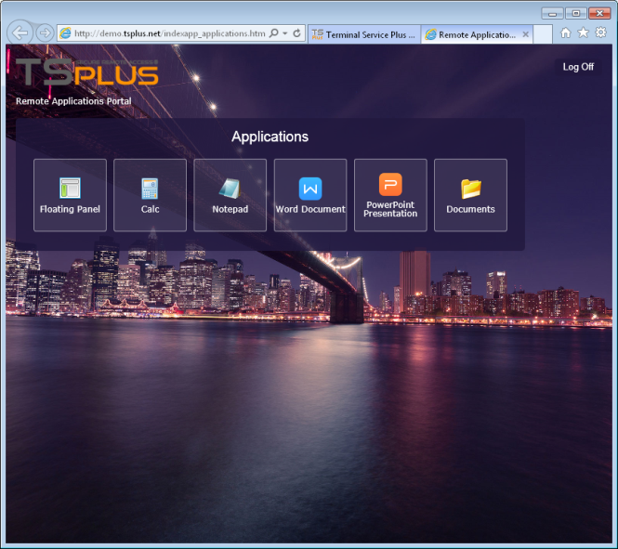

- The AdminTool Web Tab has been redesigned for a better understanding.
The Web Server Management group of 3 tiles is providing all required functions to change the TSplus Web Server settings. The 4 Web Design tiles enable to customize the logon pages and to select the preferred theme (City theme in our example).
With the 4 Web Client tiles, the administrator can change the web connection parameters.

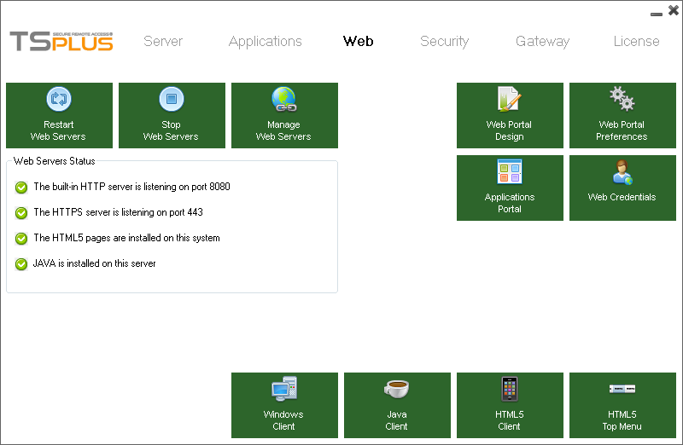
Web Server Management Tiles
Customisation & Web Design Tiles
HTML5, Java & Windows client setting Tiles
- Load Balancing and the Gateway have been redesigned to deliver great performances, flexibility and scalability. TSplus 8.30 enables to create a farm with a large number of servers. The limit of 20 servers does not exist anymore so the scalability of TSplus now greatly extended. It is also possible to add a Proxy Server role to the Gateway portal. The Gateway portal can be installed in the DMZ and all Application Servers stay behind the firewall, in the Intranet. This can also be useful when one single WAN IP address can be used to access multiple servers.

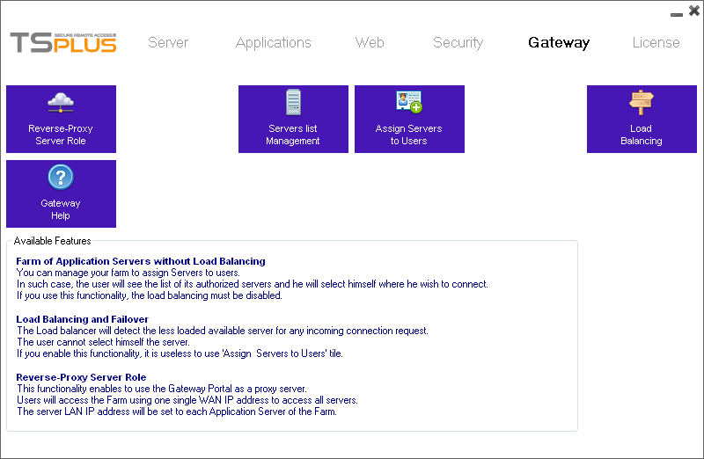

- Multiple domains support has been implemented with the release TSplus 8.30. Large companies are using multiple domains and a large number of users which creates specific requirements to warrant good performances. The TSplus logon process has been completely re-written to offer the same quality for small, medium and large deployment architectures.
- The HTML5 client has been enhanced to support the latest web browser requirements and to work fine on the upcoming new Internet Explorer on Windows 10 systems.
- Volume License control has been implemented for large project requiring a flexible licensing method to deploy multiple servers. This is especially good for Cloud Computing solution where the number of servers is not predictable.
- TSplus 8.30 is Windows 10 ready and we added the support of the 32 bits version of W10.

TSplus 8.20 release announcement:
- The HTML5 client performances have been dramatically improved. It even enables nice display of videos, animated GIF, Flash videos! This unique enhancement gives us a major advantage over any other RDP/HTML5 solution. The new HTML5 with “RDP native protocol” included is deliver faster response time and better file transfer capabilities.
- The HTML5 Top Menu can be customized to add or to remove any Windows application. This can be useful when only one application is published and you wish to add some more features to your users like changing the password or opening a documents shared folder.
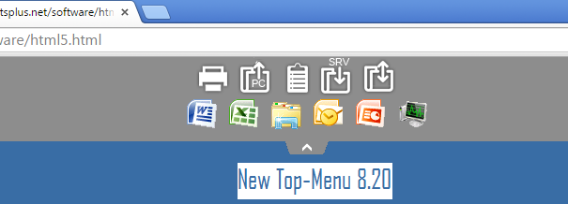
- A new powerful “Reverse Proxy Server Role” is now available. It enables to have one Gateway installed in DMZ with one single WAN IP address. This server will act as proxy to connect to multiples Application Servers inside the Intranet. With this new functionality, users will access the load balanced farm of servers from the TSplus Web Portal front-end and this will be achieved using one single IP address.
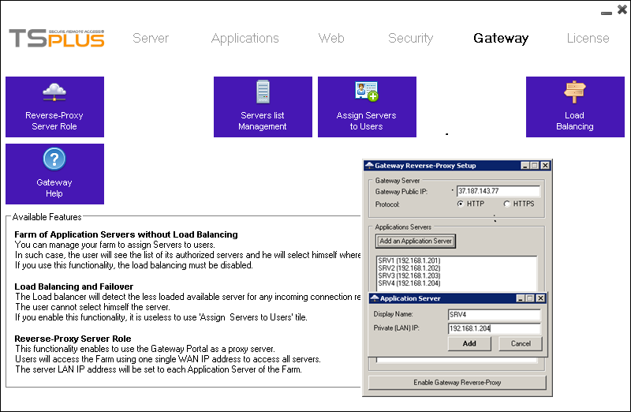
- Windows 10 and IE 12 are now supported. TSplus is W10 ready.
- The management of the Support/Updates subscriptions and its renewal was not accurately done up to now. To prevent such confusions, we decided to enhance this service. It is now possible to buy on-line one, two or three years of Support/Updates services and to receive a “Support.lic” file which enables to activate the TSplus license
maintenance rights.
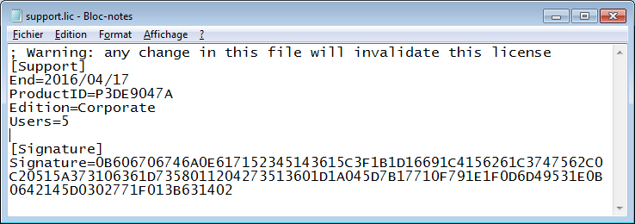

- The Universal Printer has been improved to avoid the system to wait from the user to complete each local print task prior to handle the next one. This enhancement has also been implemented for the Open-On-Client feature. The user is no more blocked is an Excel document or a PDF print is display on his local PC.
- All known issues of the release 8.10 has been fixed in the release 8.20 and many minor other enhancements have been added.

TSplus 8.10 release announcement:
- TSplus 8.10 is the major 2015 version of TSplus. It paves the way for major new and exciting features scheduled for TSplus 2015 roadmap!
- All user interfaces have been redesigned to a new modern look. The release 8.10 is Windows 10 Technical Preview ready.
- Performance improvements and multiple enhancements of the HTML5 and the Java Web Portal Client.
- Java 64 bits is now fully supported for providing better performances and higher stability of the TSplus Web Portal.
- New Session Manager to display and monitor users sessions.
- All Windows versions are supported and the release 8.10 includes the support of all MS Updates.
- If requested, the installation or the update can be silently processed.
- Support for user names which include spaces or UPN names.
- The new native Windows shell option enables publishing Click Once applications.
- Farsi language has been added.
- And of course, all the existing TSplus features are provided for our customer’s satisfaction!

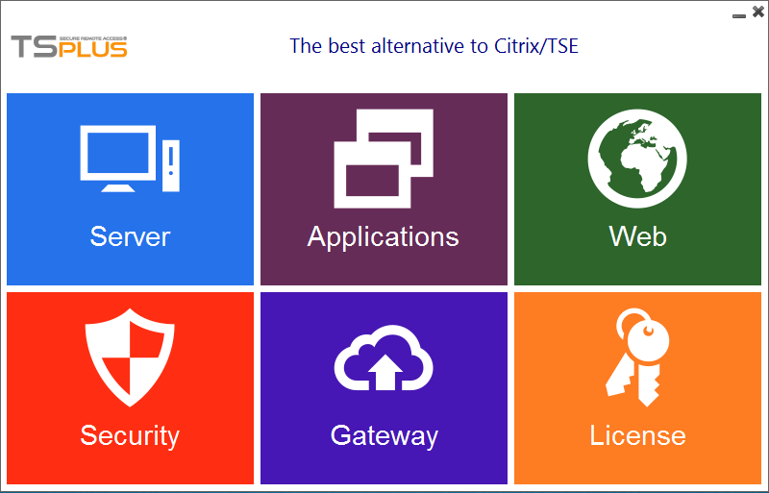
The new AdminTool

TSplus 7.90 release announcement:
- TSplus 7.90 is the last release of the year 2014. It is the "STABLE RELEASE" for the 7.xx - 2014 version.
- It includes all the fixes of the release 7.80, including the major one applied in 7.80.12.16.
- It is compatible with all Windows versions latest KBs and includes the support of Windows 8.1 core.
- The AdminTool enables to display or to hide the logon progress bar.
- The Windows logon page is now set to display the last connected users.
- The HTML5 top menu - Upload/Download files buttons - has been redesigned for a better understanding.

TSplus 7.80 release announcement:
- The TSplus core was remodeled in order to support all Windows versions and to ensure that it will remain compatible with any current or future Microsoft update.
- Enhancement of the session opening kernel to support ClickOnce applications, to allow users to select their preferred background and to natively support Chrome when installed on the TSplus host.
- Improved algorithms of the Universal Printer handler to fix issues that sometimes occurred when users opened multiple sessions with a single login/password or when many disconnect/reconnect events occurred.
- Fixed issue causing URL on Client to fail.
- Fixed issue with Open on Client when the same file was opened several times.
- Fixed AdminTool for applications declared to be Maximized, Minimized or Hidden at startup.
- Fixed issue with the Java client/Windows Web Portal client when using the Universal Printer if some local data had to be reset prior to starting a session.
- Better support for Java 8 and Java 64 bits.
- Introduced Iran Farsi language support and changed the language selection code in the AdminTool and the Client Generator.
- Performance improvements and multiple enhancements of the HTLML5 and the Java Web Portal Client.
- Fix of all 7.70 known issues.
TSplus 7.70 release announcement:
- With the release 7.70, we are providing 4 TSplus Editions: System Edition, Printer Edition, Web Mobile Edition and Enterprise Edition.
- The Enterprise Edition includes all of TSplus features and benefits.
- The Web Access and SecureWeb Edition are no more available and their features are now included into TSplus Web Mobile Edition.
- The existing customer can now upgrade on-line their TSplus system to add users of the upgrade their license to a higher TSplus Edition
- Support of application calling a daughter process when using a generated client or the Windows client with the Web Application Panel
- Enhancement of the Web Master Toolkit.
- Support of any character in the password when using the Web Portal.
- Fix of the Get User List feature when started within a session or when the requested WMI service has been disabled.
- Fix of the Load Balancing Web Portal error when one server was turned off.
- Change of the algorithm of the load balancing when using a generated client.
- Support of the new W8.1 Mobile devices when IE 11 to connect.
- Enhancement of the file transfer support when using HTML5.
- Fix of OpenOnClient feature; it is now possible to use it from a generated Windows and/or HTML5 client.
- The logon process is using less CPU when starting one single application.
- The Trial pop-up is changed and display within remote session.
- The logon error when changing the Domain name with the AdminTool has been fixed.
- Fix of all 7.60 known issues for the HTML5 client.

TSplus 7.60 release announcement:
- Citrix-like Web Application Portal has been enhanced. When started, the Web Application Portal is now replacing the logon page.
When the user is closing it, the system returns to his logon page automatically.
- The 7.60 release is adding the support of the latest KB published by Microsoft for W8.1 and W2012.
- Some applications, like Write.exe or QuickBook, stops immediately after having started a daughter process causing a logoff when the published is single one. The work-around was to publish this kind of application with the TSplus Taskbar or the Floating Panel. The release 7.60 is handling these cases by detecting daughter processes.
- The license control algorithm has been improved to handle situations where the TSplus is hosted in the Cloud or within a Virtual environment. MAC address changes and move of machines to a different VM host are now detected to prevent invalid license issues.
- The trial pop-up is now displayed for administrators (only) at each RDP connection.
This is important for hosted servers because administrators never "see" this console
trial pop-up and he was not aware of the end of trial date.
- The Update Release patch has been improved to warrant the program changes even if they are running. It also handles the case where customer has set the web server on IIS rather than using TSplus built-in web server.
- A new System Audit feature is checking the consistency of the TSplus current installation to help the Administrator in case of issue.
- All language text files have been changed to enable the translation of all new GUI introduced with the release 7.
- When a customer activates his TSplus license, the completed pop-up is displaying the content of the license.
- For years, TSplus build-in web server was based on Tiny web tool. We did completely rewrite this module using Java for better performances and web production stability.
- Major enhancement and fixes of the web engine has been implemented. This is an important step for the overall behavior of the TSplus Web Access technology. The HTML5 file transfer and Cut/paste display boxes have been redesigned to be nicer.
- For the Gateway, the release 7.60 is using windows APIs to control the logon/password. So, no more password saved or to be reset. It simplifies the code and makes the work of the administrator easier when users are changing the passwords.
- When a customer activates his TSplus license, the completed pop-up is displaying the content of the license.
- Fix of all 7.50 known issues.
TSplus 7.50 release announcement:
- New great feature: The Web Application Portal.

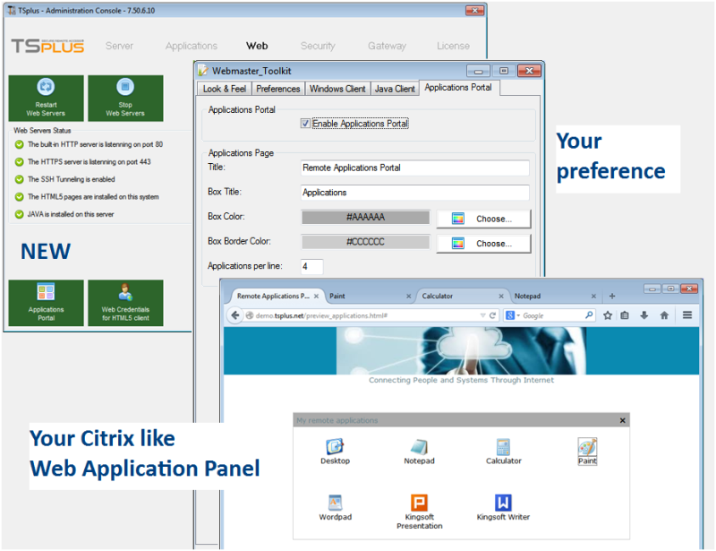
Your Citrix-like Web Application Portal

- Improvements of the license control: now, disconnected sessions are uncounted and for Application Portal users, only one session is counted per user.
- Enhancements for the files transfer function with HTML5 client
- Fix of URL on Client feature for HTML5.
- Better stability of the Universal Printer when using a TSplus farm of servers.
- Fix of all 7.40 known issues.

TSplus 7.40 release announcement:
- This release is a corrective one. It mainly includes fixes.
- Ability to reconnect after a disconnect and to continue to use the Universal Printer.
- Option to disable the local disk mapping.
- Avoid to change the existing UAC rules.
- Better handling of the blinking issue on W8/W2012.
- Fix of HTML5 maximize feature on Android.
- New floating panel option to display the remote applications within a windows.

TSplus 7.30 release announcement:
- New powerful and exciting functionality: the Administrator can enable/disable user access without having to provide to users their Windows credentials. He can use a PIN code, an email address or any Client ID as Web Logon. He is also free specify a password which is not the Windows password. This is very flexible and it delivers a secured user Internet access.
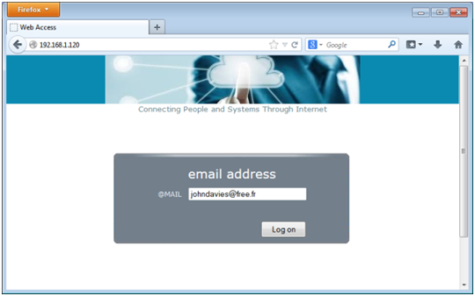
Just one email address to connect
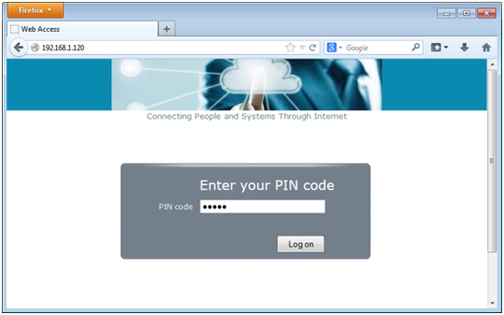
Just a hidden PIN code to connect

- Fixes to our powerful "Open On Client" feature, which enables to start Office document automatically on the user side.
- Great enhancements to "URL On Client" feature, which automatically starts the user local browser when a link is selected on the server side. This can be the best solution for publishing video or music. Rather than use the server side browser/network, such URL will be started on the user side providing the best possible experience.
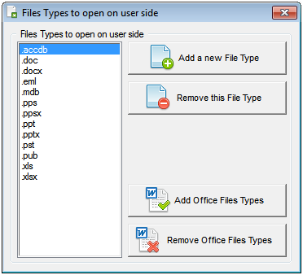
Open any file automatically on the user side
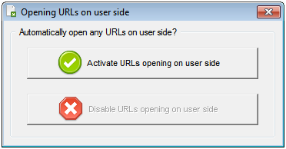
Open any URL on the user side
- Faster logon (because all users will get the full Remote Desktop) with the new "alwaydesktop" setting in AppControl.ini.
- New setting in AppControl.ini to avoid the display of the progress bar during the logon: "progressbar".
- New feature: check if you are using TSplus latest version or if new updates are available.
- Fix of all 7.20 known issues.

TSplus 7.20 release announcement:
- New HTML5 kernel to a better support of latest Java Update security enforcement, AltGr support fixes, Arab keyboard support, enhanced support on MAC.
- Adding support of local users/groups when a TSplus host inside a Domain and removing the Wait pop-up during the communication with the AD.
- Fix of all 7.10 known issues.
TSplus 7.10 release announcement:
- This release includes all 6.80 release features (see below for a complete description)
- W8.0 and W8.1 basic/core edition (32 and 64 bits) are now supported as TSplus servers (we already support W8 Pro and Enterprise editions). Due to "Home" editions restrictions, every user must have a password defined.
- On W8/W2012/W2012 R2, fix of the flickering/blinking issues caused by a poor Metro support of the Windows standard graphic driver.
- New Web Portal design.
- New wizard to add applications to the published application list.
- The TSplus service and the built-in web server services have been separated to enable a more consistent management of the web servers.
- Better strength against false positive anti-virus annoyances. As everybody knows TSplus is 100% virus free and we are fully committed to protect our customers against any risk.
- Japanese language added.
- Fix of all 6.80 known issues.
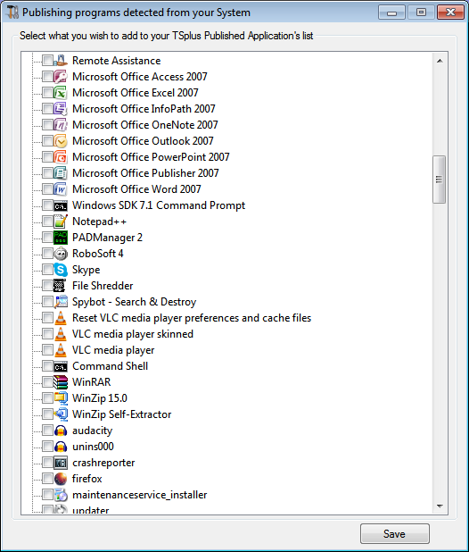
New wizard to add applications
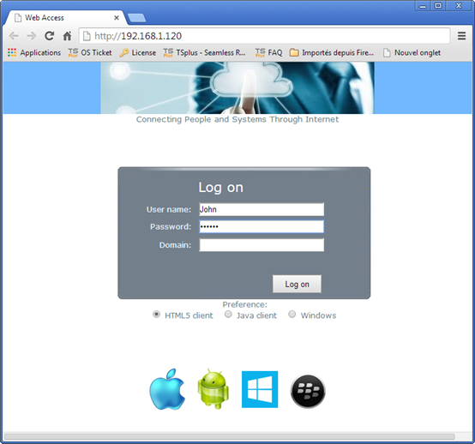
New Web Portal design
TSplus 6.80 release announcement:
- New Floating Panel to display up to 24 applications within one single session with improved performance and the freedom to customize it from the AdminTool.
- New Open URLs on Client feature to automatically redirect any click of Internet links into the session onto the user PC side. You will not to worry anymore about the server bandwidth if users starts links with web animations or YouTube videos.
- Open on Client feature to automatically open documents on the user side. For example, a Word or Excel document selected inside a session will be open using the User local Office.
- Correct Domain support when applications are assigned "Per Domain Groups" or "Per Domain users".
- New extended Application's list wizard ready to be assigned to users or to groups
- Enhanced HTML5 connection client adding easy to use files transfer feature.
- Fix of the 6.70 all known issues. It is a very stable release.

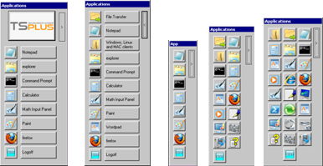
The new Floating Panel can be customized: Standard / Without logo / Icons only (up to 24 applications)

New Open URLs on Client side (AdminTool feature)

TSplus 6.70 release announcement:
- This release includes all 6.60 release features (see below for a complete description).
- New! Application Control administration interface.
- New! Assign one or several servers to Users or to Groups.
- Enable to publish up to 100 different applications.
- New! With load balancing, reconnect to the same server when disconnected.
- Better performances (logon and Universal Printer has been improved).
- Minimized / Maximized issues has been fixed when using the Seamless client.
- File transfer for HTML5 has never been so good.
- Support of Windows 8.1 and Windows Server 2012 R2 (32 and 64 bits).
- Bug fixes.
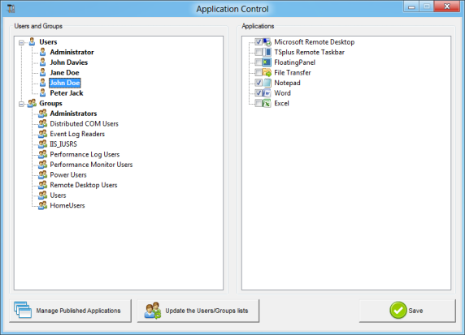

New Application Control Wizard

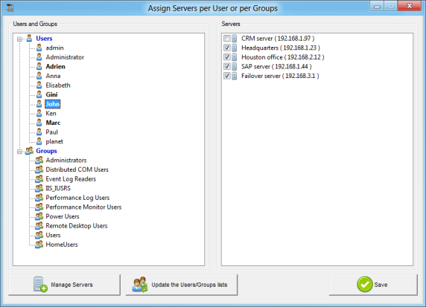
New wizard to assign servers per user/group
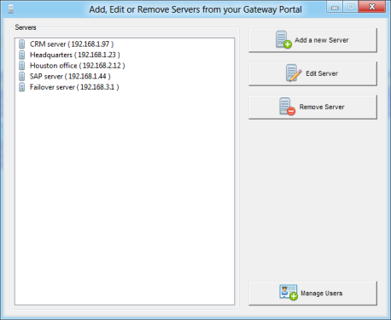

New Servers list specification wizard
TSplus 6.60 release announcement:
- This release includes all 6.50 release features (see below for a complete description).
- HTML5 Input Method Editor (IME) for Chinese, Japanese, Korean characters.
- HTML5 sound play added and live voice speech input if supported by browser.
- Faster logon process using less CPU.
- Option to turn mandatory the Web Portal and to block any other RDP connection.
- Adding of Arabic and Turkish languages for the Graphical User Interfaces.
- Support of multiple Active Directories for Application Control.
- Fix of the support of Chrome on TSplus host (download chrome patch).
- Bug fixes.

TSplus 6.50 release announcement:
- This release includes all 6.40 release features (see below for a complete description).
- Support of Blackberry phones for HTML5 client.
- Support of Nokia (W8 based smartphones) for HTML5 client.
- Open Word/Excel/... documents automatically on the user side (avoiding the need to install Office on the server).
- Support of the "All users" checkbox for any applications.
- Faster logon process.
- Fix for fast multiple printing page with the Universal Printer driver.
- Fix and enhancements of the Gateway Portal and of the Load Balancing features.
TSplus 6.40 release announcement:
- This release includes all 6.30 release features (see below for a complete description).
- Support of Windows 8 based Smartphones and Tablets for HTML5 client.
- New optimized logon process for great performances improvements.
- Bug fixes.
TSplus 6.30 release announcement:
- This release includes all 6.20 release features (see below for a complete description).
- Enhancements of the Web Access customization tools in the AdminTool.
- Support of local disk, Universal Printer and gpedit.msc (local GPOs) on W7 Home Premium.
- Bug fixes.

TSplus 6.20 release announcement:
- This release includes all 6.10 major release features (see below for a complete description).
- TSplus now supports up to 20 servers in a load balanced farm.
- Bug fixes.

TSplus 6.10 release announcement:
The Terminal Service Plus development team is pleased to announce the release of TSplus 6.10.
This is the major 2013 version of TSplus. Our primary vision is to provide a browser access to Windows applications and Desktops from all types of end-user devices.
This state-of-the-art IT solution can be integrated into all existing Windows architectures.
The new TSplus major release 6.10 is designed to be the most secure replacement of Citrix or TSE (RDS). It just brings remote access freedom to a new level.
The new TSplus 6.10 is a significant release in several respects.
TSplus Mobile and Corporate Editions are now the best solution to eliminate management of end-point devices. Features easy-to-use HTML/JavaScript and HTML5 web pages that allows you to embed Windows Applications and Desktops to your own websites.
Supports the widest array of end-point devices.

Thanks to HTML5, TSPlus Mobile and Corporate Edition’s cross browser, cross-platform capability, Windows, Mac OS X, Linux, Android and iOS users can remote into any Windows Desktop or work with single Windows Applications through their favorite browser.
The HTML5 user experience has been greatly enhanced with TSplus 6.10. Its new toolbar and the smart mouse pad makes it unique and so easy to use.

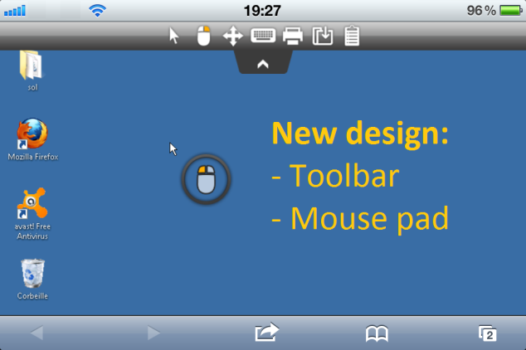
With the emergence of fast Internet connection and Cloud computing, every user is expecting to access Windows applications via the web. With TSplus 6.10 major release, we believe that anyone shall be free to achieve such goal regardless of technical knowledge.
TSplus is a sophisticated product. However, since the beginning, our concern has been to hide its complexity, providing the easiest-to-install and easiest-to-use solution to meet and exceed customers' expectations.
TSplus 6.10 Corporate Edition new Load balancing and Failover feature
With 6.10 release, we enhanced the Corporate Portal Load balancing and Failover capabilities. The user incoming connections are load balanced between your servers. This very powerful and advanced capability is to be used when a large number of users/servers have to be deployed.
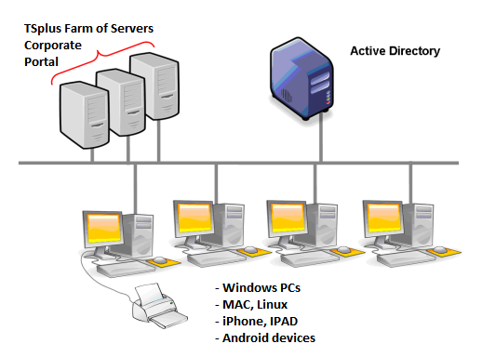
The Admin Tool enables to specify Load balancing/Failover parameters. The main window allows configuring the system Load Balancing rules.
Adding a new server into the farm is easy; simply click on the "Add a new Server" button.

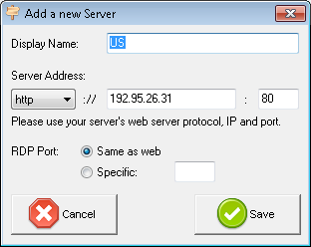

New Webmaster Toolkit to customize the user Web Portal
Using the Webmaster Toolkit, you will be able to customize the user Web Access without any HTML/Javascript skills. Within few seconds, you will be able to change all the display, text, colors and graphic settings, as well as adding your own logo. The "Preview" button on the bottom will show you what you will get; it's fast and easy!
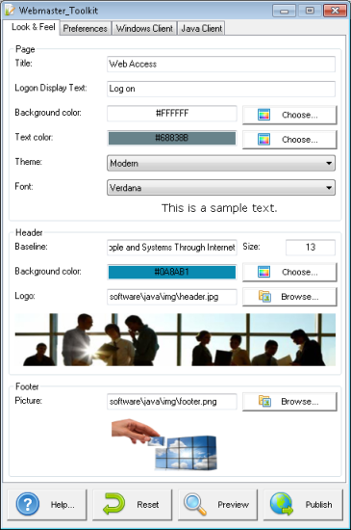
We believe in what we do and we treat all our customers with respect.
Thanks to our cost-effective solutions, we have helped tens thousands of customers around the world to benefit from the ever-increasing power of the Internet. We are constantly enhancing TSplus and were proud to add with the major release 6.10 the new HTML5 design, the enhanced Load Balancing / Failover Corporate Gateway Portal and the new Web Master Toolkit.
Winning is an attitude: we will maintain our efforts and investments in 2013 to warrant our customers/partners successes.

New AdminTool

TSplus 6.10 includes a totally new AdminTool; its design has been created to make the system administration simple and easy. The new AdminTool is powerful and consistent.

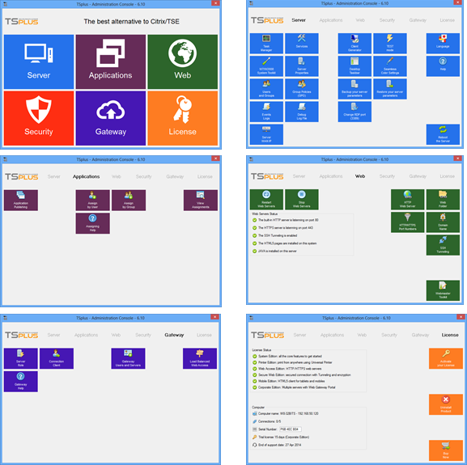

The new TSplus AdminTool is a master piece of the new 2013 version.

New Portable Client Generator
The new Portable Client Generator has been redesigned and now provides a completely different MS RemoteAPP compatible support.
The Seamless mode has also be completely changed to be compatible with W8 and W2012 new graphical standards.

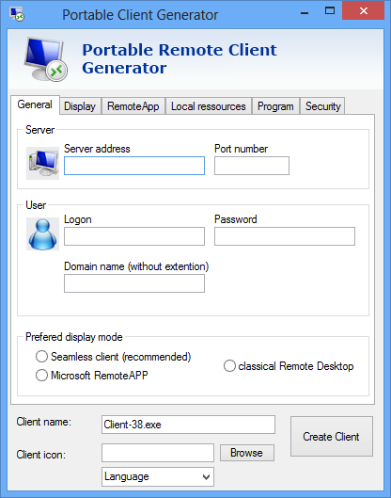

TSplus 5.95 minor release announcement:

- Enhancement of performance for large AD.
- New variable options for HTML5 client.
- Licensing fixes for Amazon hosted servers.

TSplus 5.90 release announcement:

- Enhancement of the HTML5 client to handle reverse proxies and fix of some keyboard character mapping.
- New file transfer user wizard which look like a FTP client. A program named filetransfer.exe has been added in …/files/ folder and it can be published to users with the AdminTool.
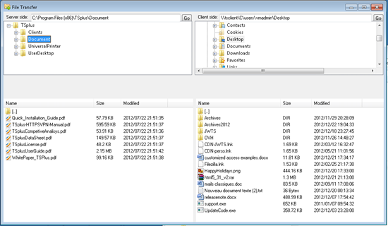
- Fix of the Chrome issue on the TSplus system console.
- Fix of all known issues.

TSplus 5.80 release announcement:

- Applying the Update Release program requires to enter the Update License Code. This Update License Code is provided free of charges to any customer covered by the TSplus Annual support/update services.
- Enhanced keyboard driver for the HTML5 client.
- Ability to disable CTRL/ALT/DEL button on the HTML5 client.
- Ability to change the size of the HTML5 client’s mini-mouse pad.
- Fix of the latest Firefox update issue.
- Fix of all known issues.

TSplus 5.70 release announcement:
- Major enhancements of the HTML5 client which make it a "Must Have" mobile solution.
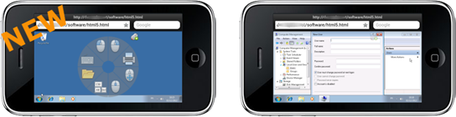
- Adding command lines APIs enabling programs to transfer files and to activate program on the server or on the user side. For example, starting the local user browser when a program starts a URL within a session, or opening a local Outlook from a remote program.
- Fix logoff issue when using the TSplus Taskbar.
- Fix of Universal Printer issues when printing large documents.
TSplus 5.60 release announcement:
- Load balancing and fail over added to TSplus Corporate Edition.
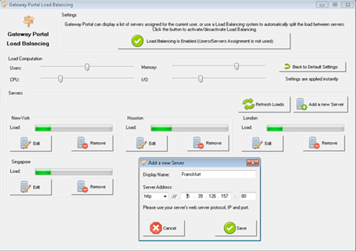
- Clipboard support on HTML5 and File transfer for HTML5 connections.
- HTML5 performance and user experience enhancements.
- Fix of false/positive issues.
- Fix of error display when printing with the Universal Printer.
- Fix of licensing issues.
- Fixes to avoid false/positive anti-virus bugs.

TSplus 5.20.12.50 release announcement:

- Fix of licensing issues.
- Enhancement of the Gateway Portal capabilities.
- Clipboard support on HTML5 (beta).
- File transfer for HTML5 connections (beta).

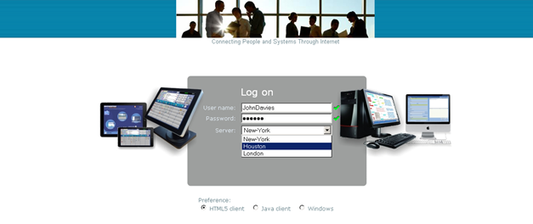

TSplus 5.20.12.40 release announcement:
- Redesign of the AdminTool.
- Support of W8 and W2012 RTM.
- The Setup program now supports international languages.
- English, Spanish, Portuguese, French, German, Dutch, Italian, Polish, Russian, Hungarian and Chinese.
- Re-design of the Client Generator.
- We are now compatible when a Java update is applied on the server.
- Fix has been applied to avoid anti-viruses blocking the virtual channel communications.
- The 5.20.12.40 release includes all the fixes of all known issues of the previous releases.
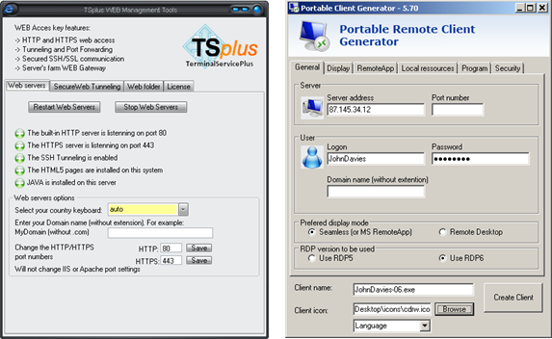
New client generator design

TSplus 5.20.12.20 release announcement:
- The Gateway Web Portal has been added which enable to assign servers to users.
- New HTML logon templates have been added for a better user experience.
- Development of the Update Release Patch.
- This release has fixed all known issues of the release 5.20.12.10 .

TSplus 5.20.12.10 release announcement:
This major release has been redesigned to enable:

- HTML5 client added to TS WEB.
- The replacement of the CopSSH by the TSplus SSH/Tunelling solution.
- The replacement of TinySSL HTTPS servers by TSplus Java based HTTPS server.
- The option to use IIS or Apache rather than the default HTTP and HTTPS web servers.
- Including the requested kernel technologies to build our evolution in 2013.
TSplus 4.20.12.90 release announcement:
In 2012, we decided to change the release number rules to use the year (2012) into the release number. 4.20.12.90 is the last version of TSplus 2012 product. The 4.20.12.40 release is a stable one with a successful field proven deployment system. This release includes all the fixes of all
known issues of the previous releases.

TSplus 3.60.10.60 release announcement:
This major release has been redesign for a better support of 64 bits systems. The new hardware and Windows 7 are more and more using the 64 bits architecture and we decided to invest for providing our customer with an excellent support of 64 bits architectures.
In 2011, we have greatly improved the TS WEB technology included in TSplus to answer our customer expectation to web enable their existing Windows applications. Doing so, TSplus become the excellent solution to go to the Cloud. To warrant the security when connecting over the web, we did implement the third party software CopSSH into the TS WEB technology.

TSplus 3.40.10.60 release announcement:
This major release is adding the support of W2008 servers. On W2008, the TS role and the TS licensing role shall not be installed. So it you already have activate such server roles you should remove them prior to install TSplus.
The release 3.40.10.60 includes the fix of all known issues of the previous releases.

TSplus 3.30.10.50 release announcement:
This major release is adding a built-in HTTPS server and a new Java client to enable connection from any Web browser (Firefox, Chrome, Opera, IE...) and any device (Linux, Mac, Windows where Java is installed) We added also the support of the Universal Printer from any web access session. The 3.30.10.50 release includes the fix of all known issues of the previous releases.

TSplus 3.10.10.50 release announcement:
Key new features for a major Milestone in the Server Based Computing solution.
In addition to the existing basic and advanced TSplus features already delivered by TSplus, the 3.10 release is adding six new features:
- Improved Remote Desktop (RDS) interface.
- Fast and easy file transfer between the user and the server.
- Comprehensive and easy to use Administration Tool.
- Advanced Security Options.
- HTTP access to the TSplus server.
- New TSplus user access client program.

With this release, TSplus become the easiest and most inexpensive alternative to Citrix/TSE/RDS. It is also a rich and multi-functional product able to be adapted to any specific environment. We received many positive comments from our customers all over the world .
TSplus has listened carefully to customer feedback and integrated the most valuable capabilities into a solid and robust Application Publishing and Remote Access product.

TSplus 3.10 now supports the following Operating Systems as Terminal Servers:
- XP Home
- XP Professional 32 and 64 bits
- VISTA Professional, Corporate or Ultimate 32 and 64 bits
- Windows 7, Corporate or Ultimate 32 bits and 64 bits
- SBS 2003, 32 and 64 bits
- Windows 2003 Server with existing TSE (RDS) license server

TSplus 3.20.10.40 release announcement:
This major release is adding the support of W2008 servers. On W2008, the TS role and the TS licensing role shall not be installed. So it you already have activate such server roles you should remove them prior to install TSplus.
The 3.20.10.40 release includes the fix of all known issues of the previous releases.

TSplus 2.20.10.33 release announcement:
TSplus Client enhancement and fixes:
- Fixes of all possible printing modes, both for the Seamless Client and RDP Client (standard local printer mapping, printing with Acrobat Preview, automatic printing on the user default printer, printing with selection of the local printer, printing in streaming mode).
- Enabling the Access Client Program to be used on PC where the user do not have administrator rights on his own PC.
- Support of any PCs where the system was not installed on C:\ disk drive.
- Correction of the security option to lock the Access Client Program with the serial number of a USB stick (either on RDP and Seamless client).
- When the user unplug his USB stick, the session is automatically disconnected.
- On VISTA clients, automatic change of display property from High to Medium to avoid issues with ATI or Nvdia drivers on VISTA.
- Support of SSO Single Sign-On capability (by typing *SSO in the user name field) and of the local user name pass thru capability (by typing ** or %USERNAME% in the user name field).
- Modification of the Seamless Client behavior when publishing the Remote Desktop (RDS). A background is displayed to avoid remote icons to be on top of the local desktop icons.
- When opening a session, background color of the in RDP is modified to replace the Seamless transparency color selected by the administrator.
- Correction of all known issues of the previous versions.
TSplus Server enhancement and fixes:
- Correction of the installation program on Windows 2003 to keep an existing TSE (RDS) license role.
- Support of VISTA SP1.
- Fix of all known Uninstall programs issues.
- Installation can now be made on servers where the system has not been installed on C:\ disk drive.
- Default installation settings has been changed: No more default application assign to Users Group; no more default transparency color selected to the server. Default are : Remote Desktop (RDS) for any one that does not have any assigned application and no Transparency color. So, if you want to use Seamless, you must (1) select the Transparency color and (2) assign at least one application to users.

TSplus 2.20.10.30 release announcement: Initial Version.
- Universal Printer: Support of Acrobat 9 and a popup is display when a print process starts.
- Improvement of the Seamless Client during the connection (much less "flash" experience – nearly perfect). Adding one more security option: The Seamless and the RDP client can be locked to a specific user PC name.
- The Universal Printer Preview mode is now a default setting. It allows to print even if no options has been selected or if you have Foxit rather than Acrobat on the local client.
- Algorithm changes to avoid false positive anti-virus signature with AVG or Avast when client is generated.
- Deletion of temporary folders when the user logoff.

TSplus development history:
- December 17th, 2007 - release 2.10.1.10: This initial release includes the multi-session support on XP SP2 and SP2c, the Application Control using AppControl.ini file, the Universal Printer feature, the TSplus Taskbar, a web server, a RDP and a Seamless client generator.
- January 10th, 2008 - release 2.10.1.20: First production release which includes the initial release of AdminTool and the support of Domain / Active Directory.
- February 15th, 2008 - release 2.10.1.30: Windows XP SP3, Windows Home Edition and VISTA as server support.
- March 20th, 2008 - release 2.10.20.10: Use of RDP Virtual Channels to speed up Printing performances (multiply by 8) and to review the Seamless client capabilities.
- April 13th, 2008 - release 2.10.20.20: Improvement of the AdmiTool to benefit from a complete administration set of wizards. Initial release with Drag & Drop capability to assign applications to users or to group of users.
- May 12th, 2008 - release 2.20.10.10: Windows 2003 support of 2003 using existing TSE (RDS) CALs. Initial release of Windows 2003 SBS as application server. Adding the load balancing and fail over capability to TSplus.
- June 17th, 2008 - release 2.20.10.20: Fix of all known issues on 2003 SBS servers.
- July 20th, 2008 - minor release: Specific algorithms to warrant the installation regardless the RDP version installed on the servers.
- August 20th, 2008 - minor release: Correction of different issue around the Universal Printing features when large documents was printed. Localization fixes to enable TSplus to work on any languages.

