USER GUIDE
TSPLUS CUSTOMER PORTAL
BY TSPLUS INTERNATIONAL – 2020 – ALL RIGHTS RESERVED
TSPLUS / all rights reserved 2020

USER GUIDE Customer Portal

INTRODUCTION
- Thank you for your interest in our products. As a TSplus customer, you can now view and manage all of your orders and licenses on the TSplus Customer Portal by entering the Email Address you gave during purchase and one of your Order Numbers (Order Numbers begin with ‘JWT ‘) :
ACCESS YOUR PERSONAL SPACE

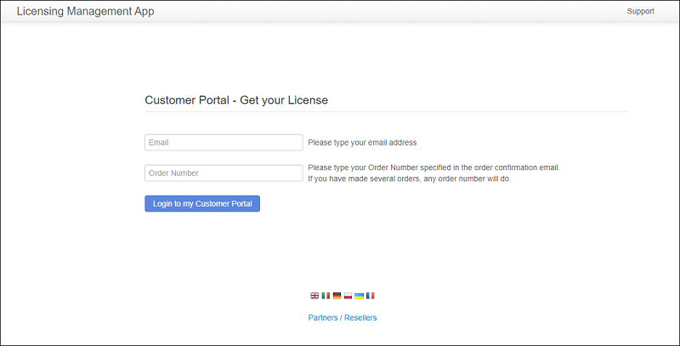
TSPLUS / all rights reserved 2020

USER GUIDE Customer Portal

HOME PAGE
LICENSES AND SUPPORT
- Once logged in, you can see your License and Support purchases with the corresponding Software name, Serial Number, Number of users, Edition, Order Number, Date of purchase and Duration of your Support and Update Services. You can also view the Activation Key related to your order:

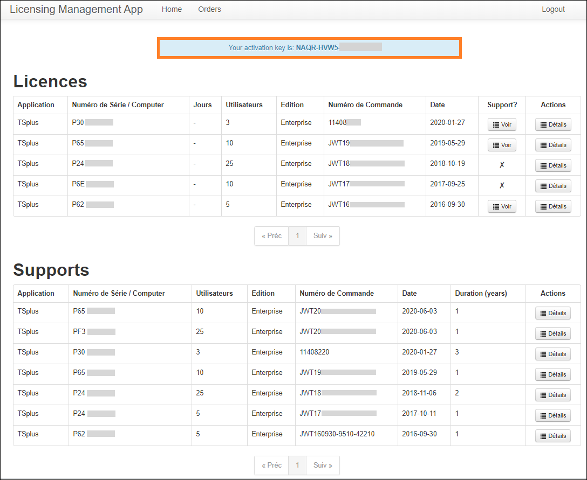
TSPLUS / all rights reserved 2020

USER GUIDE Customer Portal

- You will need to copy and paste it on TSplus or TSplus Add-Ons Administrator Tools, on the License tab. Click on the « Activate your license » button :
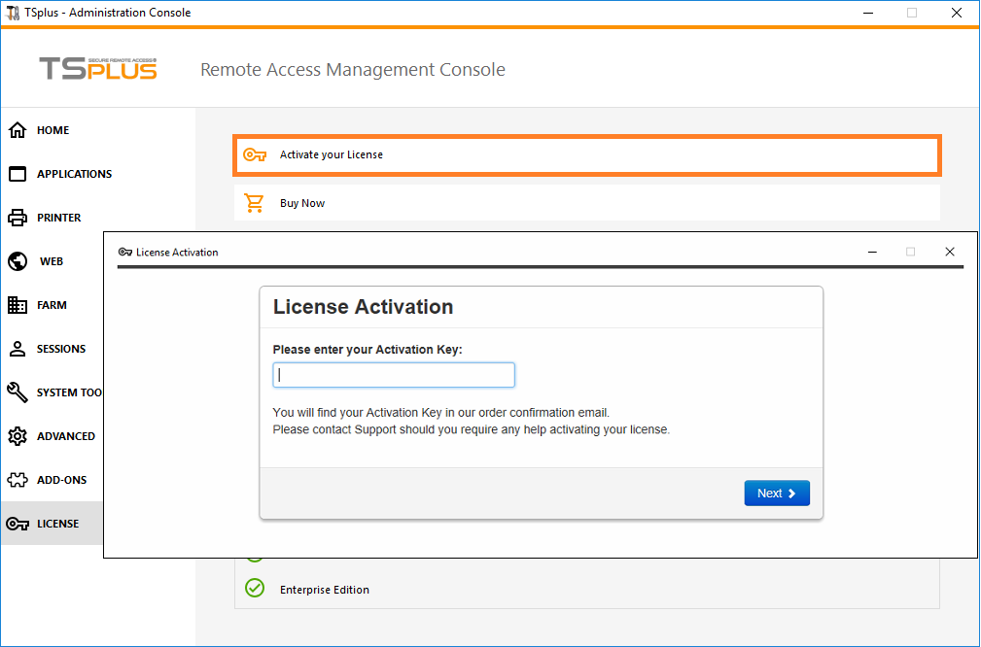
N.B : For previous TSplus/TSplus Add-Ons releases, you can still download your License and Support (.lic) files by clicking on the Details button, located in the Actions column or on the View button on the Support column.

- Following the License activation, simply click on the « Refresh your License » button to refresh your License data. Your licensing information will be synchronized with our Licensing Portal. Refreshing your license information may be required to complete the upgrade of your TSplus license or a rehost:

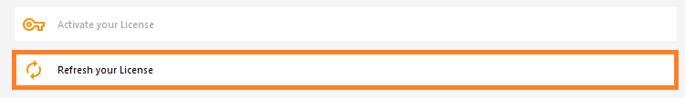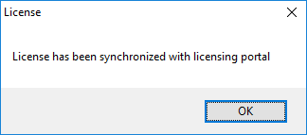
TSPLUS / all rights reserved 2020

USER GUIDE Customer Portal

ORDERS PAGE
GET INTO DETAILS

- On the Orders Page, you can view your orders Details, with the Date, Name, Country and City of the Order, as well as your purchase Contact Name and Email Address.
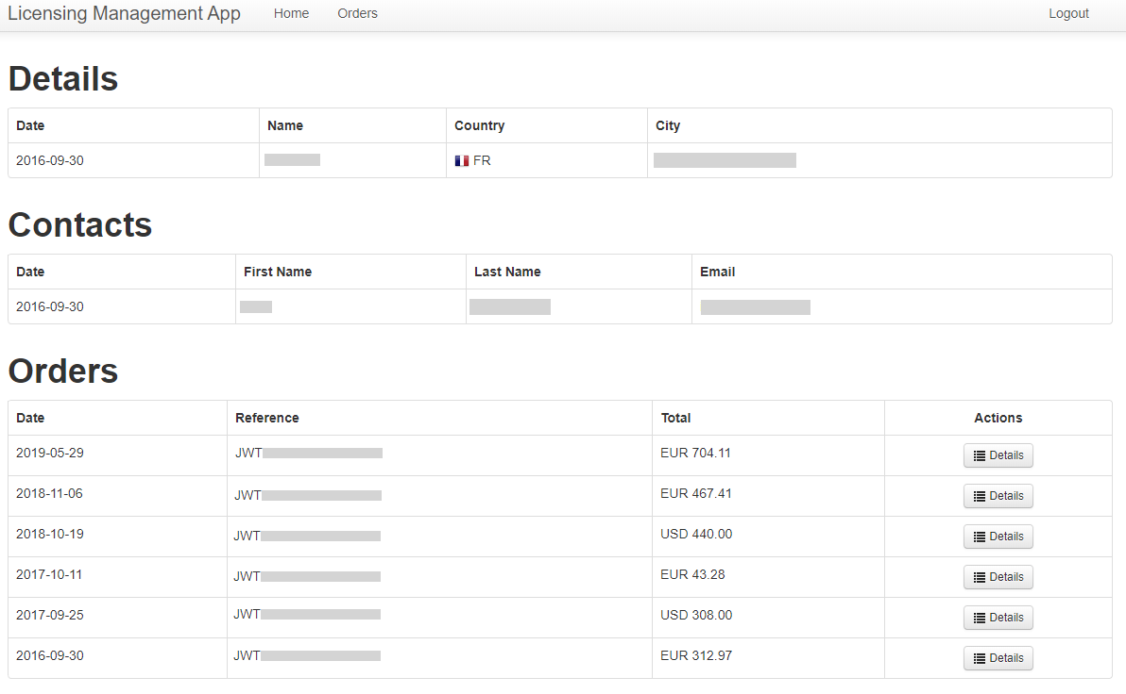
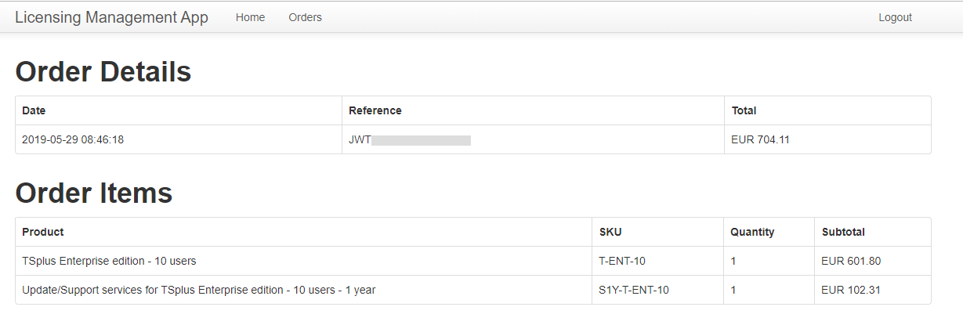
- Each order has a unique reference. The total cost for each order is displayed and you can view the Order Details and Items by clicking on the Details button of the Actions column:

TSPLUS / all rights reserved 2020

USER GUIDE Customer Portal

ORDERS PAGE
ADD WORKSTATIONS TO YOUR TSPLUS REMOTE WORK LICENSE
- You can add additional workstations to your Remote Work licence directly on the Customer Portal, under the “Upgrade” column:

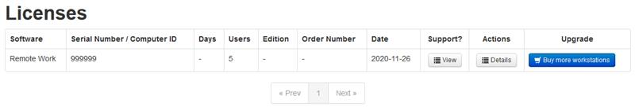

- The upgrade page opens in a new web browser tab and allows workstations to be added to an existing Remote Work license.

The following example adds 3 workstations to a 5 workstation license. The total price is calculated based on the number of workstations added and the time remaining in the current support period:

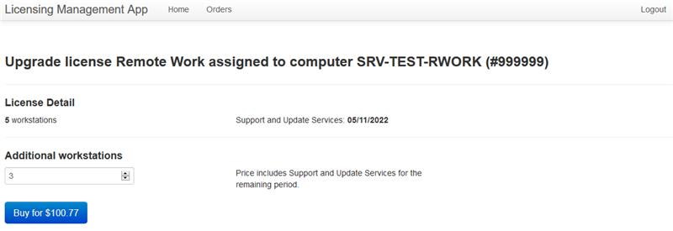

TSPLUS / all rights reserved 2020

USER GUIDE Customer Portal

ORDERS PAGE
ADD WORKSTATIONS TO YOUR TSPLUS REMOTE WORK LICENSE
- When you click on the “Buy” button, you will be redirected to the Fastpring order website in order to complete your purchase:
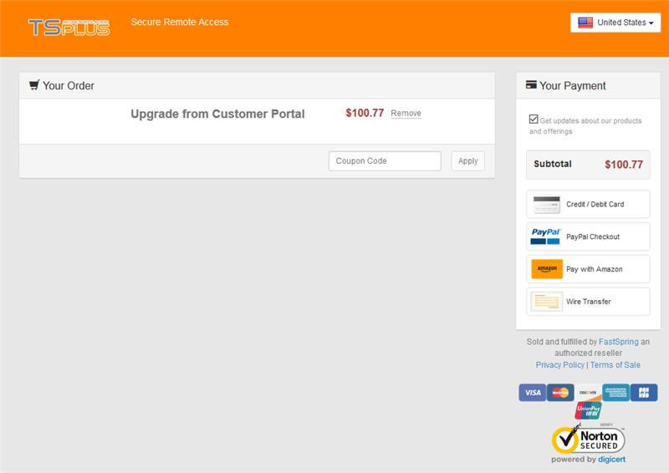

If you have any questions concerning your Orders, Licenses and Support Files, contact us at support@terminalserviceplus.com. Don’t forget to include your purchase Email Address or Order Number when contacting us!

Go to TSplus Customer Portal

