TSplus
Connecting the World

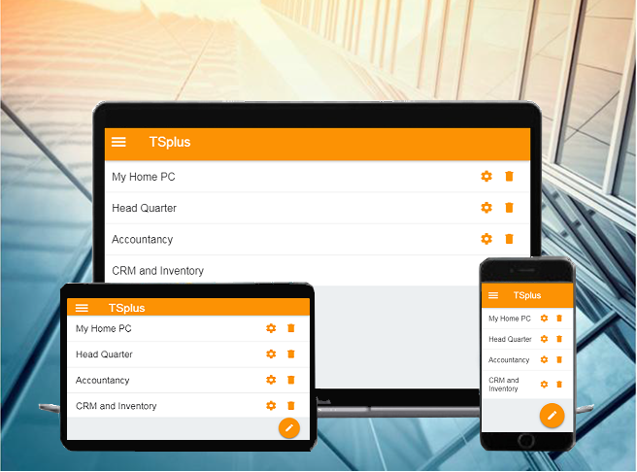

Working in the cloud... wherever you are, whenever you want. With the TSplus App, your Windows applications are available anywhere in real time, simply by using your secured WiFi or Internet connections.

TSplus is revolutionizing data management, information exchange and cooperation among all Application Servers - worldwide. Working in the cloud... wherever you are, whenever you want, with the TSplus App, business data and applications are available anywhere in real time. Whatever is your preferred device - PC, MAC, tablet or mobile - for the first time, all platforms offer:
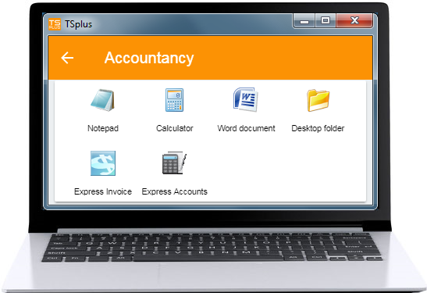
- the same professional functionality,
- the same display quality,
- the same TSplus Security
- the same high operating speed, and
- the same easy handling.

Whether you work completely in the cloud, in the secure data center, or decide to connect to your own TSplus system, the TSplus App represents a paradigm shift for business data management.
The Apps

The app can build up any number of connections simultaneously to different servers and sites. With just one click, you are connected to the server in New York; with another, you start your CRM in Los Angeles.

TSplus Apps… are available for all major operating systems as web or native apps. After a short download, your devices are ready for use within a few minutes. Whether on your desktop or mobile device, the apps are a gateway to each TSplus system. With just a click or touch of a button, you are connected to a TSplus server where you can use the provided programs, such as QuickBooks, SAP or Office, in real time - wherever you are.
Easily print any document and photo you need on the nearest local printer.

From Smartphone to tablet, up to workstation - all end devices allow the same unlimited functionality for the same operation.
From Smartphone...  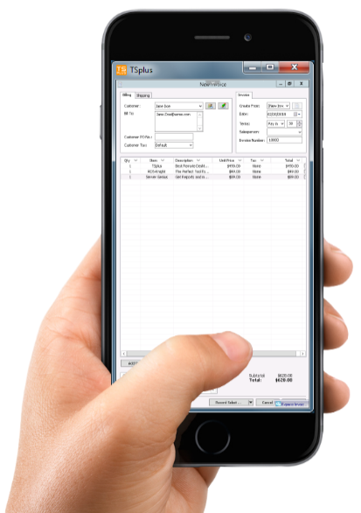 | 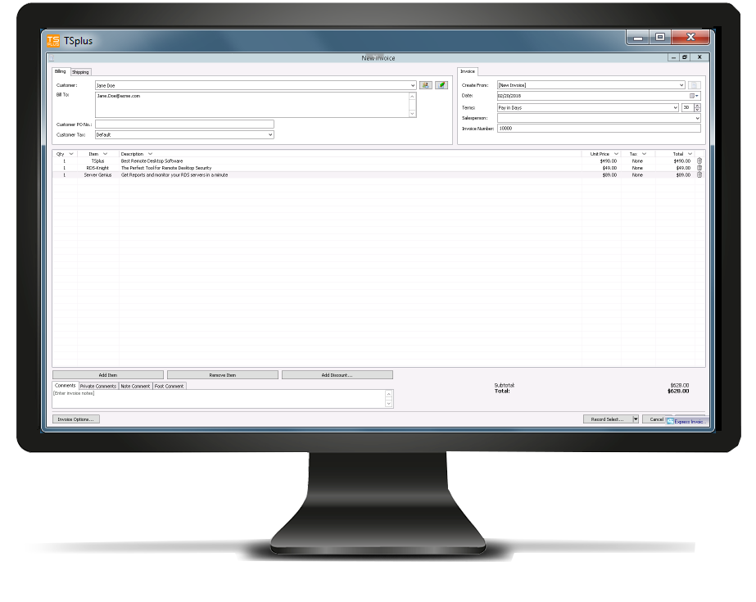  To workstation...

Mobility = Success

When leaving your workspace, you will be able to continue to work seamlessly from your mobile device.

Most users already use Smartphones or tablets for personal or business purposes. The TSplus App shows that mobile phones do not have to be limited to making phone calls or sending emails. Business professionals have unlimited mobile access to all data and applications inside and outside of their company facilities and can make important decisions at any time and place. Since time is a crucial factor for businesses, the TSplus App becomes a partner of your success.

TSplus goes mobile... anytime and anywhere, you can use all your business apps. Whether at your workplace, from home or in between... with the TSplus App, you always have a secure connection to your data via desktop, tablet or Smartphone. Furthermore, easily print any document you need on the nearest local printer!

No learning curve... you work in the same user environment, with the same full software functionality that you know from the workplace. For mobile devices, the TSplus App adapts automatically to touch operations.
Infinite freedom

Work whenever and wherever you want... with your TSplus App, business services or administrative tasks are no longer bound by any location. Read your files in the home office, have business reports written by employees at home, and outsource tasks at peak loads to other service providers.

Flexible working hour models... means easier access for staff. From the administrative assistant with a long commute, to the consultant who starts with family planning - you can now offer a working time model that fits exactly into their lifestyles.

Data protection is always a priority... even when employees work outside, your data never leaves your building. Everyone works via an encrypted data connection with your applications, either locally in your company or in a data center, without storing any data on end devices - as safe and secure as in the office.

Business professionals have unlimited mobile access to all data and applications inside and outside of their company facilities and can make vitally important decisions at anytime from anywhere. Furthermore - user data can be recorded directly with mobile devices and transferred to the TSplus system.

Where time meets business, the TSplus App is the "must-have" solution.

The future is now!
Are you ready?

TSplus centralizes all remote connections on a single platform that is securely shared between users and across the entire team. With support for Windows technologies - including multiple protocols - along with built-in enterprise grade Web Portal tools, Remote Desktop and application-level access controls, the TSplus App is a Swiss Army knife for remote access. TSplus empowers IT departments to deliver security, scalability, reliability, performance and
productivity throughout the organization,
while reducing inefficiency, cost and risk.

TSplus App is available for free from Google Store, Apple Store and iTunes. Two versions are supporting the TSplus App: TSplus Web Mobile and TSplus Enterprise.
The TSplus Mobile Web edition is perfect for stand-alone Windows servers. The TSplus Enterprise edition is the best choice for large numbers of users and teams.
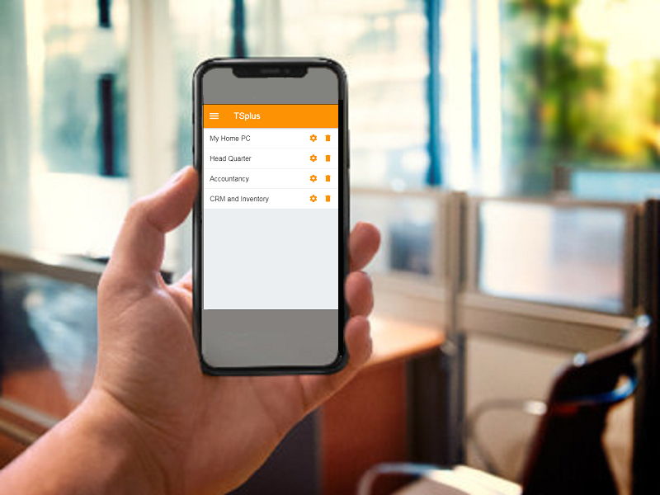

Download links

- Android (Google Play Store):
https://play.google.com/store/ and search for TSplus or https://play.google.com/store/apps/details?id=com.terminalserviceplus.mobile
- iOS (Apple App Store):
https://itunes.apple.com/us/app/tsplus/id1346566246
- Windows:
https://dl-files.com/app/Setup-TSplusApp.exe
- Linux: Linux (Debian/Ubuntu) - more recent Linux systems.

Pre-requisites: The TSplus App has 2 pre-requisites.
- The host site must be a TSplus Web Mobile or Enterprise system.
- The 11.30 release (and over) must be installed on this host
Download the latest Update Release: http://dl-files.com/UpdateRelease.exe

Contacts
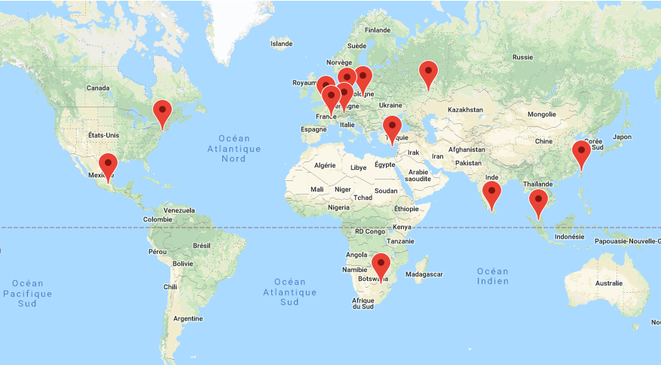

Inquiries:
- support@terminalserviceplus.com
- sales@terminalserviceplus.com

Region Directors:
- marc.shapiro@terminalserviceplus.com (USA/Canada Region Director)
- luis.perez@terminalserviceplus.com (Latin America Region Director)
- hendrik.wenschuch@terminalserviceplus.com (Central Europe Region Director)
- christian.platzer@terminalserviceplus.com (South of Europe Region Director)
- andrzej.krystaszek@terminalserviceplus.com (Eastern Europe Region Director)
- patrick@tsplus.me (Middle-East Region Director)
- rukshan.sanjeewa@terminalserviceplus.com (South Asia Region Director)
- adrian.foo@terminalserviceplus.com (South East Asia Region Director)
- alan.yang@terminalserviceplus.com (Eastern Asia Region Director)

