**Strong security-**

**lite INTERFACE !**



protects your remote desktop connections and your remote access environment.

discover version 6 with a new lite mode

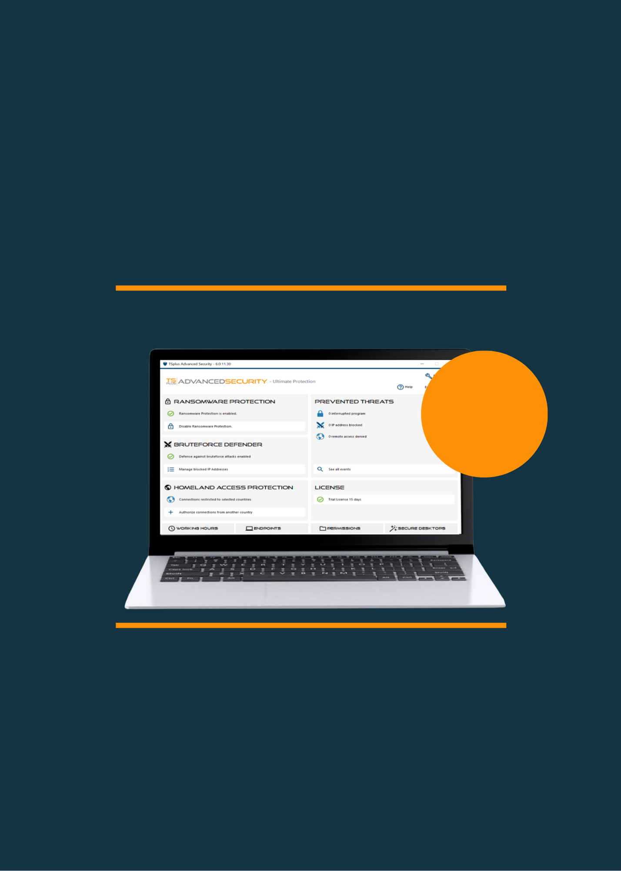

Version 6 offers a LITE mode for first-time users. Same PROTECTION, but with a streamlined design to highlight the most powerful FEATURES and enable STRONG SECURITY FROM THE START. EXPERT mode available at no extra costs!

Download the trial version of TSplus Advanced Security Ultimate Protection (15 days, All features)

[**DOWNLOAD**](https://tsplus.net/download/)

Multi- Security Tool:

Up to 7 features

FEATURE-rich. affordable. user-FRIENDLY

**THE cyber-security software specifically designed for remote access networks**