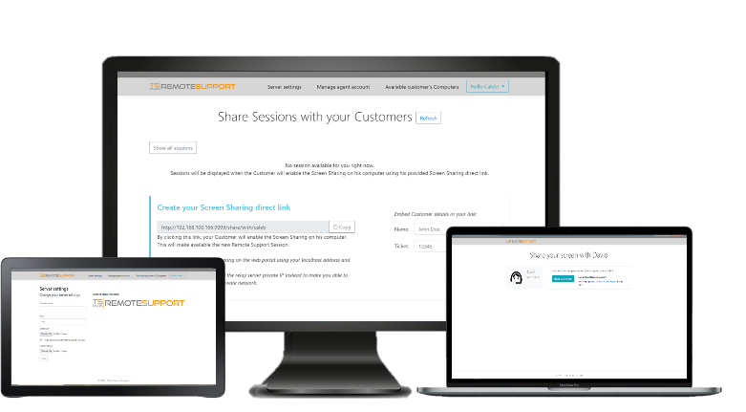
vs. Competitors

TSplus Remote Support allows you to provide instant remote assistance for your clients anywhere, at any time. No third-party servers. Keep control of your connections! With permanent licensing, you pay once and own your remote support infrastructure forever.
Features & Benefits | REMOTE SUPPORT | tEAMVIEWER | LOGMEIN | SPLASHTOP
remote desktop access
screen sharing & control
unattended accesss
chatbox
clipboard & file transfer
branding customization
multi-sesssion
multi-monitor support
send command prompts
BROWSER-BASED INTERFACE |  | -
integration with others software |  |  | -
session sharing with url or id |  | - | - | -
self-hosted relay server |  | - | - | -
encryption | TLS | AES | TLS | TLS
licensing per agent | PERMANENT  PER AGENT  $50 | PER YEAR  PER AGENT  $396 | PER YEAR  PER AGENT  $660 | PER YEAR  PER AGENT  $439

